**JS**



**Dashboarding Your Data**

**with Dossiers**



**Introduction for:**

All user roles and personas

**CONTENTS**

1. **MicroStrategy: Data-Driven**

**Intelligence**

1. **Create a First Class**

**Dossier**

Owning the datascape: Becoming an Intelligent Enterprise...................... 6 Dossiers: Create an analytical book of business.............................................. 8

Your class environment: Cloud analytics and mobility................................ 9

Exercise 1.1: Explore a sample dossier......................................................11

Key Intelligence Center roles: Departmental analytics and mobility....18

Consuming data across the Intelligence Center...................................19

Building your dossier with federated data......................................................20

Prepare data.......................................................................................................22

Refresh data........................................................................................................24

Class project: The Supplier Report dossier......................................................25

Exercise 1.2: Import data to build a new dossier ..................................26

Leveraging the Intelligence Platform: Attributes and metrics ................28

Business concepts: Attributes......................................................................29 Business measures and KPIs: Metrics ........................................................30 Exercise 1.3: Create a grid visualization....................................................31

Exercise 1.4: Import another dataset.........................................................33

Building your dossier..............................................................................................39

Format your dossier for a visually appealing design...........................42

Communicate visually: Leveraging data visualizations .............................45 Finding the best fit visualization for data analysis...............................46

Heat map.............................................................................................................49 KPI visualization................................................................................................50

ESRI map..............................................................................................................51

|  |
| --- |
| Contents Dashboarding Your Data With Dossiers |

1. **Layering, Filtering, Sorting, and**

**Thresholding**

1. **Analyze Data and Collaborate with**

**MicroStrategy Library**

Exercise 2.1: Enhance the Supplier Dossier with visualizations.......56

Workshop 1: Import data and add the appropriate visualization  

to a dossier..........................................................................................................65

Layer related data: Chapters and pages ..........................................................75

Exercise 3.1: Add a page to the Supplier Dossier..................................76

Narrowing data: Filters...........................................................................................77

Filtering chapters .............................................................................................78

Exercise 3.2: Add a subcategory filter to the Supplier Report  

chapter.................................................................................................................80

Filtering specific pages and visualizations..............................................81

Exercise 3.3: Add an object filter to the Supplier Details page........82

Easily identify trends...............................................................................................83 Sort data ..............................................................................................................83 Forecast data: Trend lines .............................................................................84

Reference lines..................................................................................................85

Dig deeper into your data: Drilling....................................................................85

Activity: Sort data.............................................................................................87

Highlight important changes in data: Thresholds .......................................87

Workshop 2: Visualization analysis ............................................................91

Create a metric based on existing metrics: Derived metrics..................100 Calculate values in an existing metric: Aggregate By.......................101 Combine values of metrics: Calculations...............................................101

Workshop 3: Visualization analysis ..........................................................103

Add dossier details: Insert text or images .....................................................106

Add text .............................................................................................................106 Add an image...................................................................................................107

Exercise 3.4: Insert text and complete the dossier.............................108

Workshop 4: Analyze data to determine areas of opportunity .....113

Share and collaborate: MicroStrategy Library .............................................126 Exercise 4.1: Add a cover image........................................................................128 Verify and validate: Certified dossiers.............................................................129 Personalize and manage your Library ............................................................130

Collaborate and communicate with MicroStrategy Library ...................131

Activity: Explore collaboration in Library...............................................133

Dashboarding Your Data With Dossiers Contents

Activity: Elevate your dossier analysis using HyperIntelligence ...........136

Explore zero-click analysis with HyperIntelligence in Chrome......136

Data on the go: MicroStrategy mobile...........................................................139

The Library app: Seamless dossier mobile deployment ..........................140

Mobile preview in MicroStrategy Web...................................................140

Mobile Library: Your virtual dossier bookshelf............................................140 Activity: Download and explore the Library App ...............................144

Explore zero-click analysis with HyperMobile .....................................150

1. **Unified Authoring** Managing the Enterprise Platform: MicroStrategy Workstation...........156

**and Administration:** Resources at your fingertips.......................................................................157

**Workstation** Design and distribute dossiers..................................................................158

Connect to the cloud and on premises data storage: Access  

multiple environments.................................................................................159

Upload and prepare data ............................................................................161

Build HyperIntelligence Cards...................................................................161

MicroStrategy administration: User and group management ......163

1. **Workshop: Port** Create and analyze the Port Analysis dossier ..............................................166

**Analysis Dossier**

Contents Dashboarding Your Data With Dossiers



**1**

**M**

**ICRO**

**S**

**TRATEGY**

**:**

**D**

**ATA**

**-**

**D**

**RIVEN**

**I**

**NTELLIGENCE**

# Owning the datascape: Becoming an Intelligent Enterprise

Organizations are facing an increasingly complex landscape while working to sustain a competitive edge. Three major forces are driving enterprises to seek comprehensive business intelligence solutions and leverage their data, people, and enterprise assets.

* Data overload: Without federated analytics and standard data governance, enterprises are at risk for getting over saturated with data and losing the ability to make intelligent decisions. Smart data management is key for business success — enterprises need a single source of truth to help make smart business decisions, along with the right tools to analyze and collaborate on insights.
* Disruptive change: Every day, new technologies emerge, changing the BI landscape in dynamic ways. From Big Data to open source predictive analytics, the aggressive pace of change challenges organizations to successfully use new technologies to their full potential. To take advantage of these innovations, enterprises need a flexible foundation that powers the next wave of intelligence with an open platform.

Owning the datascape: Becoming an Intelligent Enterprise

* The era of personalized experience: Today, users want tailored answers to their questions without burdensome and complicated processes. From tailored movie recommendations on streaming services to consuming data that is relevant to your job role, personalization plays a major role in the day-to-day. Using innovations like Machine Learning, HyperIntelligence, and Natural Language Query, enterprises can deliver customized insights and answers to end users.

Organizations can rise to meet these challenges by becoming an Intelligent Enterprise. The Intelligent Enterprise is a data-driven organization that effectively designs and implements business intelligence solutions while promoting effective use of data across your enterprise. To help organizations on their journey, MicroStrategy developed a comprehensive Map of the Intelligent Enterprise that lays out how organizations can leverage all of their assets to be successful while navigating external pressures. The Map contains every detail of how to get to an Intelligent Enterprise. On the highest level, the following image shows you the general areas of focus.



In this course, and across the next three days, we'll discuss the how to navigate the Map of the Intelligent Enterprise and MicroStrategy. In today’s class, we’ll cover departmental analytics and how you can support your business through data discovery.

Owning the datascape: Becoming an Intelligent Enterprise

# Dossiers: Create an analytical book of business

Dossiers, MicroStrategy’s next generation dashboards, make powerful analytics available to anyone, regardless of skill set or role, helping improve data literacy across the workforce. Featuring a simplified, streamlined interface, dossiers compile data from across the organization in intuitive, interactive applications and allow analysts to transform data in minutes to create visually appealing dossiers that tell an analytical story. Dossiers make analytics simple, interactive, and social—ideal for increasing adoption of BI across an Intelligent Enterprise.

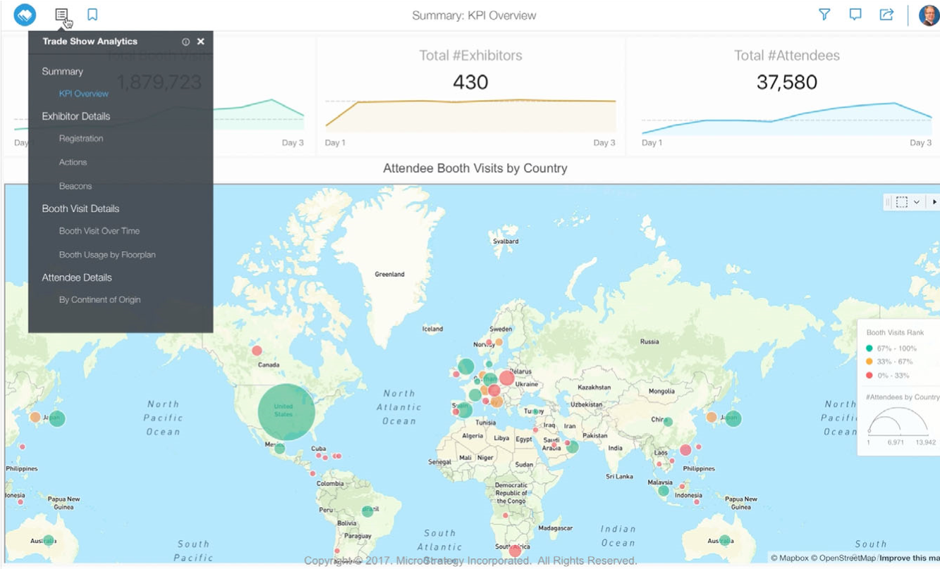

Quickly visualize data with out-of-the-box grids, graphs, charts, and maps to help you easily discover patterns, trends, and relationships. Dossiers are organized in pages and chapters that make it easy to navigate and share reports and visualizations.

Dossiers: Create an analytical book of business

You can easily collaborate and share business intelligence using MicroStrategy Library. MicroStrategy Library provides a simple visual library to find the dossier content you and your colleagues need. With live collaboration, commenting, and notifications, your team can stay in sync.

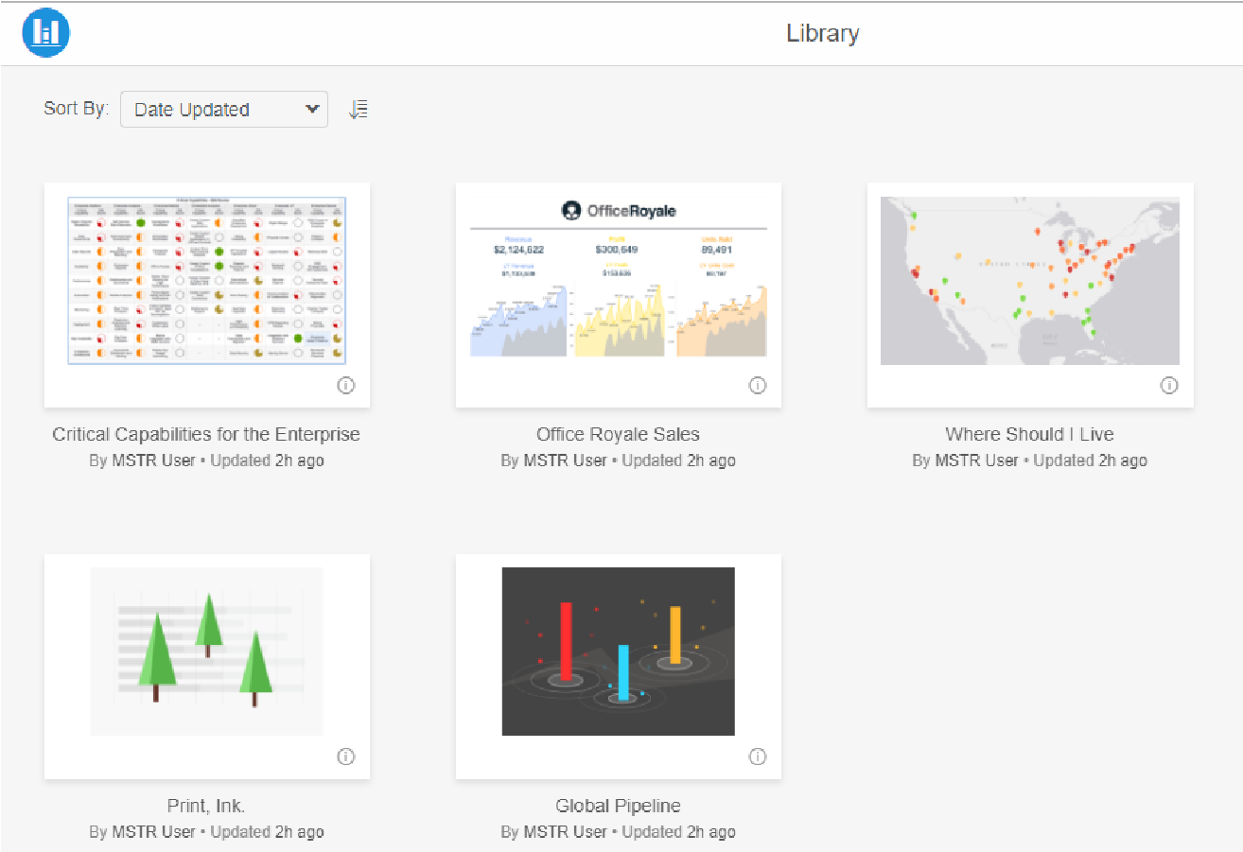

To take an in-depth look at building dossiers and leveraging MicroStrategy Library, take the *Introduction to Dossiers: Storytelling and Collaborating 11.116* course.

# Your class environment: Cloud analytics and mobility

Today's class exercises will be performed in an AWS cloud environment. To deploy fully configured environments in minutes, MicroStrategy partners with Amazon Web Services and Microsoft Azure to deliver a modern cloud experience.

With an AWS or Azure deployment, you get instant access to the powerful services and applications offered by these leading cloud platforms. Enterprises can deploy an environment on their own, or MicroStrategy can deploy a cloud environment for them. MicroStrategy Cloud has a dedicated team of cloud operations experts that manage, monitor, and maintain all customer cloud environments.

With MicroStrategy on AWS or Azure, you can:

* Deploy fully configured enterprise environments and eliminate the need to download, install, or configure environments on your own. Choose from

Your class environment: Cloud analytics and mobility

different instance types and sizes based on your budget and usage requirements.

* Easily monitor and manage the environment with real-time notifications, automation, and scheduling. Schedule actions such as starting, stopping, rebooting and resizing. Reduce costs by stopping your environments during non-peak hours.
* Seamlessly scale the environment up or down based on usage, without a long-term commitment. Start with small teams, add new users as you go, deploy multiple environments and projects when needed, and pay only for what you use.

## Exercise 1.1: Explore a sample dossier

To delve into dossier and Library capabilities, let’s view and analyze a sample dossier, Office Royale Sales, in MicroStrategy Library. The Office Royale sales team uses this dossier to understand key sales performance pipeline metrics. Chapters include an opportunity analysis, individual sales rep performance, and performance by product categories.

As a Regional Sales Manager, you will create a business plan for the year ahead using the dossier information.

**Download and save external files**

1. The instructor will send you the following files:
   * Office Royale Sales.mstr
   * Airline Data.xslx
   * Article Database.xlsx
   * Facebook data.csv
   * NewCompanyData.xlsx
   * NewCompanyDataII.xlsx
   * Supplier Report by Region.xlsx
   * GeospatialService.mstr
   * Campus Recruiting.mstr
2. Create a folder on your computer titled **Jump Start Exercise Files**.
3. Download and save all of the exercise files to this folder. Make sure to store the folder in a convenient location, as we will be accessing it regularly.

**Access the MicroStrategy Cloud environment**

**Log in to MicroStrategy Cloud**

1. In the Welcome to MicroStrategy on AWS email, click **Access MicroStrategy**.
2. In the Login MicroStrategy web page, scroll down, and click **Credentials.**

The system displays the option to log in using Standard authentication.

1. In the **User Name** and **Password** boxes, type (or copy and paste) the login credentials provided in the MicroStrategy on AWS email.
2. Click **Login**. The MicroStrategy Cloud landing page displays in the Chrome browser window of your cloud environment.
3. On the landing page, hover over **MicroStrategy Web** and click **Launch**.
4. On the next page, click **Go to MicroStrategy Web** in the top right corner.

**Add the Office Royale Sales dossier to MicroStrategy Web**

1. You are now in the Shared Reports area inside the MicroStrategy Tutorial project. To add the dossier to your MicroStrategy Web environment, click **My Reports** on the menu on the left.
2. Click **Create**.

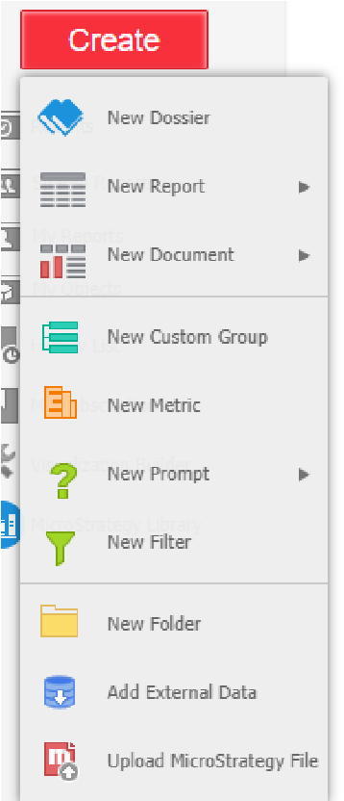

1. Select **Upload MicroStrategy File**.
2. Navigate to your Jump Start Exercises folder, then double-click the **Office Royale Sales.mstr** file.

**Launch the dossier in MicroStrategy Library**

1. In the Upload window, click **Share Dossier**.
2. From the Share: Office Royale Sales window, click **Library Link**.
3. Click **Launch** under the URL to open your Library.

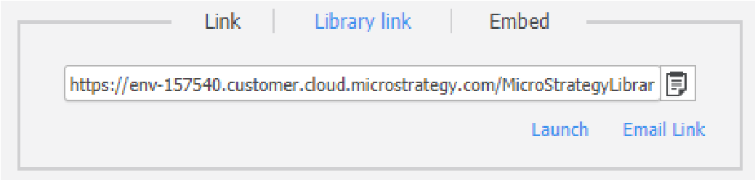

1. Ensure you are on the Summary chapter, Overview page of the dossier. If not, click the table of contents icon  and select the **Overview** page in the **Summary** chapter.

You are now on the Summary chapter, Overview page of the dossier. This page outlines key performance indicators across the past calendar year for Office Royale. What trends do you notice across the KPIs?

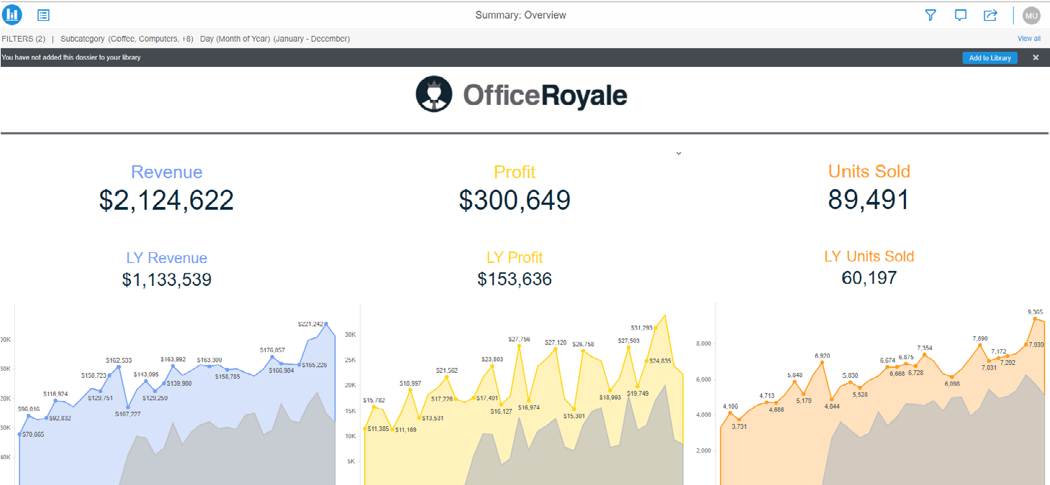

**Add the dossier to your Library**

When you add a dossier to Library, you will be able to directly access all your content by simply logging into your Library. Whether you log in to your Library via Web or on a mobile device, you can quickly find the content you need.

1. Click **Add to Library** at the top of the page. You will now be able to access the dossier at any time via the Library home page.

**Interact with the Office Royale Sales dossier**

1. Now that you’ve taken note of KPIs across the year, you want to view information for your region, North America. Click the **Table of Contents** iconto view all chapters and pages in the dossier.

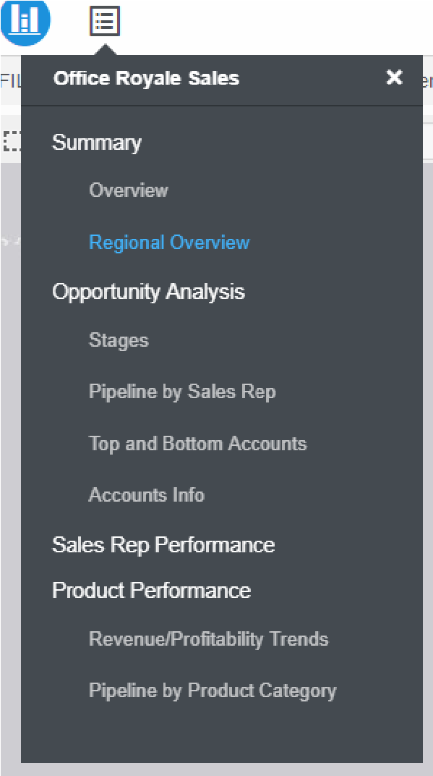

1. Select the **Regional Overview** page, under the Summary chapter.

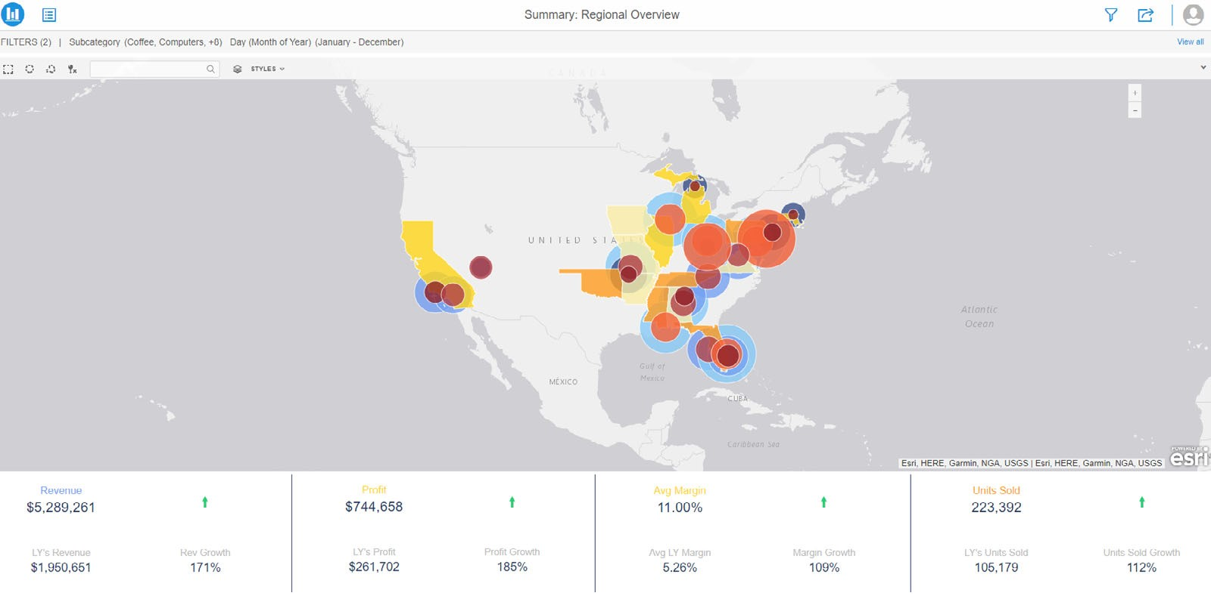

1. Dossier authors can add filtering options, so users can customize the data shown in each chapter when interacting with dossiers in Library. Click the **Filter icon** to view the filters the Office Royale dossier author added to the Summary chapter.

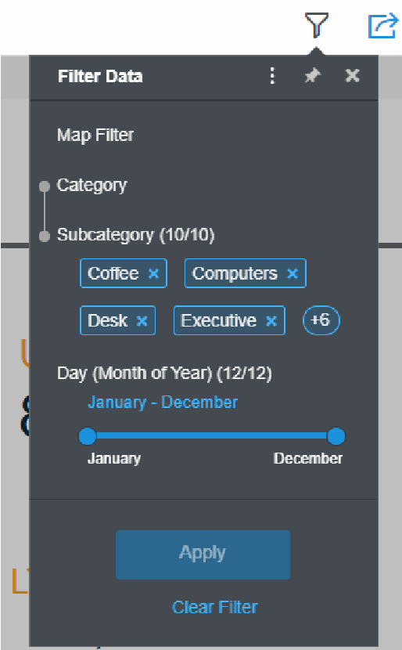

1. Visualizations, such as bar charts, can be added as interactive filters for each chapter. Visually presenting filters in the Filter Panel enables the user to make more informed selections and frees up page space to focus on the results. The Office Royale dossier author has chosen to add a map. From the **Filter Data** menu, click **Map Filter.**

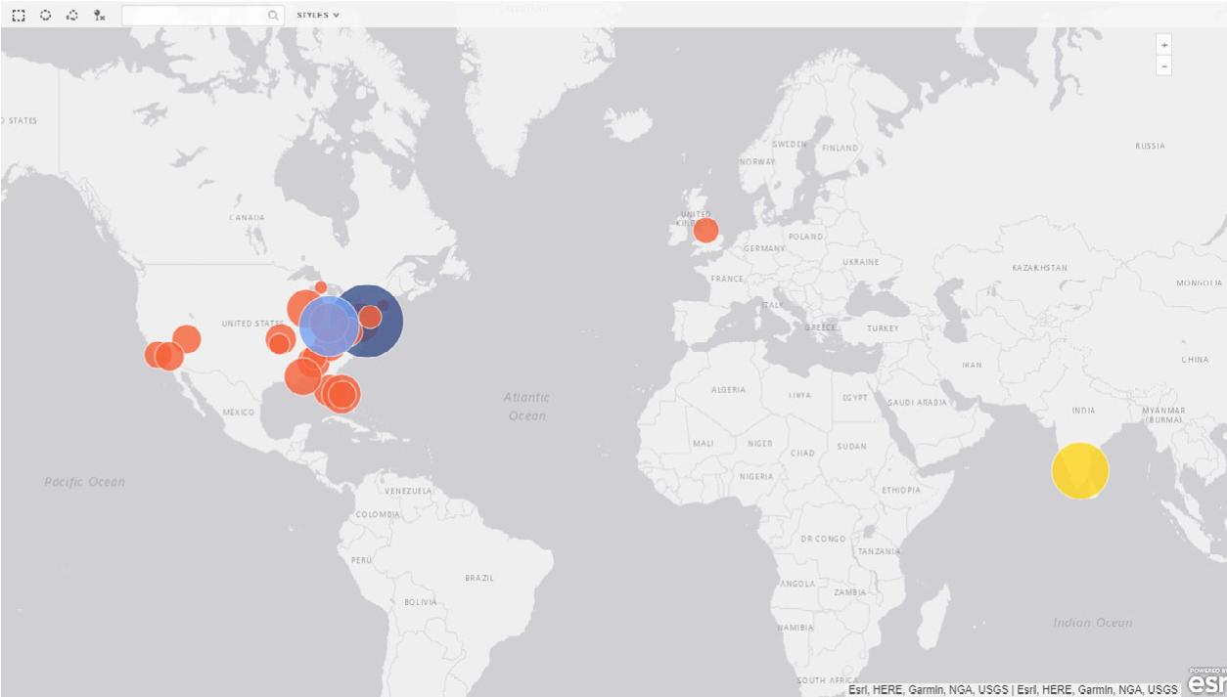

The bubbles on the map represent Office Royale’s office locations, sized and colored by revenue.

1. Your sales region includes Pennsylvania, and you would like to view more information for the city in your region with the highest revenue. Click the **dark blue** bubble, then click **Apply** on the filter panel to narrow the data to show only information for Langhorne, PA.

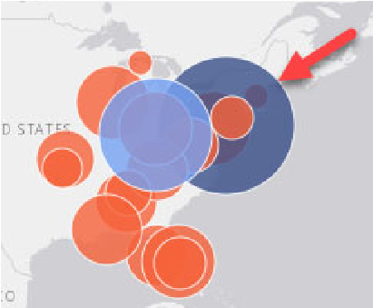

The page now reflects data for Langhorne across the year.

1. The Langhorne office had impressive growth last year and you would like to share this information with your counterpart. Click the **Comment** icon to add a comment.
2. In comments, you can tag users and add filtering states using the @ symbol. To tag a user, type @ then their username. To save your filtering state, type @filter. In the **Add Comment** box, type **@MSTR User, take a look at the Langhorne numbers: @filter**. Then click **Post**.

*Leave a space between the filter tag and period to create the tag.*

1. To utilize the comment filter, first clear your map filter. Click the **Filter** icon.
2. Click the **drop-down icon** to the right of Map Filter, then click **Clear.**

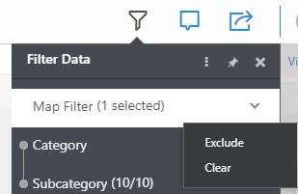

1. Click the **Comment** icon, then click **@filter**. The chapter will show only Langhorne data.
2. Now that you have a high-level view of KPIs across last year, you would like to analyze the opportunity for the year ahead. Click the **Table of Contents** icon, then click the **Pipeline by Sales Rep** page, under the Opportunity Analysis chapter.

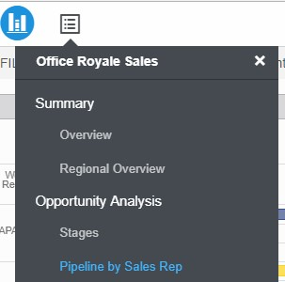

This page shows opportunity by regional manager, sales rep, account owner, and region.

*The map filter has not been applied here — filters are on a chapter by chapter basis.*

1. To view this page for your region (North America) only, click **NAM** at the top of the page.

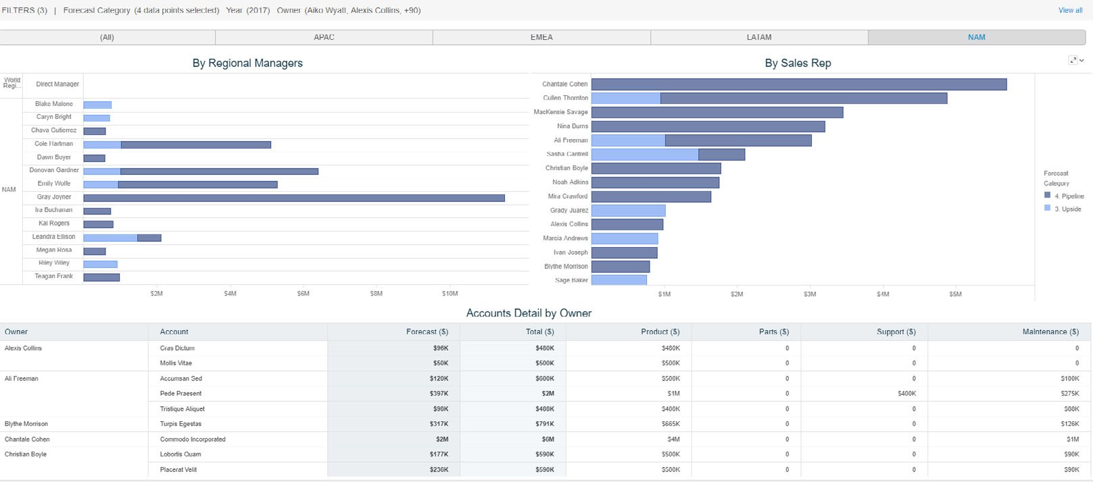

1. Use the Table of Contents to navigate to different pages and chapters. What do you think of the Office Royale sales outlook for next year?

With an intuitive table of contents and interactive collaboration options, the Office Royale dossier in Library promotes data literacy throughout the organization with modern analytics. In the next sections, we will take a deeper

dive into a snapshot of the users that create dossiers and leverage Library capabilities.

# Key Intelligence Center roles: Departmental analytics and mobility

The Map of the Intelligent Enterprise not only guides organizations on what tools to leverage for success, but also the people who support the enterprise. A Business Intelligence platform should support every user role, ranging from executives and business users engaged in self-service data discovery, to analysts and data scientists that build analytics and mobility applications for their departments.

Taking a look at the Roles portion of the Map, this class focuses on the Business User and Analyst roles - how to use local, third-party, and published federated data to build individual and departmental dossiers.

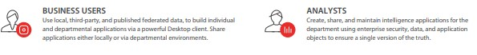

MicroStrategy also helps Intelligent Enterprises inject business intelligence in their users’ daily workflows, and harness the power of that data. HyperIntelligence is a Chrome browser extension that uses MicroStrategy data to identify and

Key Intelligence Center roles: Departmental analytics and mobility

highlight key information on a web page. When a user hovers over a highlighted item, a KPI card with key information is shown.

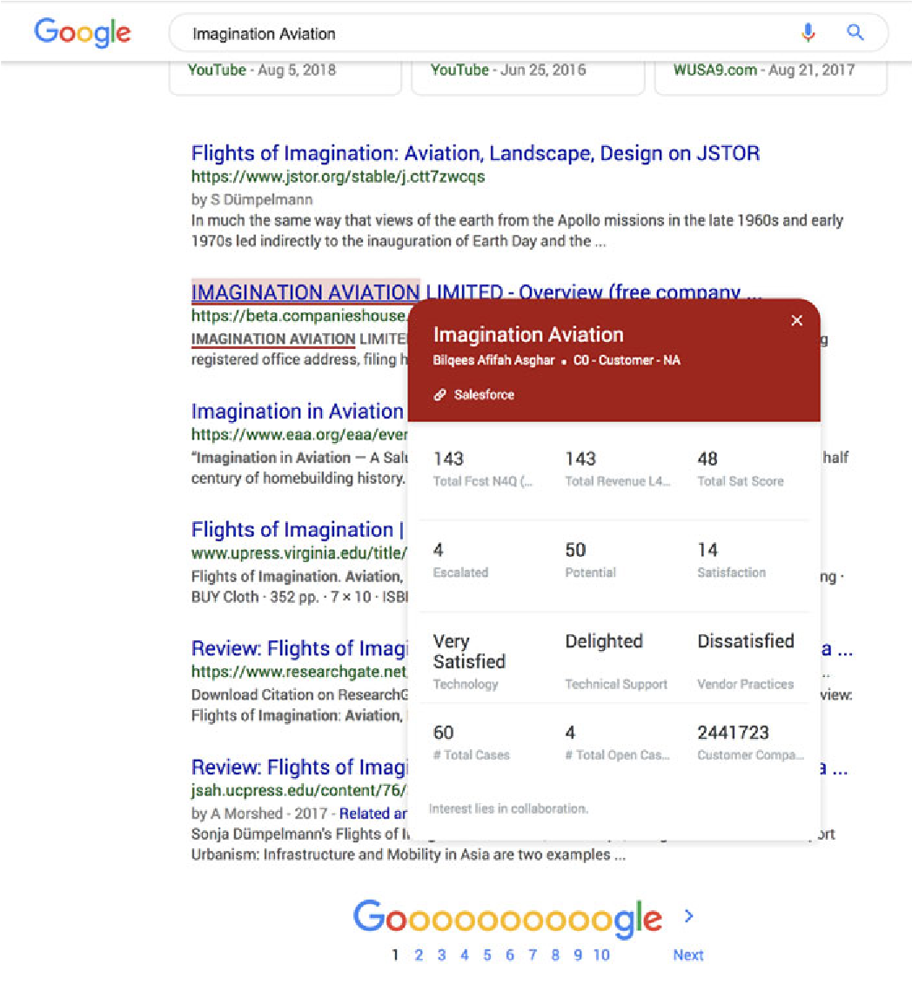

For example, a sales representative at a television production company needs to see key account information while typing notes during a meeting with her manager, while a supply chain manager needs to view a count of set props to manage inventory numbers.

Instead of logging into multiple systems to get the data they need, the company leverages HyperIntelligence to embed in-line analytics in their web-based applications such as Salesforce and Google Documents. HyperIntelligence is one example of leveraging data to make business decisions.

## Consuming data across the Intelligence Center

HyperIntelligence is the most easily accessible way for users to consume data by simply hovering over a key word to see information about customers, products, and employees. Users can then take data discovery to the next level by interacting with a dossier to drill into information and visualizations to enable informed insights. In the example below, a sports analyst is able to see match

Key Intelligence Center roles: Departmental analytics and mobility

information for upcoming soccer matches in Library, while viewing team statistics through a HyperIntelligence Card.

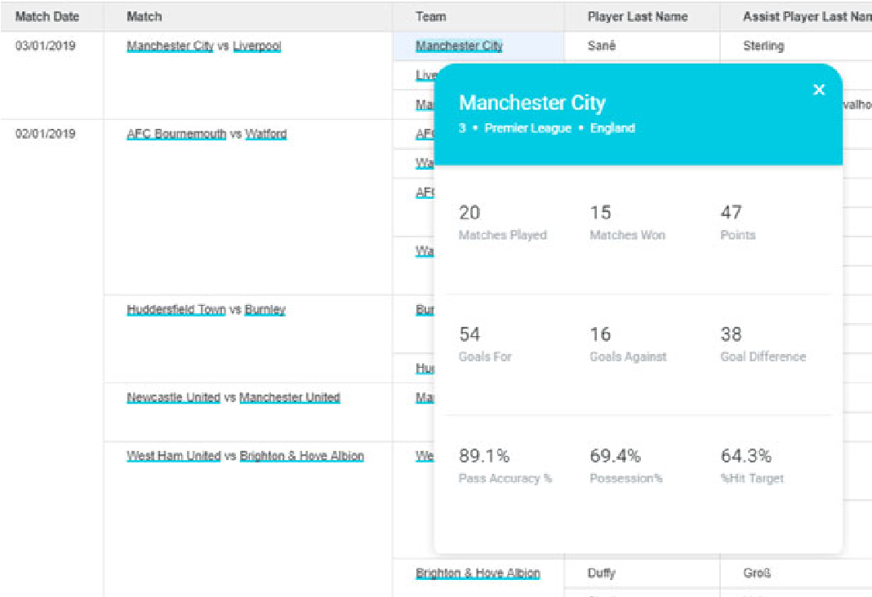

At the analyst level, users can build dossiers with that same dataset in either MicroStrategy Web or Desktop. Finally, at the administrator level, organizations can leverage MicroStrategy Workstation to analyze how users interact with data and dossiers with network topology. Administrators can also understand usage telemetry within the MicroStrategy platform in real-time with Platform Analytics. We will take a deeper dive into HyperIntelligence later in the course.

# Building your dossier with federated data

MicroStrategy's connectors provide a layer of federated analytics, that combine multiple data sources to provide a seamless, cohesive picture of your business, and then leverage that data in other analytic tools. For example, a dossier can access objects from a MicroStrategy project, a web page, and a Salesforce report, to combine sales data, customer reactions, and marketing information that are kept in separate systems, in a single display.

Many of the company's analysts use Web or Desktop to create informative, interactive visualizations with the combined, certified data. But for the business user that prefers to work with Tableau, Qlik, or other BI tools, MicroStrategy's connectors allow him to leverage the governed data extracted by MicroStrategy. Federated analytics allow access to data and its insights, by importing it into MicroStrategy for modeling and analysis, and by extracting it for use in other tools.

You can import data into MicroStrategy Web in a variety of ways to build reports and dossiers. This imported data serves as the dataset for the visualizations placed on the dossier. Data can be imported from many different data sources, such as:

* File sources
* Database sources
* Hadoop
* Salesforce report
* Google Analytics
* Google BigQuery
* Google Drive
* Dropbox
* Reports and queries in BI tools
* Twitter

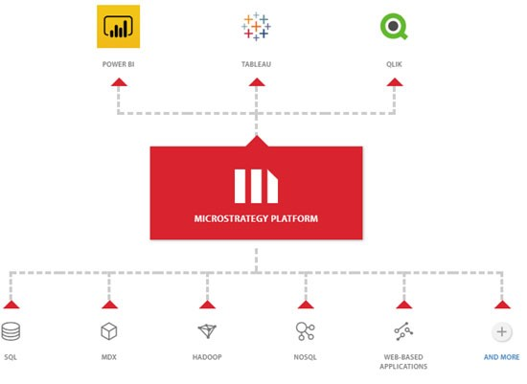

Building your dossier with federated data

## Prepare data

You may need to standardize and clean your data in some instances. For example, it may have City data that lists New York in some cells and NYC in other cells, and some cells might even be empty. To make sure your imported data is useful to you, you want to wrangle, or prepare, your data. You can refine the data from different sources to standardize formatting across the board. Wrangling can also be used as a data discovery tool and to bypass some traditional extraction and transformation (ETL) — avoiding the need for IT involvement or the use of third-party ETL tools.

MicroStrategy’s data wrangling capabilities supports business analysts and data scientists by allowing them to easily prepare different kinds of data for their analytical purposes.

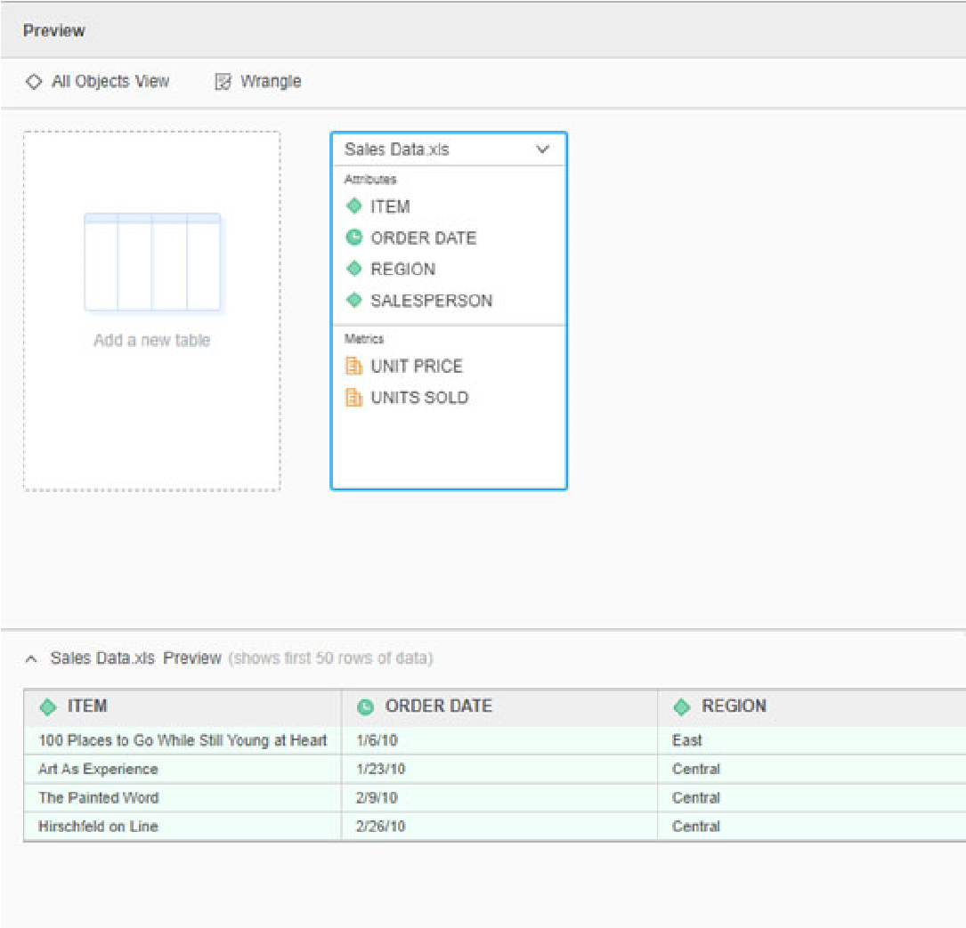

On the Data Wrangle page, you can explore your imported data to evaluate its quality and usability, then manipulate your data to fit your needs before using it in a dossier. You can also use the automatic recommendations MicroStrategy provides to make improvements simpler.

Some examples of data wrangling include:

* Deleting a column or row.
* Removing duplicate cells or rows.
* Extracting data to create a new column.
* Finding and replacing a cell or characters in cells.
* Changing the data type.
* Adding characters before or after the text in cells (padding). For example, if your Region column contains “South” and “North,” you can add “ern” using the Pad After option. The column then contains “Southern” and “Northern.” **•** Grouping similar data into a cluster and editing the entire cluster at once.
* Concatenating or combining two columns into a new column.

For example, you can standardize naming conventions, such as Washington, DC, versus D.C. From the **Data** menu, click **Text Selector** to easily search and edit the text in columns.

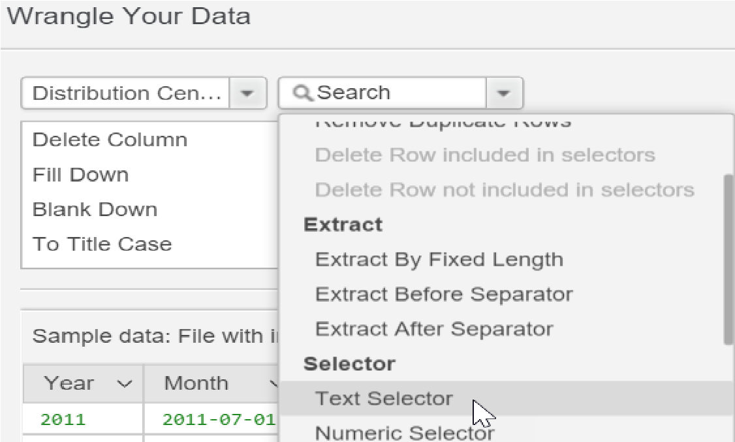

With the Text Selector you can easily edit all of your values at once.

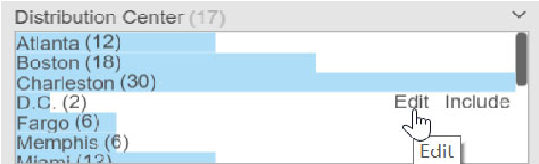

Building your dossier with federated data

As another example, this time you want to split the Camis and Location ID column into two columns.

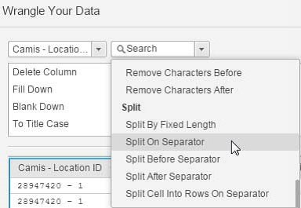

In the Wrangle Your Data window you can choose to split the data and indicate the separator. The data is now split into two columns, as seen in the image below:

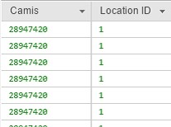

Finally, you can save time and effort with history scripts that keep track of data transformations so they can be reapplied to other analyses.

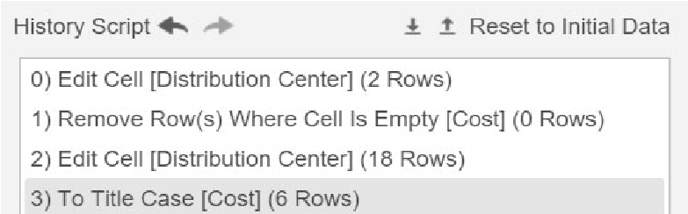

## Refresh data

To make sure that the data in MicroStrategy Web is up to date when compared against your data sources and to promote good data governance practices, you can republish or refresh your datasets. Any new data can either replace or add to your existing data. If you make changes to your source file outside of MicroStrategy Web, you will need to republish/refresh your data. When you republish imported data, MicroStrategy Web automatically updates the dataset.

You also have the option to automatically refresh your data and to set the refresh frequency.

# Class project: The Supplier Report dossier

You are a supply chain analyst for a large distribution company. Your Application Architect, who guides and leads the application design process, has assigned you to create a dossier detailing key performance indicators for regional suppliers. The dossier requirements are as follows:

* A map visualization detailing profit among each supplier city
* Display supplier revenue
* Analyze revenue per supplier
* Show the relationship between region and category
* The dossier should only be one page
* Use of corporate colors of blue and green

The Application Architect approved your dossier mock-up below.

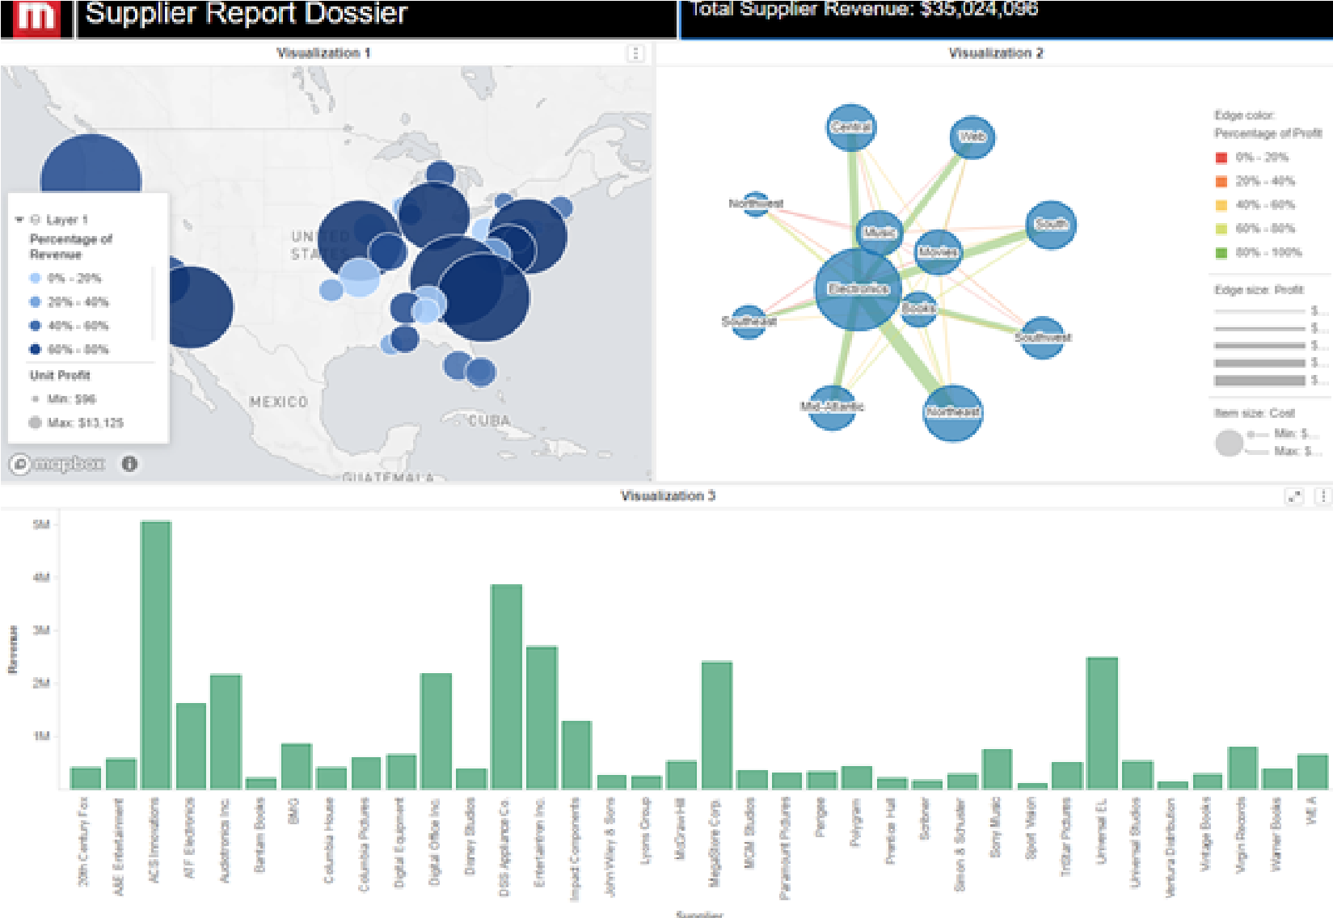

Class project: The Supplier Report dossier

## Exercise 1.2: Import data to build a new dossier

To get started, you will import a dataset into a new dossier. The Analytics Architect, who oversees federated data and schema objects at your organization, has sent you an Excel file containing supplier by region data.

**Open a new dossier and add data**

1. From the Tutorial Homepage, click **Create**, then select **New Dossier**.

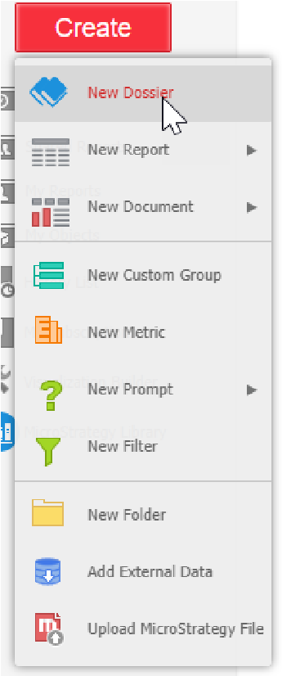

1. In the Datasetpanel, under Add Data, click **New Data**.
2. In the Connect to Your Data window, click **File From Disk**.
3. Click **Choose files**.
4. Select the **Supplier Report by Region.xlsx** file, and click **Open**. *This file should be located in your Jump Start Exercise Files folder.*

Class project: The Supplier Report dossier

1. To make sure the data imports properly, click **Prepare Data** in the Upload your files window.

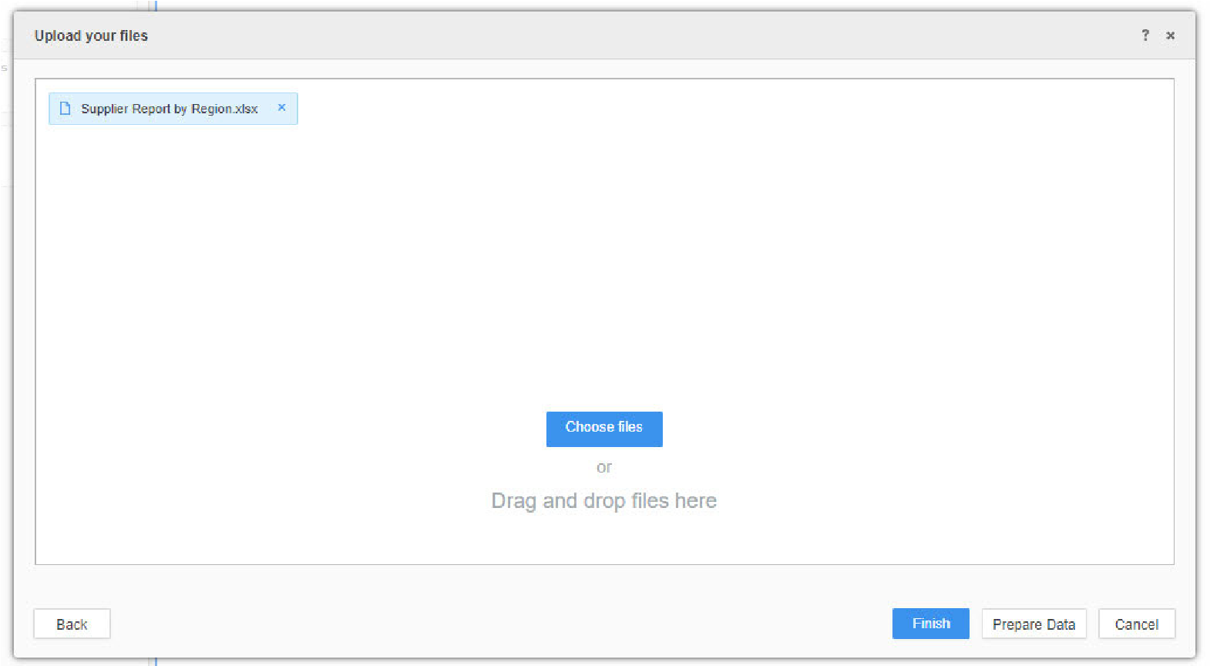

1. In the new window, select only the **Supplier Overview** worksheet and click **Select**.

*When there are multiple worksheets in an imported file, you are prompted to select which worksheet you would like to add.*

1. Verify that Region, Category, and Supplier are listed as attributes (data that reflects business concepts), and that Cost, Profit, and Profit Margin are listed as metrics (data that reflects business measurements).

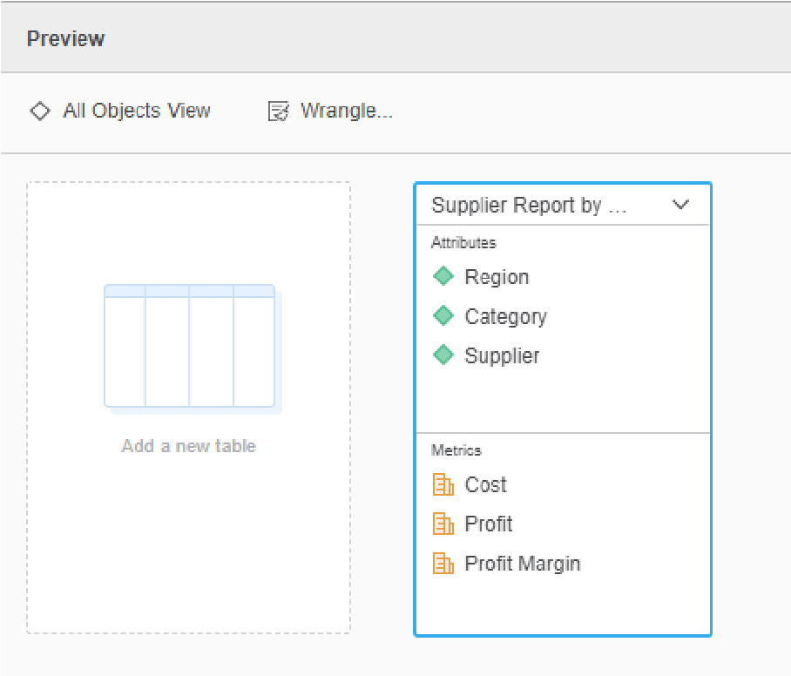

1. Click **Finish**.

You have now successfully added a dataset to the dossier.

Class project: The Supplier Report dossier

1. Save the dossier as **Supplier Dossier** in the My Reports folder.
2. Click **Run newly saved dossier**.

# Leveraging the Intelligence Platform: Attributes and metrics

MicroStrategy’s metadata repository indexes and abstracts an organization's data, allowing users to rapidly build dossiers and deploy them on any device. Leveraging a centralized platform architecture, organizations can easily deploy governed analytics applications that preserve data integrity and accuracy, while still offering flexibility through advanced data blending capabilities.

As mentioned, you can also leverage MicroStrategy's trusted data source within multiple BI tools, such as Tableau and Power BI. For example, the MicroStrategy Connector for Tableau allows Tableau users to fetch data from reports or cubes that reside in MicroStrategy projects or environments.

In the section below, we’ll learn about two schema objects that are the building blocks of dossier data, attributes and metrics.

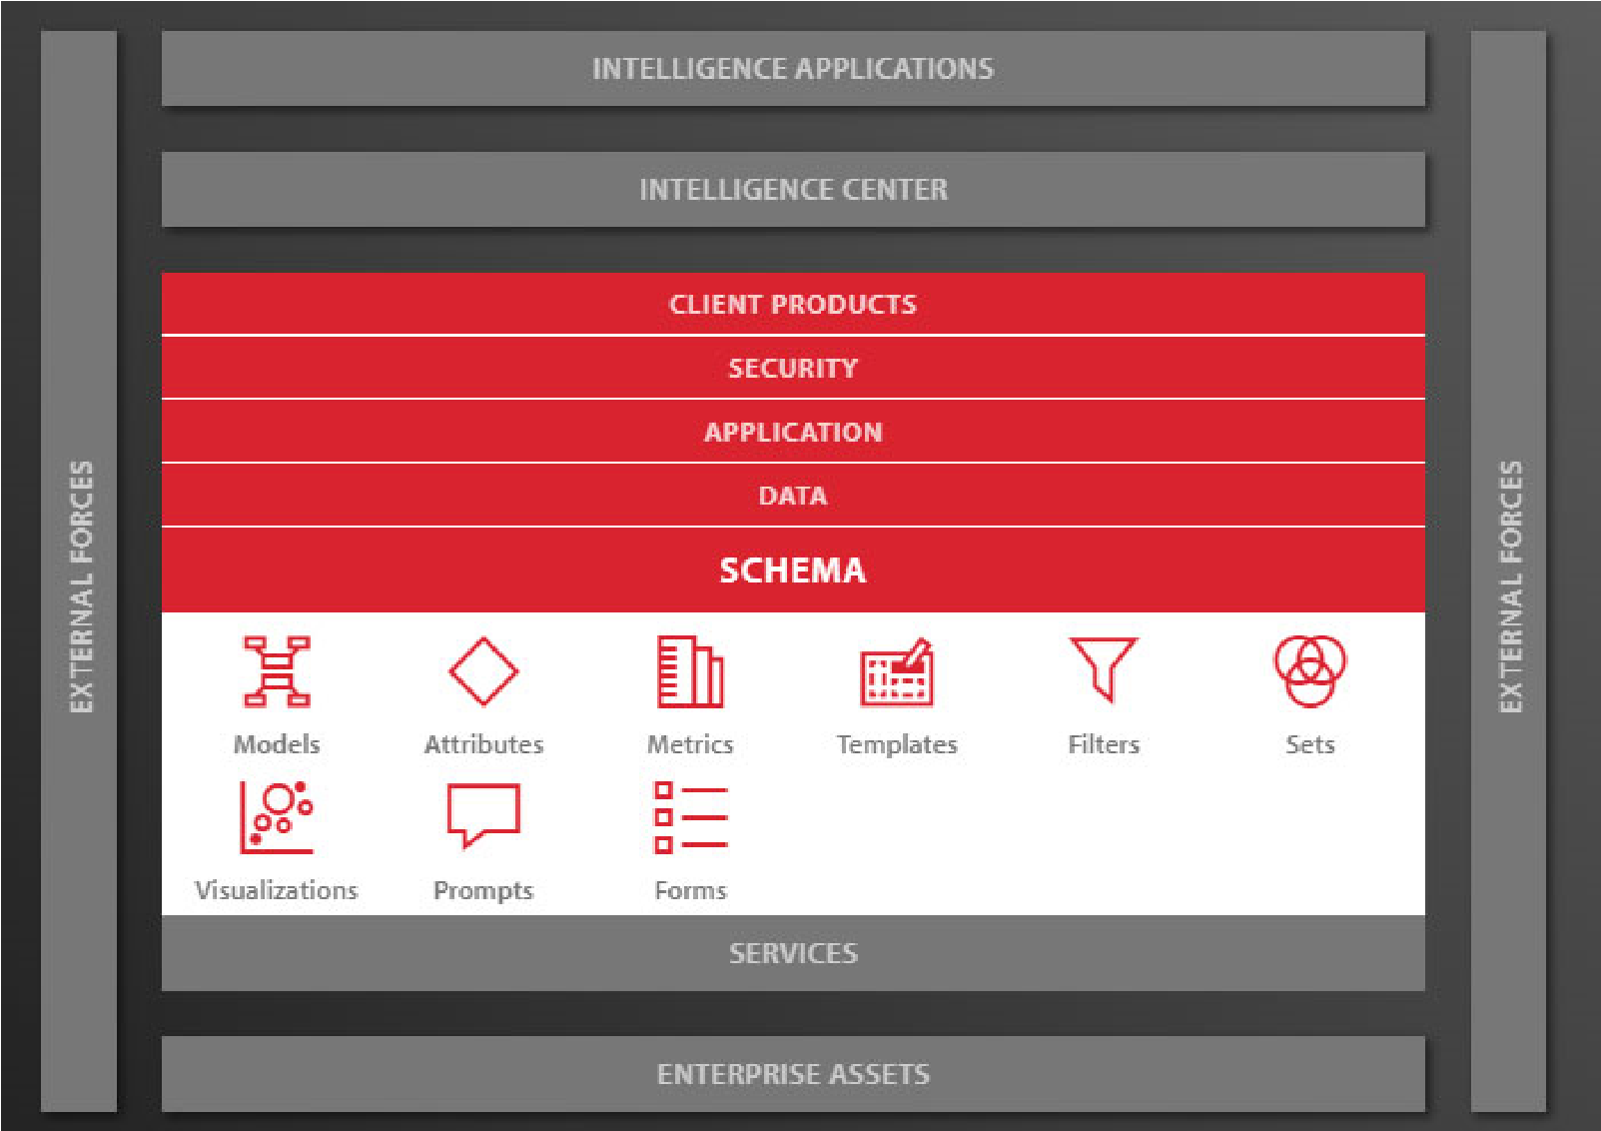

To learn more about MicroStrategy’s metadata capabilities and developing a physical schema, take the *Project Architecting 11.411* course.

## Business concepts: Attributes

Attributes are the business concepts that are reflected in your data source. Attributes provide a context in which to report on and analyze business facts or calculations. An attribute on a dossier serves as a label for metrics. Examples of attributes may be Month, Year, Department, or Region. In the following example, Region and Distribution Center are the attributes:

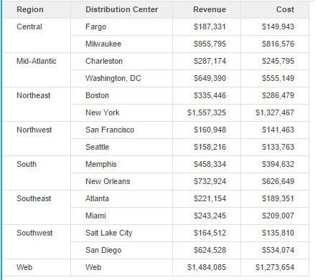

Attributes are comprised of attribute elements. An attribute element is the value of the attribute. In the example above, Central, Mid-Atlantic, Northeast, etc. are the attribute elements of the Region attribute. Attributes are automatically created by MicroStrategy when you import your data. Attributes are displayed with the following icon on the Dataset panel:

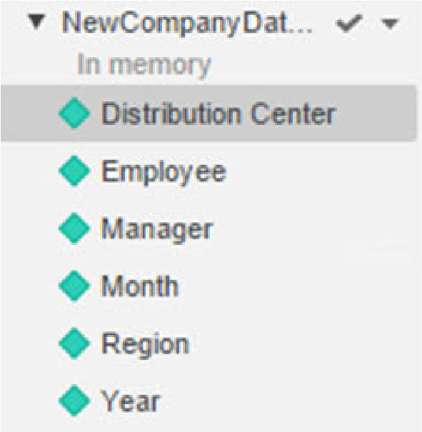

## Business measures and KPIs: Metrics

Metrics represent business measures and key performance indicators. A metric on a dossier shows a list of values that are used for analytical calculations. Examples include Revenue, Cost, and Number of Clients. Metrics can be used to show sales trends, profit analysis, growth patterns, and more. In the following example, the metrics in the grid are Revenue and Cost.



Similar to attributes, metrics are automatically created when you import your data. Metrics are displayed with the following icon in the Dataset panel:

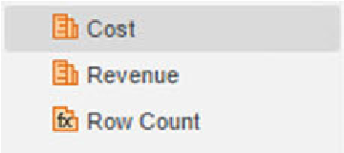

## Exercise 1.3: Create a grid visualization

Before you start building data visualizations per the Supplier Dossier mock up, you want to analyze data the you added to your dossier. In this exercise, you will use the dataset metrics and attributes to create a simple grid visualization on the Supplier Dossier.

**Create the grid visualization**

1. If needed, reopen the **Supplier Dossier** from the **My Reports** folder.
2. A Grid is the default visualization for dossiers. To ensure you are using the correct visualization, click the **Grid** icon in the Visualization Gallery.

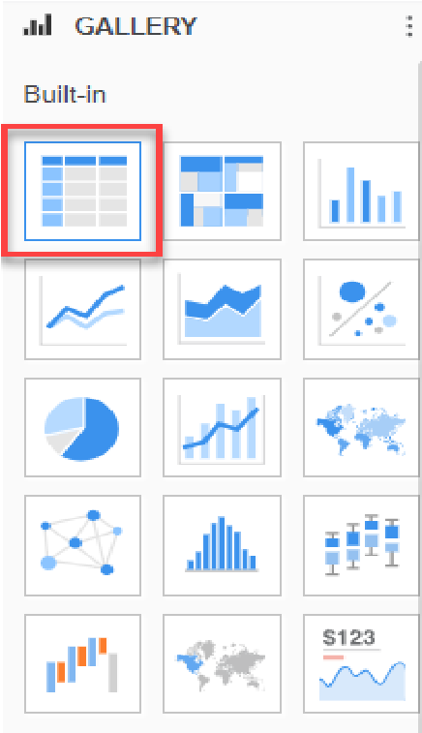

1. To add data to the grid, double-click each **attribute** and each **metric** to populate the grid. Do not add Row Count.
2. Save the dossier by clicking the **Save** icondata can you make based on the grid?

. What observations about the

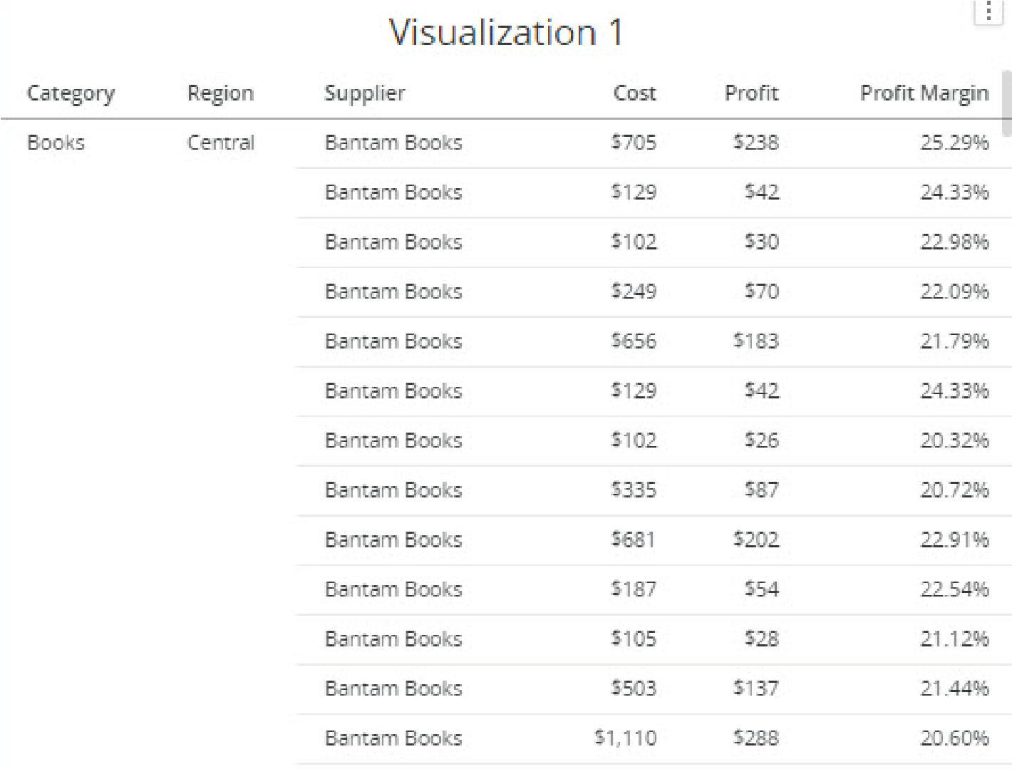

## Exercise 1.4: Import another dataset

The Analytics Architect team prepared another data for to use in your dossier that contains additional information on the company’s suppliers. In this exercise, you will insert that dataset into the Supplier dossier. Then, you will prepare and wrangle the data before adding it to the dossier to verify accuracy.

**Import and wrangle data**

1. On the toolbar, click **Add Data** and select **New Data**.

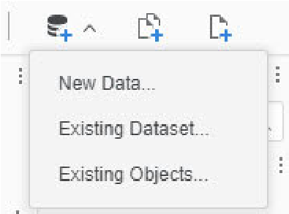

1. Click **File From Disk**.
2. Click **Choose files** and select the **Supplier Report by Region.xlsx** file, then click **Open**.
3. In the Upload Your Files window, click **Prepare Data**.
4. Clear the **Supplier Overview** check box and only select the **Supplier Report** check box.
5. Click **Select**.

There are two issues with this data:

* + Order Count and Units Sold should be metrics, not attributes
  + Some of the Subcategory fields are missing

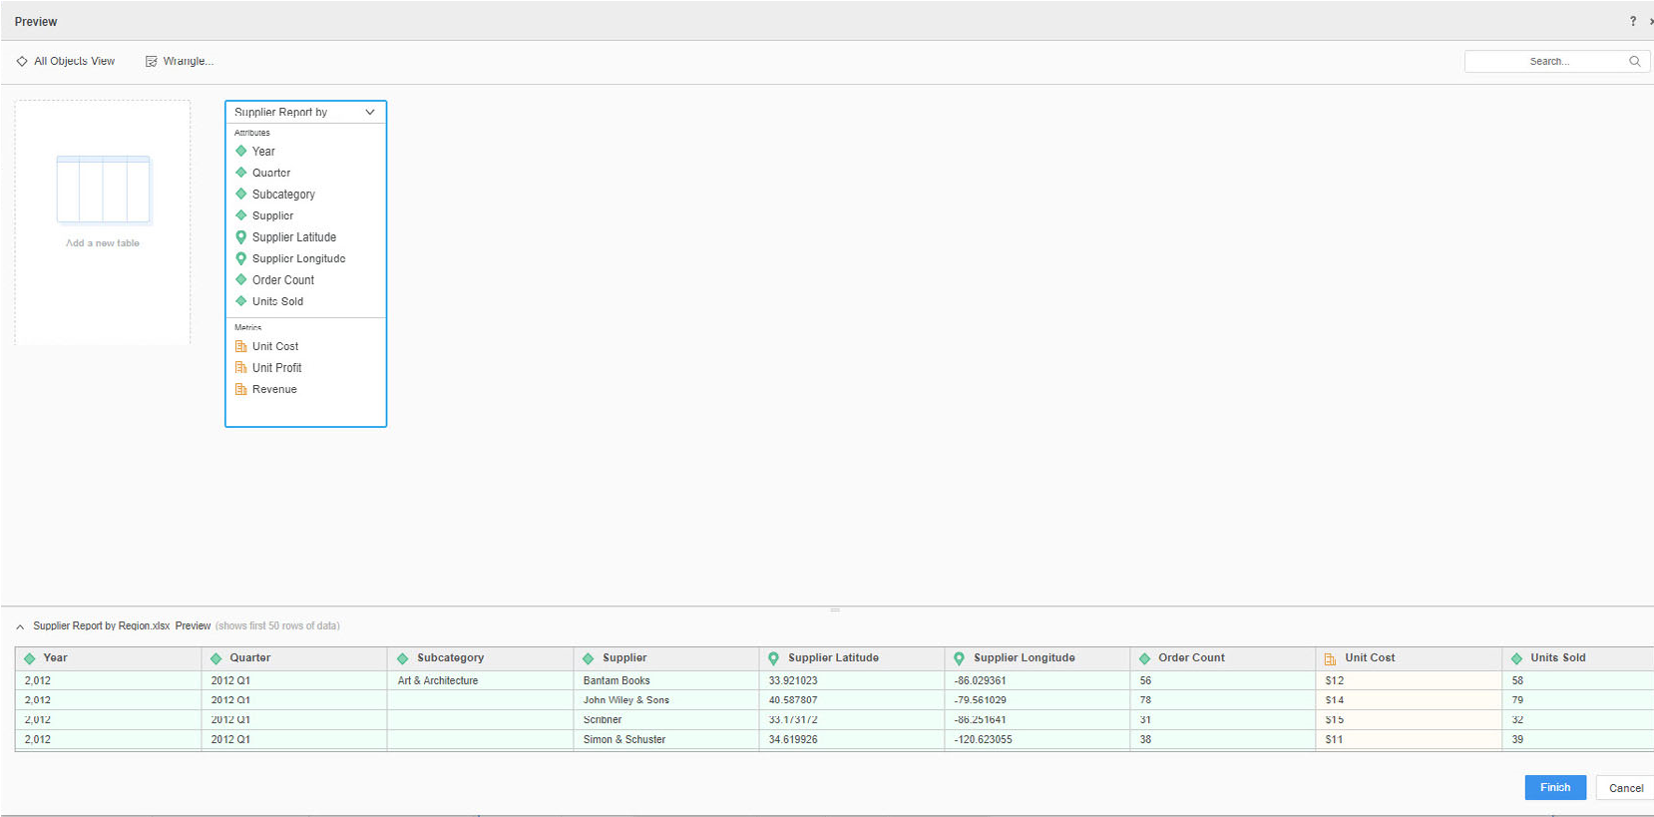

1. To convert the Order Count and Units Sold objects to metrics, click and drag the objects to the Metrics area of the table. The table should now resemble the following:

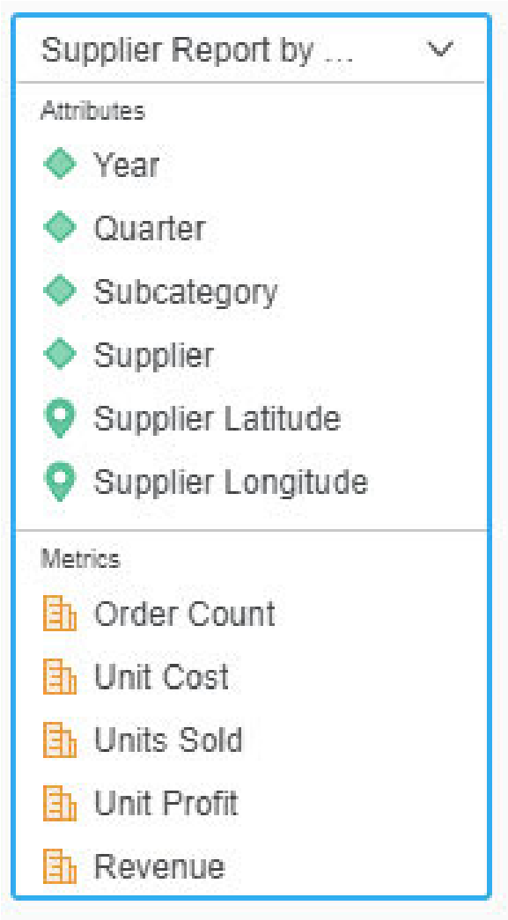

1. To fix the missing Subcategory data, click **Wrangle** at the top right of the Preview window. Notice the empty spaces. These should all be filled with the Art & Architecture subcategory.

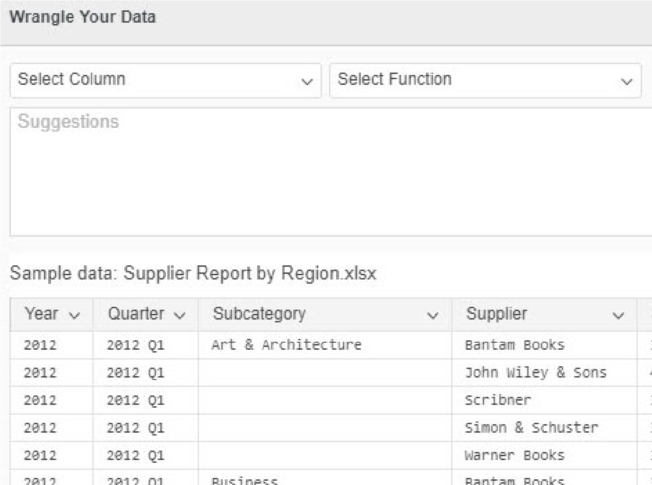

1. In the Wrangle Your Data window, select the **Subcategory** column and from the **Function Selector** drop-down list, choose **Text Selector**.

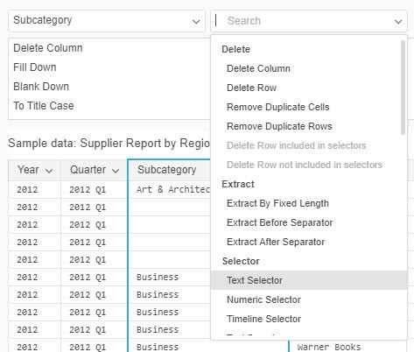

1. In the bottom panel, scroll to the bottom of the Subcategory menu, hover your cursor over the **(blank)(4)** option, and click **Edit**.

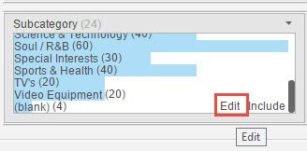

1. From the menu, click **Art & Architecture**.
2. You will see Art & Architecture replace the blank field. Click the **Apply To All** icon.

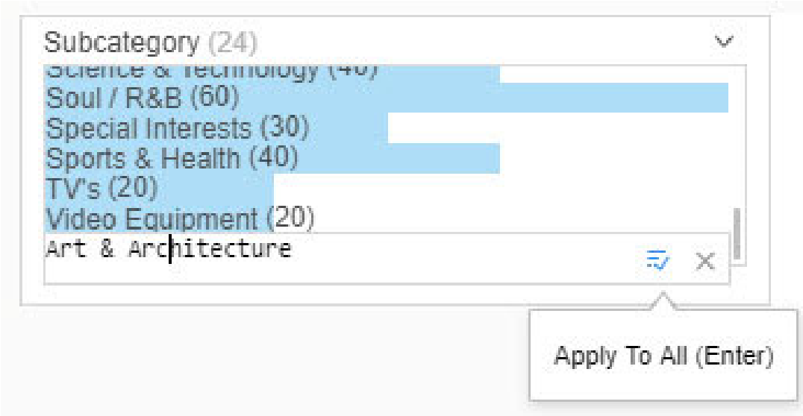

1. Notice that now the first 5 rows all have Art & Architecture listed as the subcategory. The data is now ready to be imported. Click **Apply**.

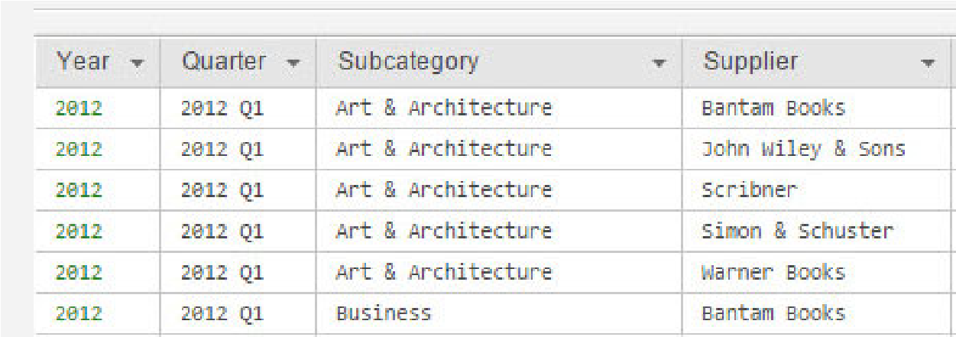

1. In the Preview window, click **Finish**.
2. Click **Save**.

Now that you’ve verified and cleaned the data, the dataset is ready to use to build the dossier. With the metrics and attributes, you can create data visualizations that help answer business questions, such as which suppliers had the highest cost per unit and which region had the highest profit.

The Datasets panel should match the image below:

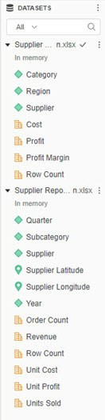



**2**

**C**

**REATE**

**A**

**F**

**IRST**

**C**

**LASS**

**D**

**OSSIER**

Once you have added your dataset, you can quickly create targeted dossiers that incorporate responsive design, visual filters, intuitive workflows, and sophisticated charts and grids. Showcase and explore your business intelligence through visualizations. Visualizations are grids, graphs, and other displays placed on the dossier that make your data interactive and easy to interpret. Add multiple visualizations to create an interactive display of key data.

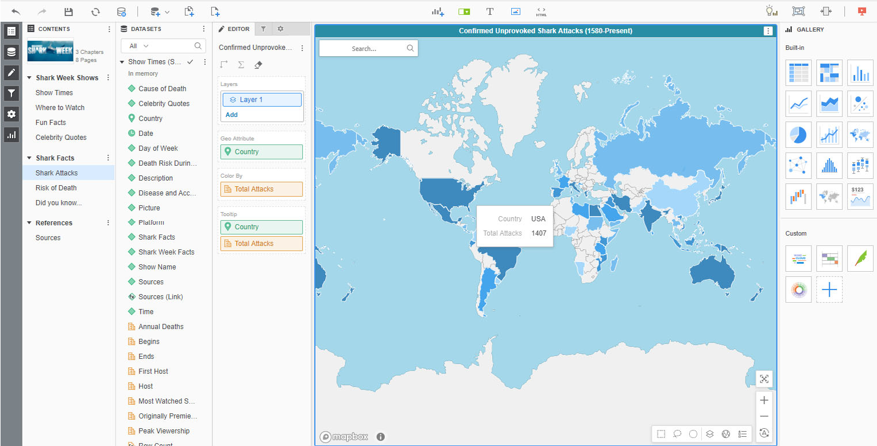

# Building your dossier

The dossier interface has an intuitive, simple drag and drop design. Panels and tool bars help authors easily design their dossiers.

* Contents panel: This panel displays the dossier table of contents showing the chapters and pages of your dossier. Edit, add, and remove pages and chapters in the table of contents. You can also add a thumbnail image for the dossier on this panel. This helps to identify dossiers once added to Library. For example, you might add an image of a map for a dossier analyzing geographical performance.

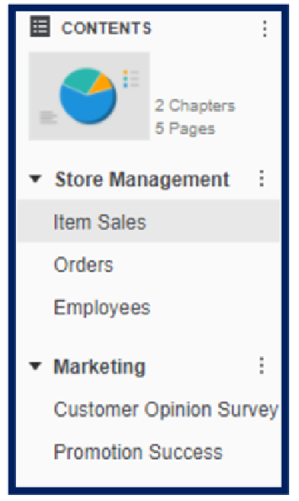

* Datasets panel: The Datasets panel shows the dataset objects from each dataset in the dossier, organized by the dataset that they belong to. You can also add new datasets through this panel, or click Add Data 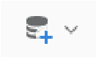 from the toolbar.

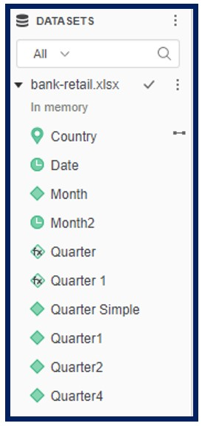

The Format, Filter, and Editor panels are stacked next to the Dataset panel. Flip between these three panels to customize your visualizations and chapters.

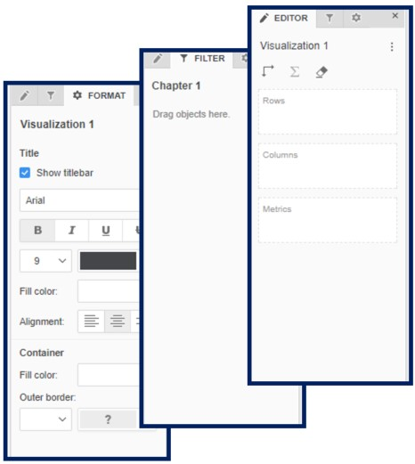

* Format panel: To customize your visualizations, use this panel to change your visualization’s font and the visualization container to fit your dossier needs. You can also customize visualizations by adding a legend, reference line, changing the shape of a graph, and so on.
* Filter panel: To apply filters to limit and specify the data visible on the dossier chapter, use the filter panel. You can use metrics, attributes, or visualizations to filter the data.
* Editor panel: To create your visualizations by adding data, use the Editor panel. Drag and drop attributes and metrics into the Rows, Columns, and Metrics boxes to see them appear in the visualization. Options in this panel depend on the selected visualization.
* Visualization gallery: Available visualizations are listed here. Hover over an icon to see the visualization name and data requirements.

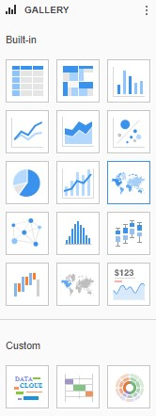

* The toolbar above the dossier page gives you several options to add items to the page.

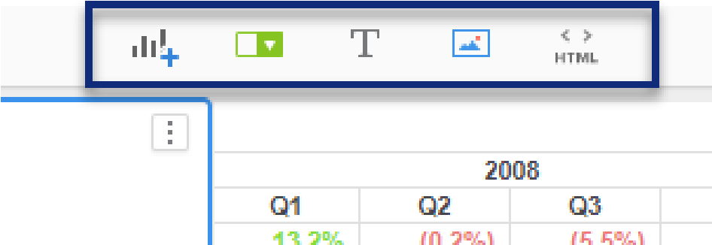

  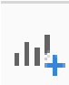 Add a visualization.

   Add a filter to the page to target visualizations. In the example below, users can click the buttons listing each department to filter the visualizations below it to see data for only that department.

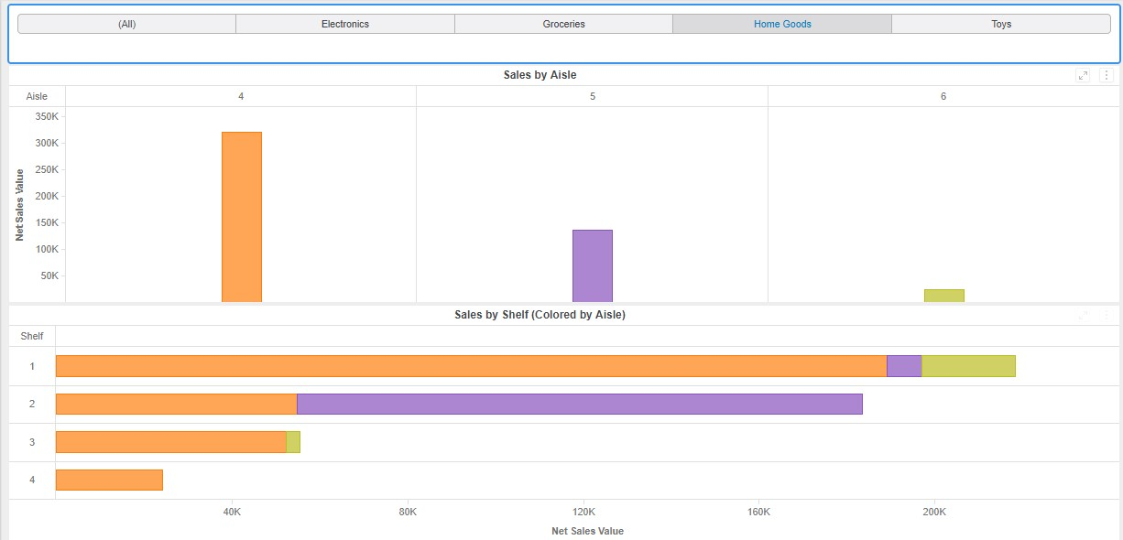

   Add text.

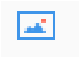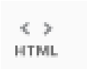

  Add an image.

  Add HTML.

## Format your dossier for a visually appealing design

The use and selection of color when designing dossiers can improve the readability of charts, drawing the users’ attention to important changes, trends, and measures. You can format your dossier’s font and colors for each page, or format specific visualizations. Intelligent Enterprises can leverage dossier formatting to create standardized, best-in-class dossiers that adhere to corporate branding.

### Custom color palettes

From the **Format** menu, you can choose from a list of predefined color palettes or create your own. These color palettes apply to the entire dossier, but you can select specific objects within the page and use the **Format** panel to change a visualization’s formatting.

MicroStrategy’s built-in color palettes are by nature to help build visually appealing dossiers. Color palettes are applied to all chapters and pages in the dossier.

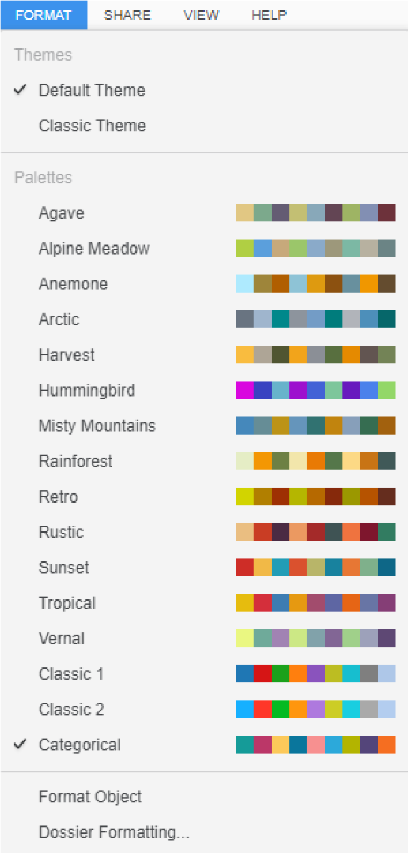

### Dossier formatting

There may be instances where you want to customize overall formatting properties, such as text size and visualization border size, to create a uniform dossier feel. From the **Format** menu, select **Dossier Formatting** to customize those formatting properties. All selections from this menu are applied to all objects in the dossier, such as visualization titles and text.

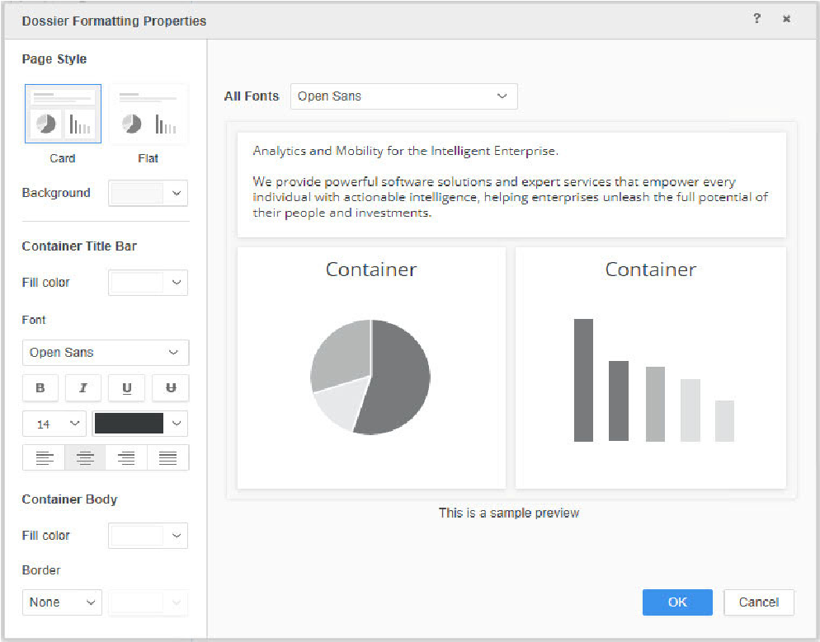

### Format specific objects

In addition to customizing the entire dossier, you can also format a specific object, such as a visualization or a text box. For example, when formatting a bar graph displaying revenue by item, you can highlight a specific item by changing the color of one bar, remove data labels, and add a reference line that displays the average revenue across items.

Each visualization has different format options. Click the **Format** panel, then click the object container you would like to edit to format that object. In the image below, the Sales by Aisle visualization has been selected.

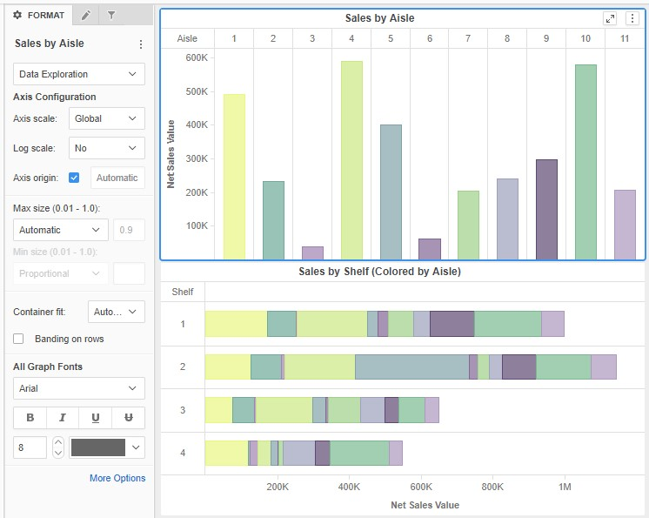

# Communicate visually: Leveraging data visualizations

Data visualizations are essential to tell an analytical story through your business intelligence that might have otherwise been lost in a sea of data. Visualizations form a picture of business trends at a glance, explore relationships between data, and quickly identify areas of improvement. This helps all end users, from the sales team to the CEO, avoid becoming over-saturated with numbers and data points.

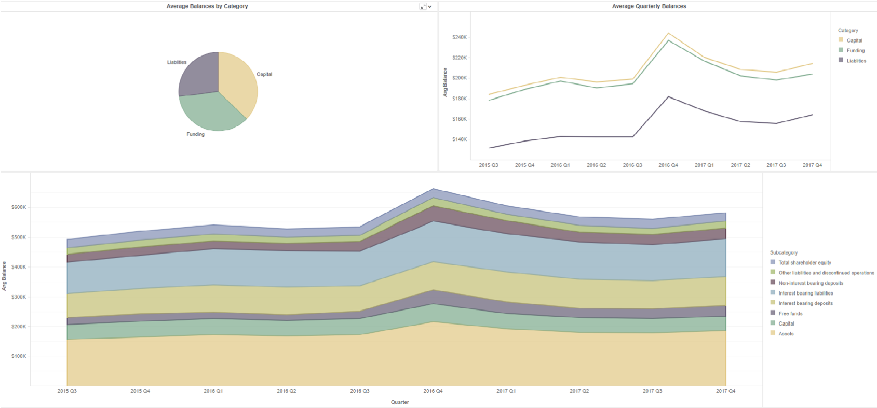

MicroStrategy Web provides an extensive library of out-of-the-box visualizations you can add to your dossier, found in the Visualization Gallery. Additional visualizations can be found on the MicroStrategy Community gallery: https:// community.microstrategy.com/s/gallery. To learn how to create your own customer visualizations, take the *Advanced SDK for Customizing Visualizations 11.511* course.

**Best**

**Practice** You should design your dossier with clear, intuitive, and interactive visualizations

that make data analysis easy for business users and encourage follow-up action. Adding visualizations to a dossier page is simple: select the appropriate visualization from the gallery, then drag and drop dataset objects to the **Editor** panel. If you choose to change a visualization, for example, switch from a bar chart to a line chart, click the **menu** icon, hover over **Change Visualization**, then select the appropriate visualization.

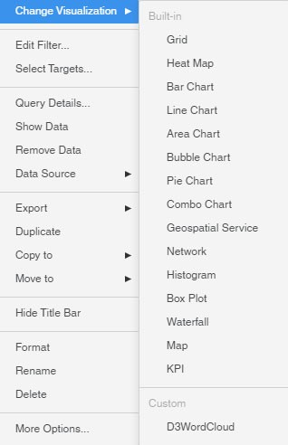

You can also use visualizations as filters, which we will discuss in *Chapter 3, Layering, Filtering, Sorting, and Thresholding*.

## Finding the best fit visualization for data analysis

To help determine which visualizations can answer your business intelligence questions contained with the dossier’s datasets, you can query your data using natural language to generate visualizations based on dataset metrics and attributes. By typing business questions or Google-like queries in plain text, MicroStrategy automatically generates the most appropriate chart or graph, displaying the answer as an interactive visualization.

For example, a data analyst wants to start building a dossier evaluating shipping trends across North America but isn't sure how to begin. She clicks the NLQ icon in the tool bar and types, what is the total trade by port name?

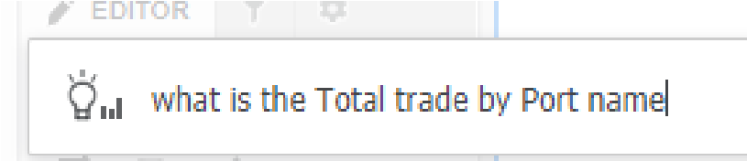

Based on the Total Trade metric and the Port Name attribute, the following marker map visualization is generated to answer her question:

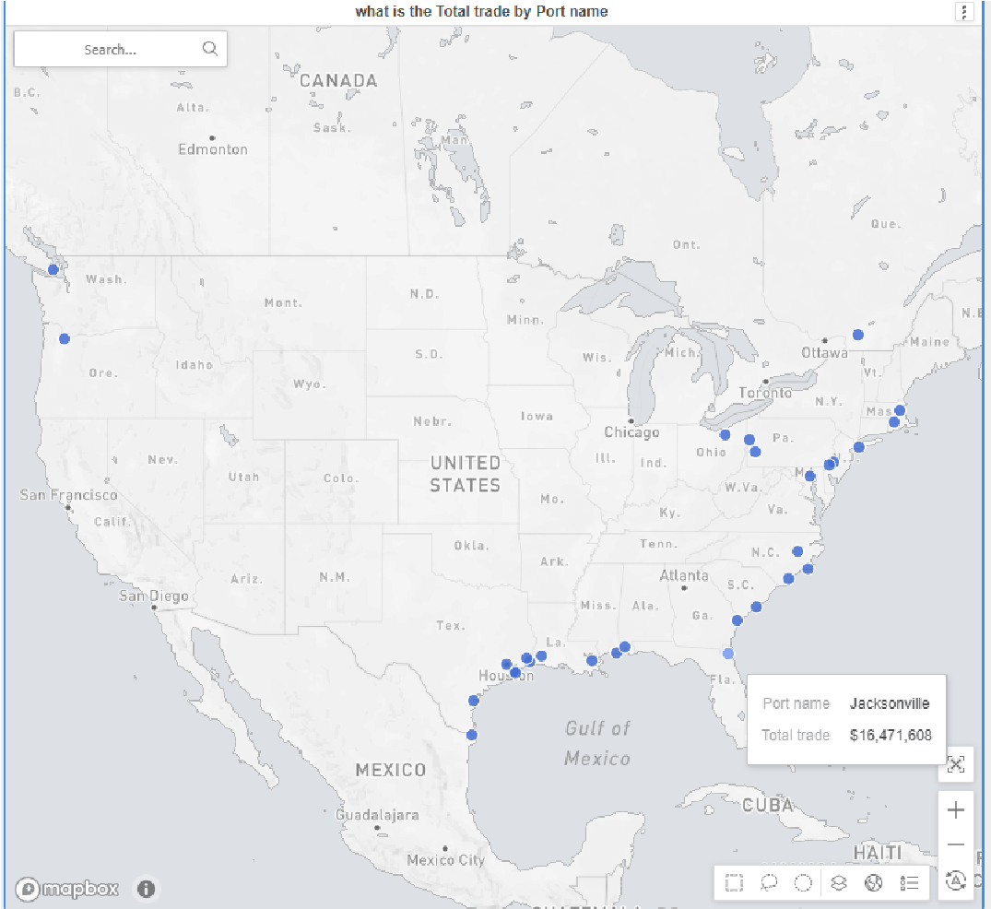

The data analyst uses the map visualization as a starting point to analyze total trade. She adds an additional State layer to her map, so the final visualization analyzes trade at both the State and Port level, as seen in the image below.

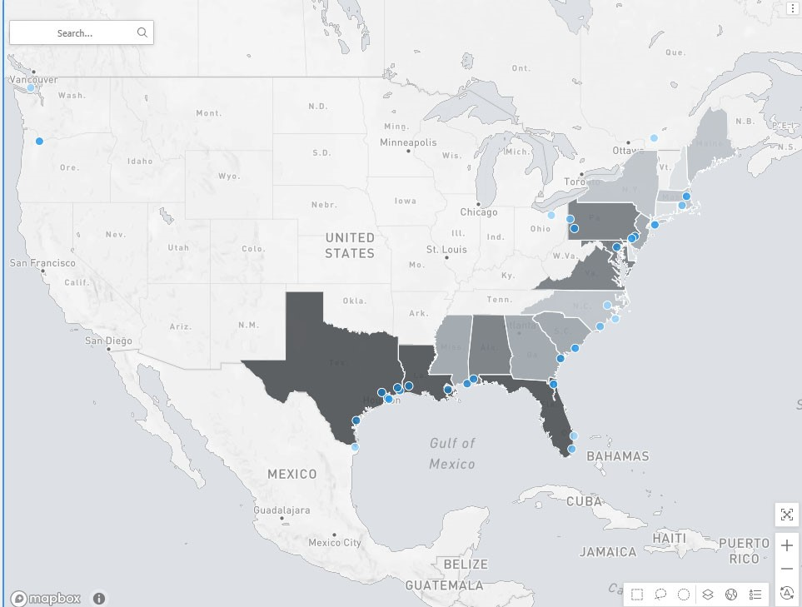

To help analysts find insights faster, MicroStrategy leverages AI to recommend questions and search terms based on the dataset. Like the Google search functionality, MicroStrategy leverages AI to recommend new questions or business terms, which appear below the search bar. These suggestions empower analysts to get started and ask questions that hadn’t occurred to them.

In addition to standard visualizations like bar and pie charts, dossiers offer a wide variety of methods to tell your analytical story. For more information on leveraging visualizations to build compelling dossiers, take the *Dashboarding and Visualizations 11.142* course.

## Heat map

Use a heat map to quickly understand many variables at one time. A heat map displays data in nested, colored rectangles. For example, you can quickly assess which call centers and regions are producing the most revenue and profit.

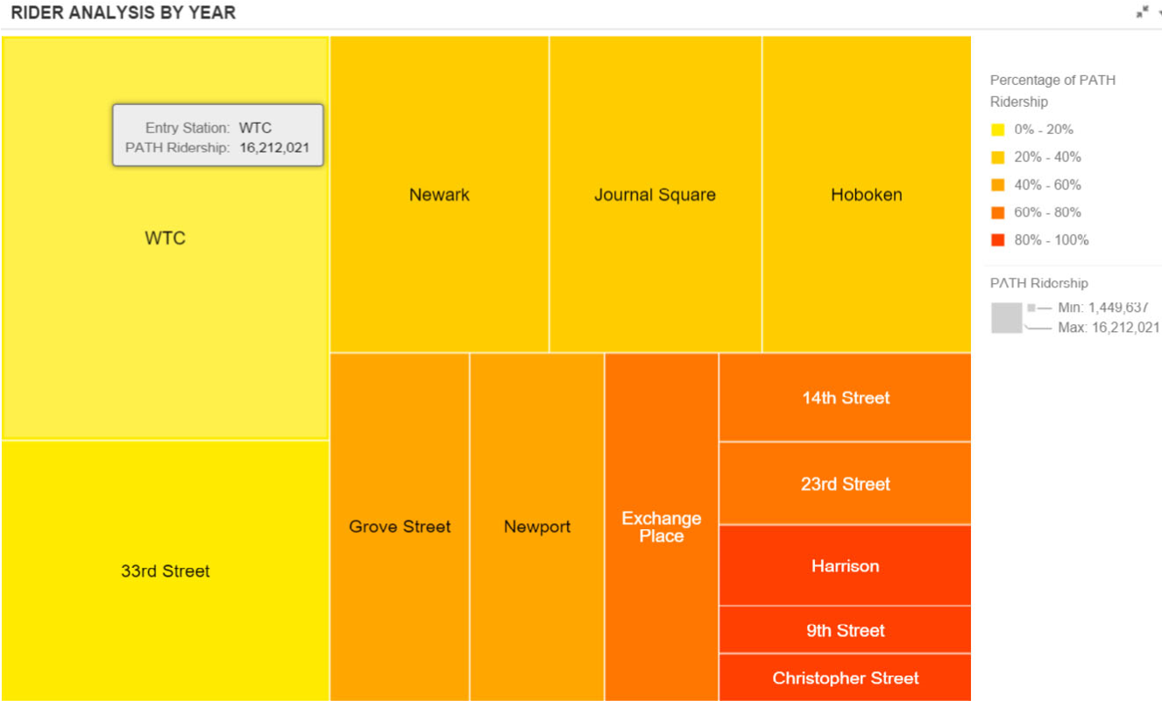

To create a heat map, you need at least one attribute and two metrics. Choose which metric adjusts the size of the boxes (Size By) and which controls the color (Color By). In the example above, the rectangles represent PATH stations, colored and sized by ridership per year.

## KPI visualization

KPI visualizations allow you to display a snapshot of Key Performance Indicators and how those KPIs have changed over time. The example below displays revenue over nine months, broken out by category.

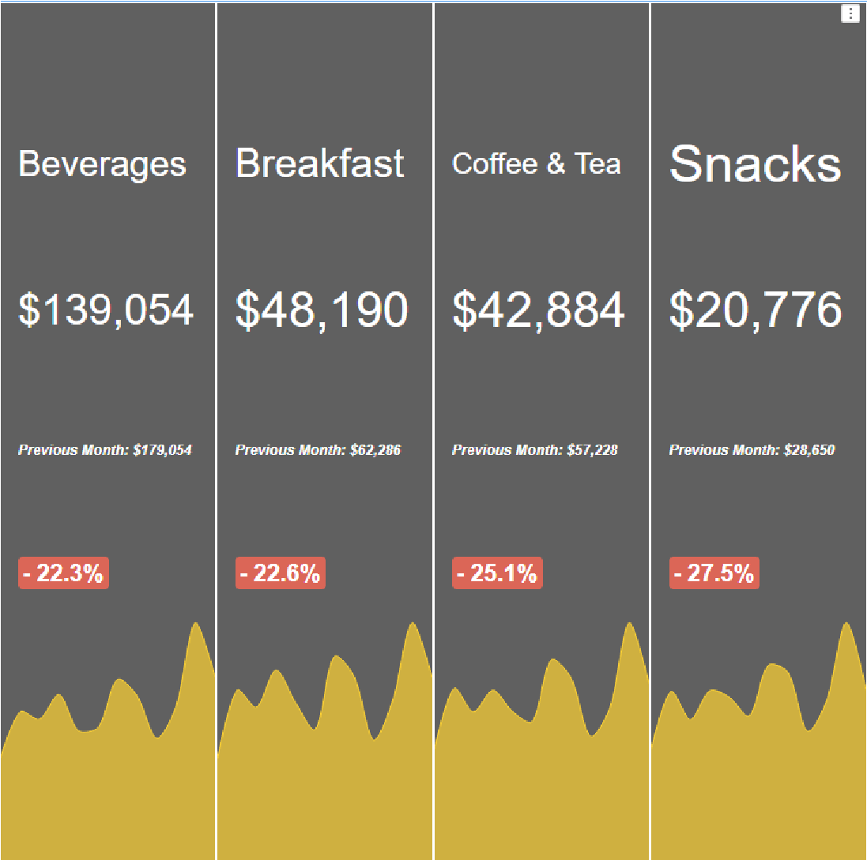

Cards within the same visualization can be organized to be displayed based on design considerations and screen size. Within the format panel, you can change the display mode of the cards to:

* Default—MicroStrategy will choose the most optimized display of cards to increase readability.
* Stacked—This shows a single card and stacks other cards underneath the first, so users will need to manually swipe between cards or select the Auto Play option to see other stacked cards.
* Vertical or Horizontal (displayed above)—These show all the cards displayed vertically or horizontally within a visualization.
* Grid—Distribute all cards evenly in a matrix display, where users can choose the number of columns to display.

Additionally, you can select a color theme and invert threshold colors. In the example below, the threshold for cost is inverted as an increased growth in cost is negative, so the dossier author changed the trend indicator to red.

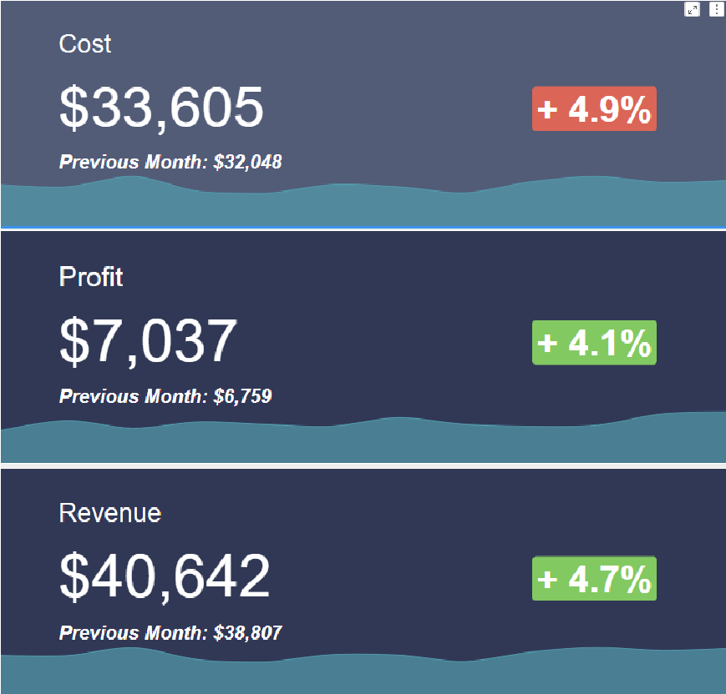

## ESRI map

ESRI map visualizations display your data as markers on an interactive map. For example, you can create a visualization that displays how customer households are clustered in different parts of the country using a density map, or display retail locations as a series of map markers that users can click to view additional information about stores in their area.

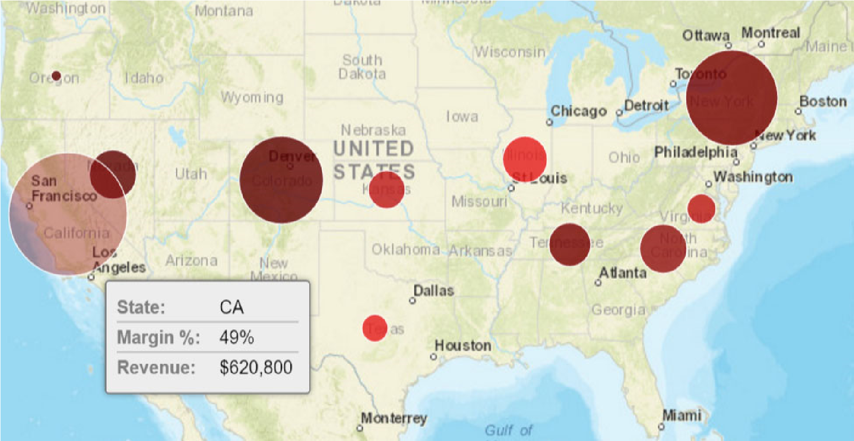

To display map markers in the ESRI Map visualization, you must provide a geo attribute that contains longitude and latitude. During the data import process, you can assign an attribute, such as city or state, as a geo attribute. MicroStrategy Web automatically assigns that attribute a latitude and longitude. You can then use that attribute on an ESRI map visualization.

There are three different map styles: marker, density, and area. You also have the option to select the type of map such as topographical, satellite, light gray, and street.

### Map markers

Map markers are ideal when you want to display an individual marker for distinct geographic locations, such as a store or supplier location. You can display markers as images or as bubble markers.

Bubble markers have the widest variety of uses. Bubble markers give you the ability to use metrics to size and color the bubbles, as in the example above. These bubbles quickly provide a variety of information and data simply by viewing the map. For example, a retailer can use the bubble sizes to easily identify stores with performance problems by sizing the markers by yearly cost and coloring them by profit margin.

### Density map

A density map is a type of ESRI map used to analyze patterns and trends across geographic locations. The trends are displayed by color gradients based on the concentration of geographic data. In the example below, the density map indicates the volume of stores in a given area. Red indicates the highest volume and blue the lowest. The color range can be customized.

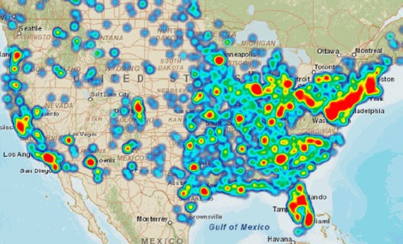

### Map areas

Geographic data such as countries, states, and counties are indicated by colored regions on a map. You can include metrics on the map to differentiate the colors. There are various base maps built into MicroStrategy Web. To use base maps, your attribute must include data that matches the available base maps.

Some examples of base maps include:

* Countries of the world
* United States state names
* United States counties

As an example, if your attribute contains US state name data, you can select the

United States state names base map to display the data. As you see below, the base map combined with the attributes shows data on a state level. The metric, if added, changes the color of the map areas.

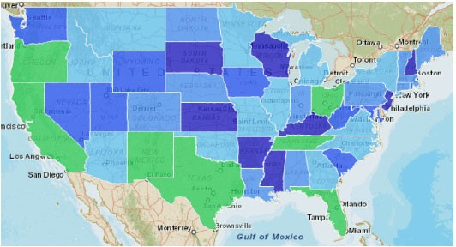

### Geospatial Service maps

Display a high-performance vector map using a Geospatial Service map, powered by Mapbox, which provides a modern approach to analyzing geographical data. With a Geospatial map, you can:

* Show geographic areas down to the detail of the postal code for most countries.

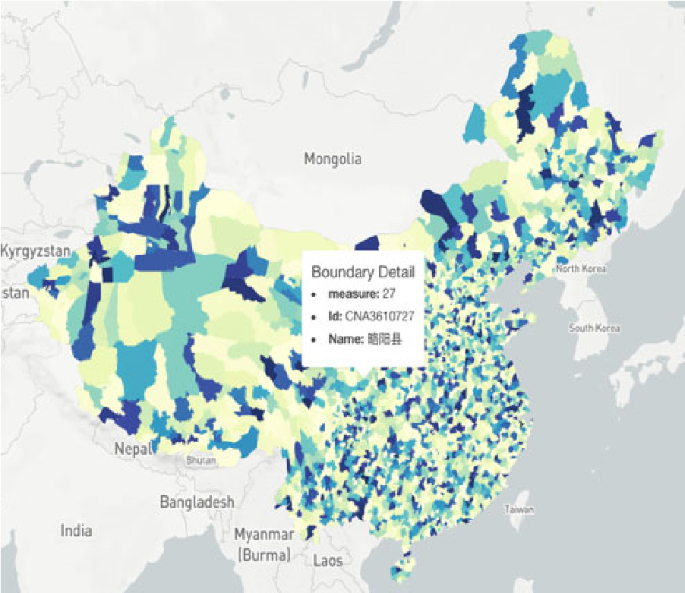

* Zoom through map layers from the entire world to the street level.

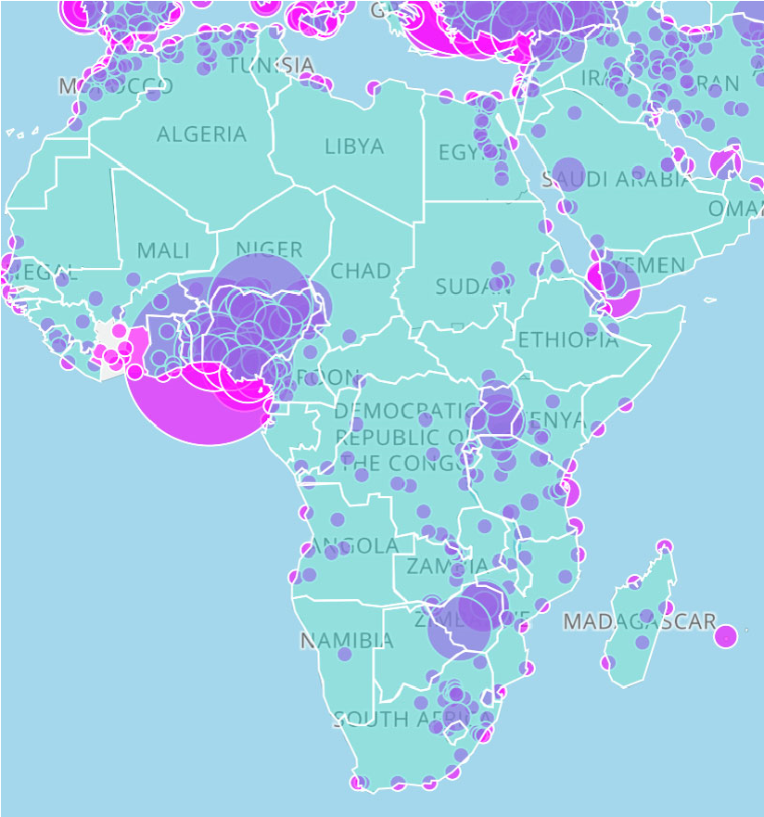

* Tilt the map for a 3D view.
* Color areas using an attribute’s elements.

## Exercise 2.1: Enhance the Supplier Dossier with visualizations

In this exercise, we will use the Supplier Report by Region datasets to add visualizations and shape Page 1. We will add three visualizations according to the mock up:

* A bubble map to display profit and revenue by supplier location
* A network visualization to analyze profit by region and category **•** A bar chart to show revenue per supplier

**Change the dossier theme**

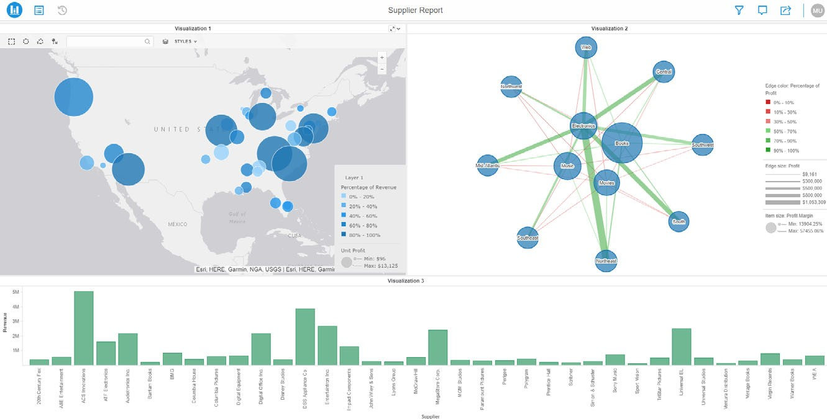

1. Navigate to and open the **Supplier Dossier**.
2. Dossiers have two formatting themes — Classic and Default. Currently, the Supplier Dossier in Default theme. Your Enterprise Application Design Guidelines require that dossiers are created in Classic Theme. To switch themes, click the **Format Menu**.
3. Select **Classic Theme**.

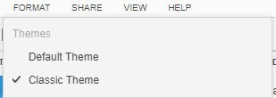

1. In the notification window, click **Apply**. In the pop up window, click **Dismiss**.

**Add a bubble map**

1. Since you want to add a new visualization, remove the grid currently on the dossier. Hover over the top right corner of the visualization and click the **Menu** icon , then click **Delete**.
2. Click the **Geospatial Service** map icon from the Visualization Gallery.

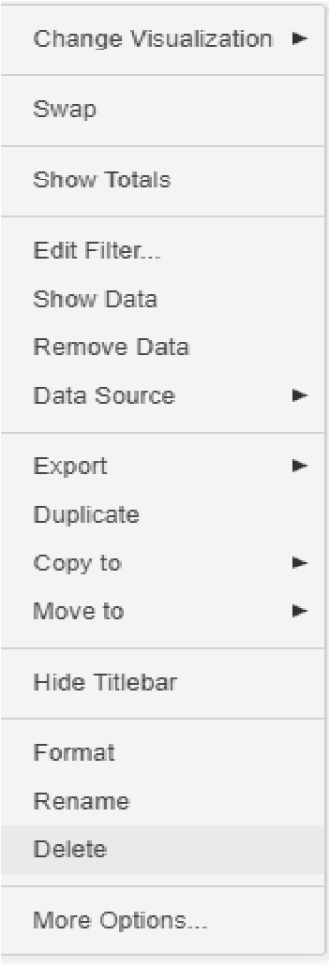

1. In the Dataset panel, click and drag the **Supplier Latitude** attribute to the **Latitude** area on the Editor panel, and add the **Supplier Longitude** attribute to the **Longitude** area.
2. Click and drag the **Revenue** metric to the **Color By** area. Now, the darker the marker is, the higher the revenue.

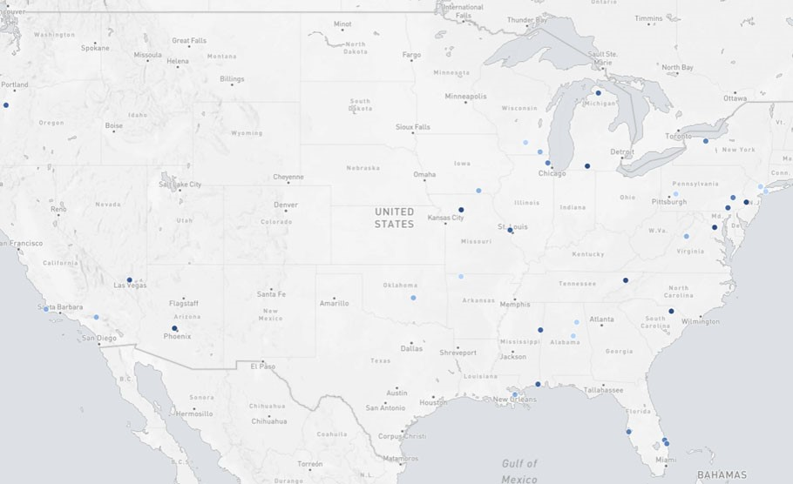

1. Click the **Map style** icon  to view the map options Geospatial Service offers. Keep the default **Light gray** style.
2. Select the **Format** panel.
3. In the **Type** drop-down list, select **Bubble**. Markers are ideal when you want to display an individual map marker for each geographic location, such as stores or cities. However, since we want to show regions sized by Unit Profit, bubble markers are a better fit for this map.
4. Select **Show Legend**.
5. Select the **Editor** panel and add the **Unit Profit** metric to the **Size By** drop zone. The bigger the bubble, the higher the unit profit.

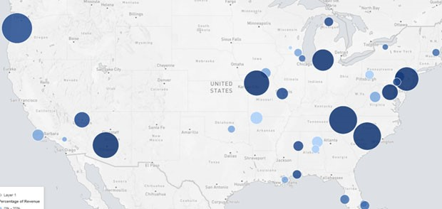

1. Click **Save**.

View the legend on the map. The bubbles are colored by their percentage of the Revenue and sized by the Unit Profit.

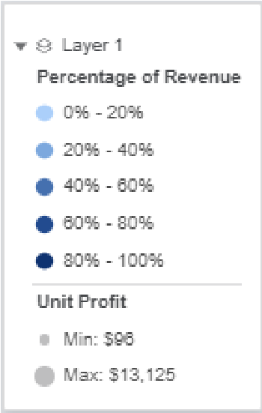

The map now shows the location of our suppliers, what they contribute to overall revenue, and which suppliers are the most profitable.

**Add a network visualization**

1. On the toolbar, click **Insert Visualization**.

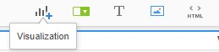

1. A new visualization container is added below the map. Click the **Visualization 2 container**. A blue box shows around the visualization container that signifies which visualization you are editing.
2. To move the visualization container to another area of the dossier, hover over the title, **Visualization 2**.
3. Ensure the Visualization 2 container is to the right of Visualization 1. If it is not, from the title of the Visualization, click and drag the container to the right of the Geospatial Service map.
4. With Visualization 2 selected, in the Visualization Gallery, select **Network** .
5. You want to create a network visualization that shows the relationship between categories and region. In the **Editor** panel, click and drag the **Category** attribute to the **From Item** drop zone. This displays the Category attribute elements as nodes.
6. Add the **Region** attribute to the **To Item** drop zone. This displays the Region attribute elements as nodes opposite the Category elements.
7. To color the relationship lines, add the **Profit** metric to the **Edge Color** drop zone.
8. To view the profit relationship between category and region more clearly, add the **Profit** metric to the **Edge Size** drop zone.
9. You want to ensure users can visually differentiate the edge lines, so you want the threshold to show different colors. Right-click **Profit** in the Edge Color drop zone and select **Thresholds**.
10. Select **Tropical Jungle**. Now, the more profitable relationships are in green, and the less profitable are in red. Click **OK**.

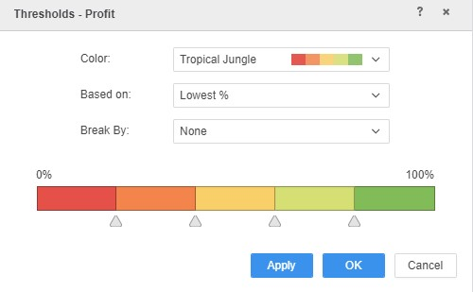

1. To analyze a metric for all the attribute nodes (Category), add the **Cost** metric to the **Item size** drop zone. Now, the nodes are sized by Category and Cost.

Your dossier should look similar to the following image:

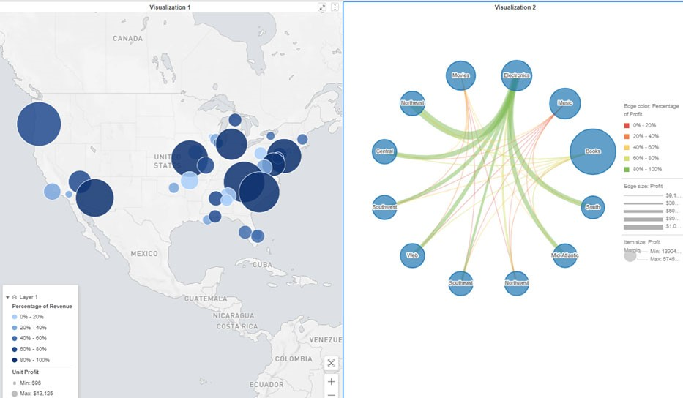

1. Hover your cursor over the node labeled **Central** in the network visualization to see what other nodes it connects to. The relationship lines appear in black.

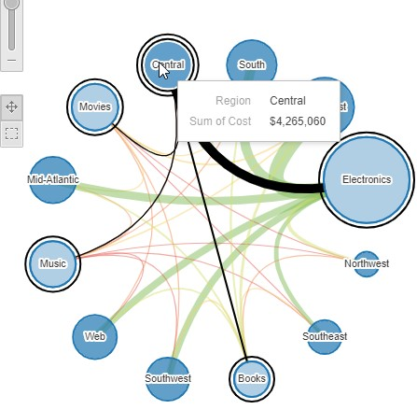

1. Change the look of the Network visualization by clicking in the **network visualization container**, then selecting the **highlighted option**, seen below:

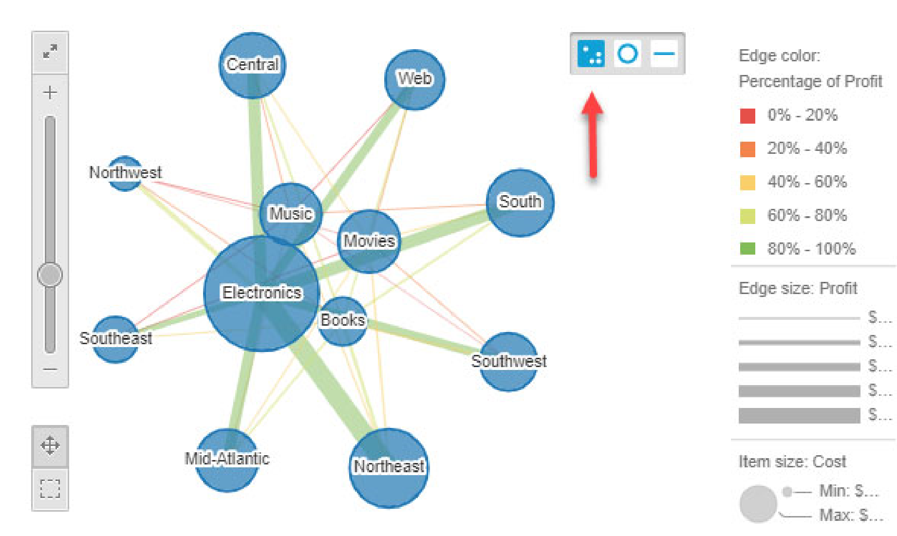

1. **Save** the dossier.

**Add a bar chart to show revenue by supplier**

**1**

Click

**Insert Visualization**

to add a third visualization to the dossier.



1. Move the **Visualization 3** below the other two visualizations.
2. Select the **Visualization 3** container.
3. In the Visualization Gallery, click **Bar Chart**.
4. Add the **Supplier** attribute from the second dataset(Supplier Report by Region) to the **Horizontal** drop zone to separate the bars by supplier.
5. Add the **Revenue** metric to the **Vertical** drop zone. Now, the taller the bar is, the higher the supplier revenue.

**Format the chart**

1. To hide the grid lines in the graph, right-click between the grid lines and select **Grid Lines**.
2. From the Grid Lines options, select **Hide**.

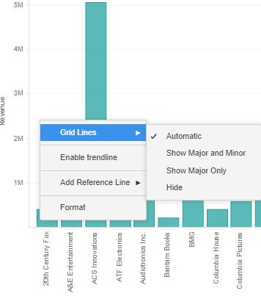

1. To change the color of the bars, select the **Format** panel.
2. In the first drop-down list, select **Shapes and Data Labels**.
3. In the **Shape Formatting** section, change the fill color to **Sea Green**.
4. Click **Save**.

**View the dossier in MicroStrategy Library**

1. The dossier’s end users will interact and collaborate with the dossier in MicroStrategy Library. To launch the Supplier Dossier in Library, click the **Share** menu on the toolbar.

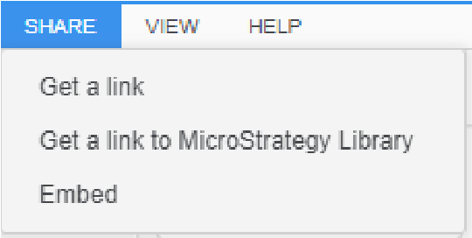

1. Select **Get a link to MicroStrategy Library**.
2. Click **Launch** under the Library link.
3. Log in using your **Username** and **Password**.
4. On the black bar, click **Add to Library.**



1. Compare your dossier to the image below:

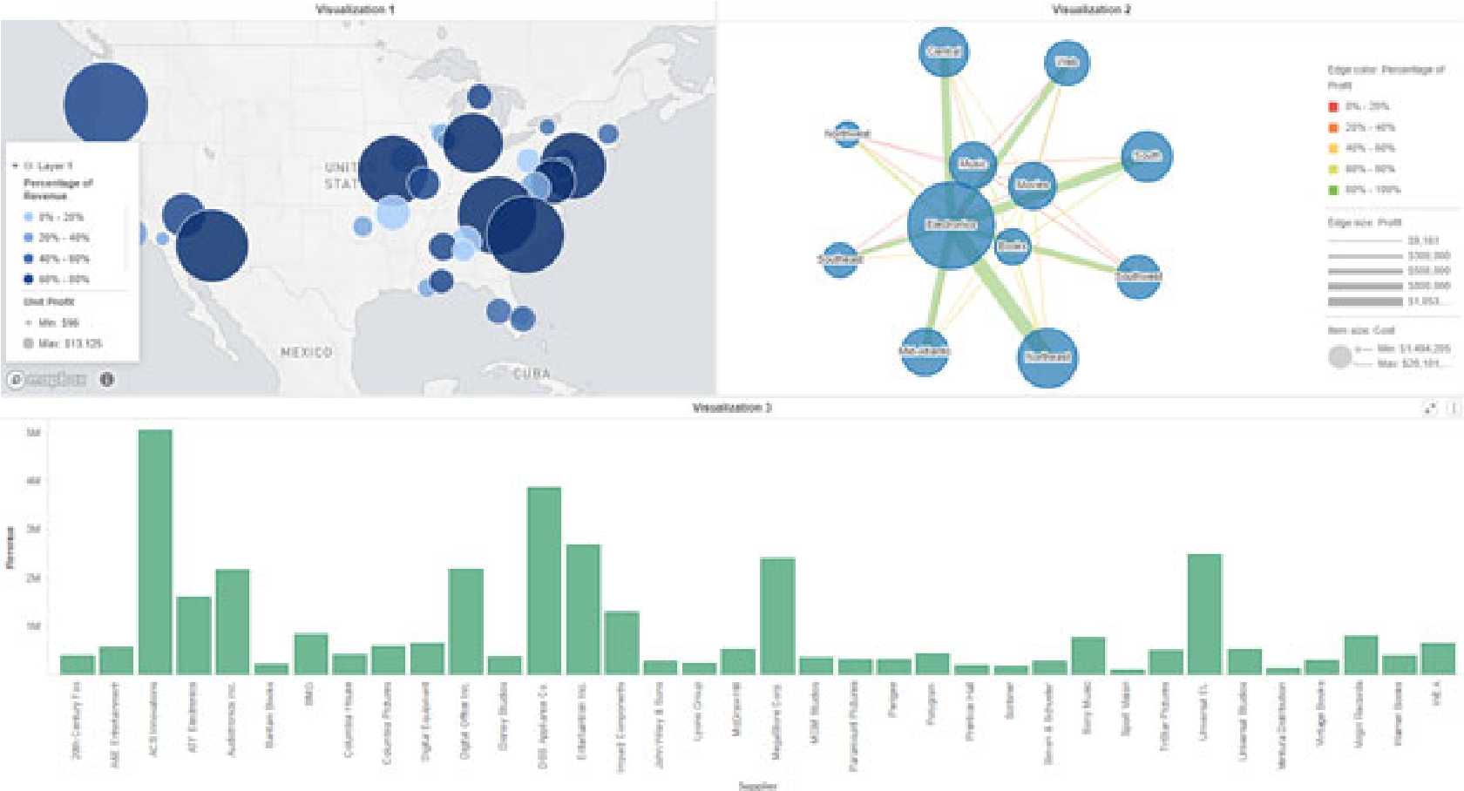

**Workshop 1: Import data and add the appropriate**

## visualization to a dossier

Your organization considers increasing their digital marketing presence as they grow across the United States. As the marketing data analyst, you’ve been asked to create a dossier that analyzes Facebook user penetration in the US market. This dossier is based on imported data from Facebook.

To create your dossier, you will first see if your data needs any wrangling before using it as a dataset. Then, you will explore visualizations to determine the best way for the Marketing team to understand the underlying data.

**Import data**

1. If needed, log back into **MicroStrategy Web** using your **User name** and **Password.**
2. From the **My Reports** folder, click **Create** and click **New Dossier**.
3. From the Datasets panel, click **New Data**.

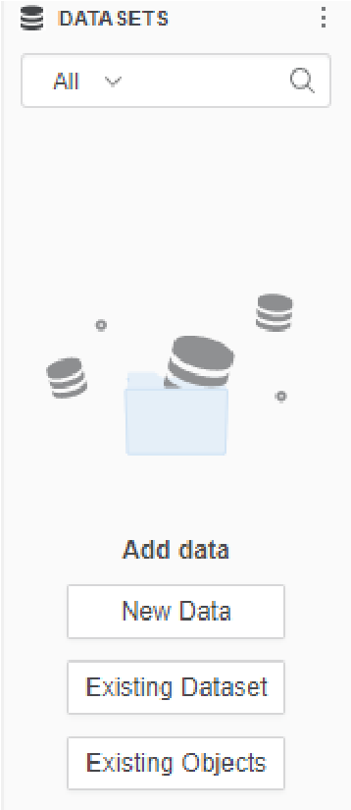

1. The Connect to Your Data window opens. Select **File from Disk**.

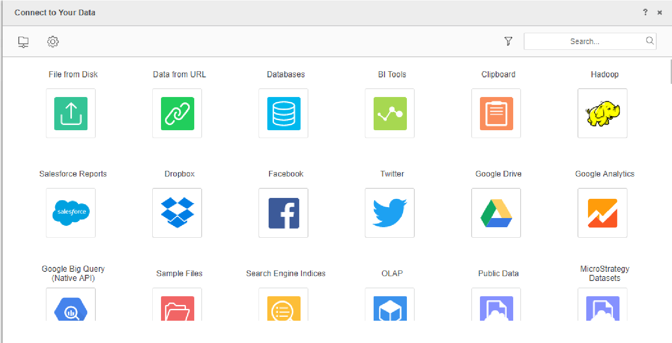

1. From the Upload Your Files window, click **Choose files**, then select **Facebook data.csv**.

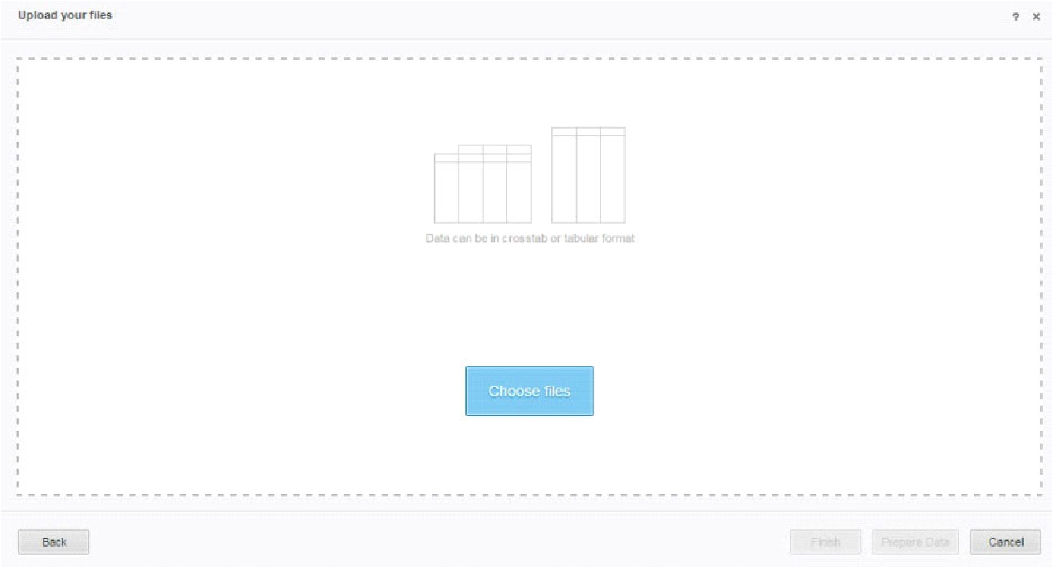

1. Click **Open**. The file is listed on the Upload Your Files window.
2. Click **Prepare Data** at the bottom of the Upload Your Files window.
3. The Preview window opens. Click the **arrow** above the data grid to expand the full preview of your data.
4. Click **Wrangle**.

The Wrangle Your Data window displays.

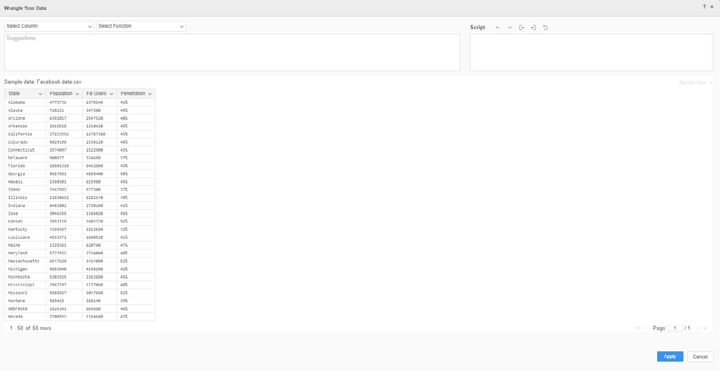

As a reminder, theWrangle Your Data window allows you to explore data and evaluate its quality and usability. You can then prepare the data and improve its quality before importing it into MicroStrategy Web.

For example, you can remove white space, filter data, delete duplicate rows or cells, find and replace data, and concatenate columns.

1. There are no corrections that need to be made, so click **Finish** to return to the dossier. Your dataset is ready to use in the dossier.

**Rename a metric**

This dataset shows the relationship between Facebook users and the population of a particular state. You and your team want to understand the percentage of Facebook users per state. In this dataset, the Penetration metric is the percentage of a state population that uses Facebook. To ensure that other users have a clear understanding of all the dataset objects’ meanings, rename Penetration.

1. In the Dataset panel, right-click the **Penetration** metric, select **Rename**, and rename it as **Facebook Users per State**.

**Add a visualization**

You would like to add a visualization that displays how much Facebook has penetrated the market in individual states. Viewers should be able to quickly understand the connection between the population of a state and the number of Facebook users in that state.

There are many possible approaches; a good place to begin is with a simple and familiar visualization, in this case, a bar chart. To start, create a bar chart that presents the state population and the rate of Facebook use side by side as bars.

1. Click the **Bar Chart** icon in the Visualization Gallery.
2. Drag the **Population** and **FB Users** metrics from the Dataset panel to the **Horizontal** area in the Editor panel. Drag the **State** attribute to the **Vertical** drop zone in the Editor panel.
3. To merge the graphs, drag **Metric Names** to the **Break By** drop zone. Select **Clustered** to stack the bars above and below each other.

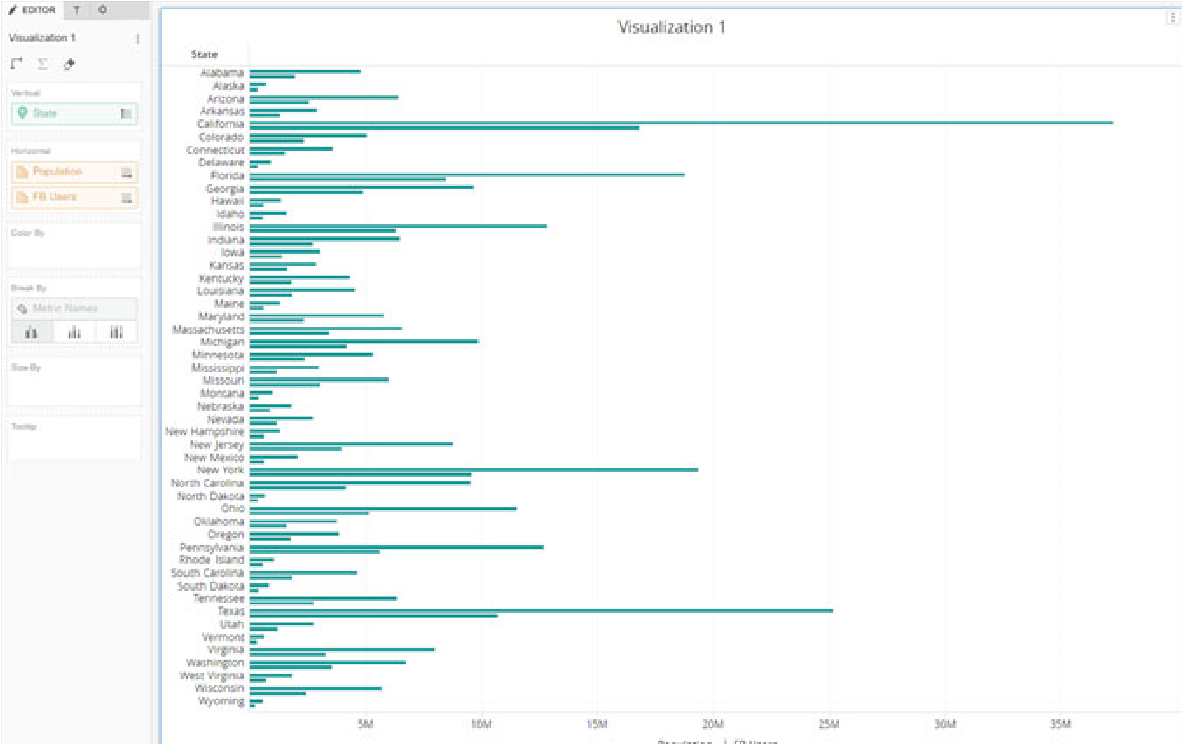

1. To distinguish the metrics and make the bar chart easier to read, drag **Metric Names** into the **Color By** area. A legend is added to the graph that indicates Population and FB Users.

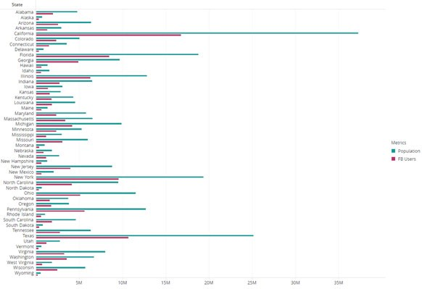

*What other visualization types might work for this dossier page?*

**Rename the visualization**

1. At the top of the visualization container, double-click **Visualization 1**.
2. Type **Facebook Users per State**.

**Explore the data using other visualizations**

You want the visualization to clearly express the relationship between the number of Facebook users per state and the overall state population. The bar chart is hard to read because of the number of states on the Vertical axis.

Change the bar chart to two other visualizations to see which one best meets your business needs.

1. Click **Menu** (the three dots) at the top of the visualization, then hover over **Change Visualization.**

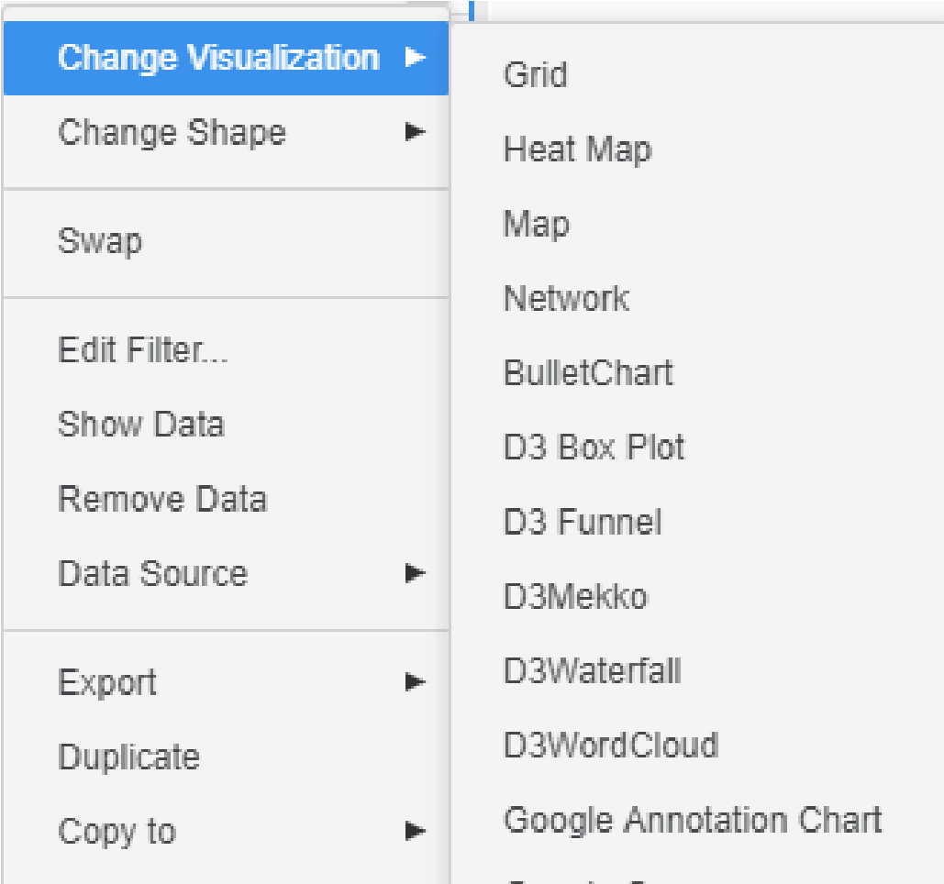

1. Select **Heat Map.**
2. Drag **Population** to the **Color By** drop zone to replace the State attribute.

A heat map displays a combination of colored rectangles, each representing an attribute element, sized by a metric. You should choose a heat map when you need to display the impact of a metric on a large number of attribute elements at once.

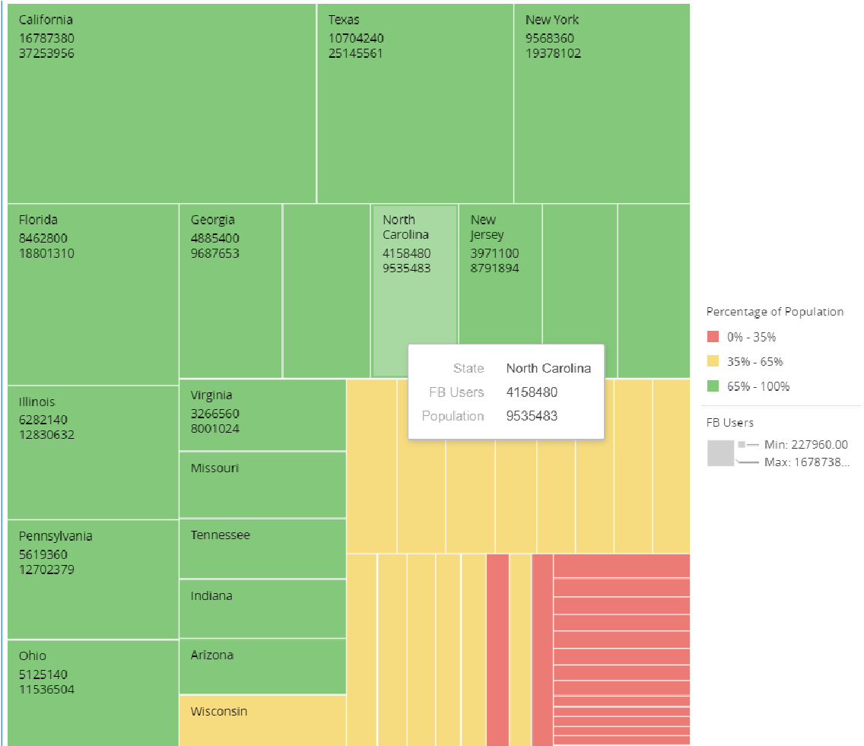

The Facebook data heat map shows the rectangles representing each state colored by state population and sized by number of Facebook users. The contrast of red, green, and yellow makes the visualization easy to analyze — California and Texas clearly have the most Facebook users and highest

**Best** populations. The concept of the heat map fits well with the goal of our dossier.

**Practice** However, some of the rectangles are too small to display the state names. A dossier page should always be easy to read and all text should be clearly readable so users can quickly grasp the analytical message.

To see if another visualization is a better fit, let’s convert the heat map into an area chart.

1. Click the **Area Chart**  icon in the Visualization Gallery.
2. On the Editor panel, click **Swap**  to switch the Vertical and Horizontal axes.

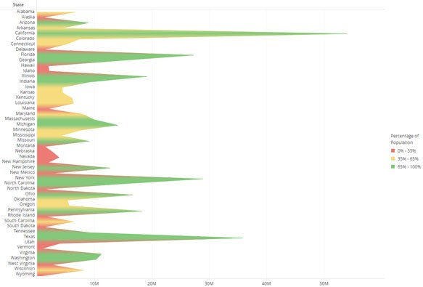

1. Drag **FB Users** from the **Tool Tip** drop zone to the **Horizontal** drop zone.
2. Drag **Metric Names** to the **Break By** drop zone to combine the graphs. Keep the metrics **Stacked**.
3. Drag **Metric Names** to the **Color By** drop zone so the metrics have different colors. Your visualization should now match the image below:

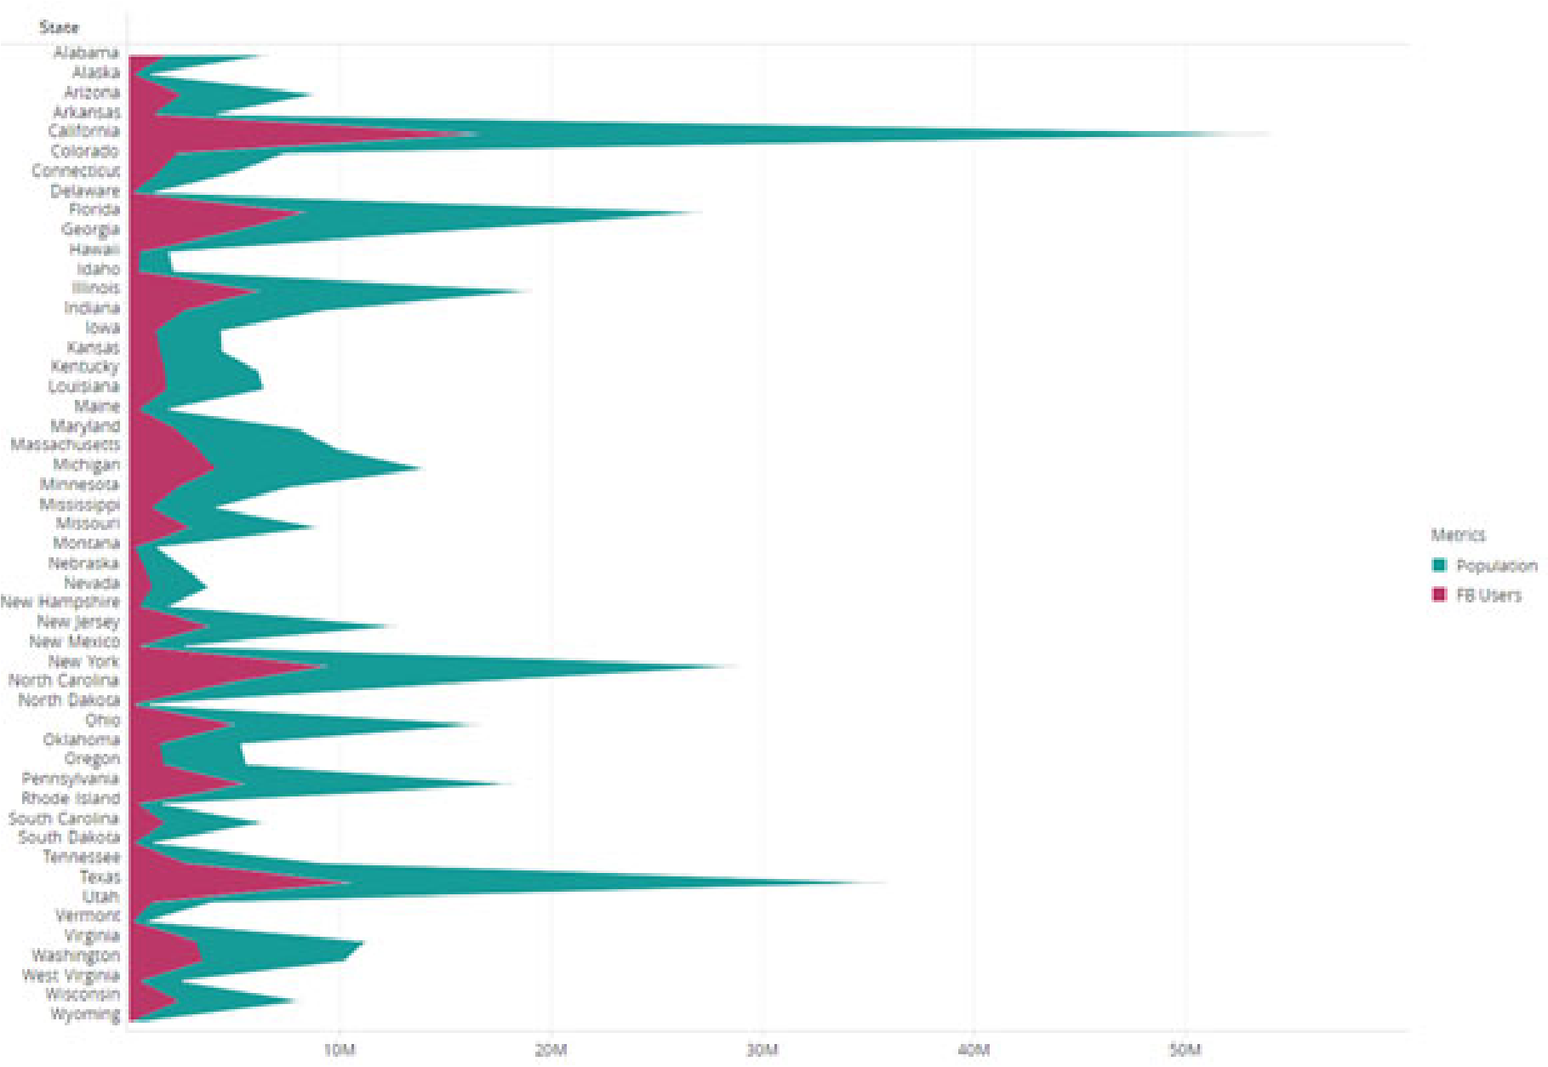

While the bar chart displays horizontal bars to compare individual items, the area graph stacks two data series and shades the area between the axis and the line that creates a visual comparison of the two items.

Area charts are helpful for showing overall trends — this particular chart shows a clear relationship between Facebook users and state populations. The higher the population, the more Facebook users. The area chart is a better choice than the previous heat map as we can read all data points clearly.

*Q: What other conclusions can you draw from this visualization?*

1. Save the dossier as **Facebook Users per State Dossier**. Close the dossier.



**3**

**L**

**AYERING**

**, F**

**ILTERING**

**, S**

**ORTING**

**,**

**AND**

**T**

**HRESHOLDING**

Now that you’ve added visualizations to our dossier to analyze your business intelligence, we will explore ways to enhance the data discovery experience with innovative design features. In this chapter, we will focus on:

* Layering related data through chapters and pages
* Narrowing data through filters
* Sorting data
* Drilling within visualizations to view data at a different level
* Applying thresholds to highlight specific data points and outliers
* Inserting text and images

# Layer related data: Chapters and pages

Dossier pages and chapters allow designers to logically group related data. The table of contents then helps end users navigate through that related content. Grouping like data together will allow users to navigate through the information easily, notably when multiple users with different goals or from different departments are viewing the same dossier.

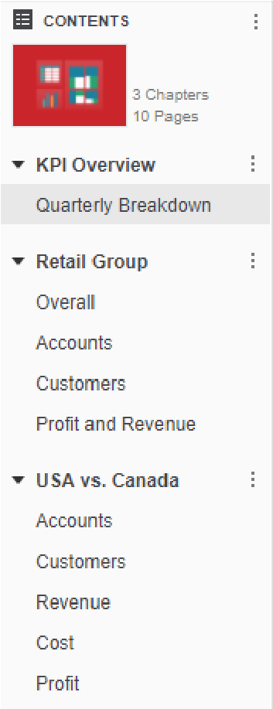

To add a page, click the **Add A Page**  icon from the toolbar. To add a chapter, click the **Add A Chapter**  icon from the toolbar.

To change the order of chapters and pages, click the desired title and drag the chapter or page to the new position.

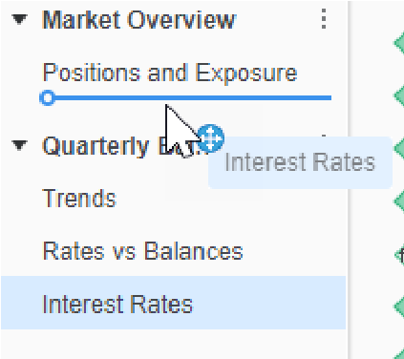

Layer related data: Chapters and pages

## Exercise 3.1: Add a page to the Supplier Dossier

You would like to add a page outlining the details of your suppliers by name, profit, cost, and units sold. The best visualization here is a grid, because the purpose of this page is to view the numbers in detail. As this page will include detailed data points, not an overview like Page 1, we are going to add a new page to Chapter 1.

**Add a page and grid visualization**

1. If needed, navigate to **My Reports** and reopen the **Supplier Dossier.**
2. Click **Add A Page** .

The page defaults to a grid visualization, so we don’t need to change the visualization type.

1. Drag the **Supplier** attribute from the second dataset(Supplier Report by Region) to the **Rows** drop zone.
2. Add **Unit Cost**, **Unit Profit**, and **Units Sold** to the **Columns** drop zone.
3. **Save** the dossier.

**Rename the dossier chapter and pages**

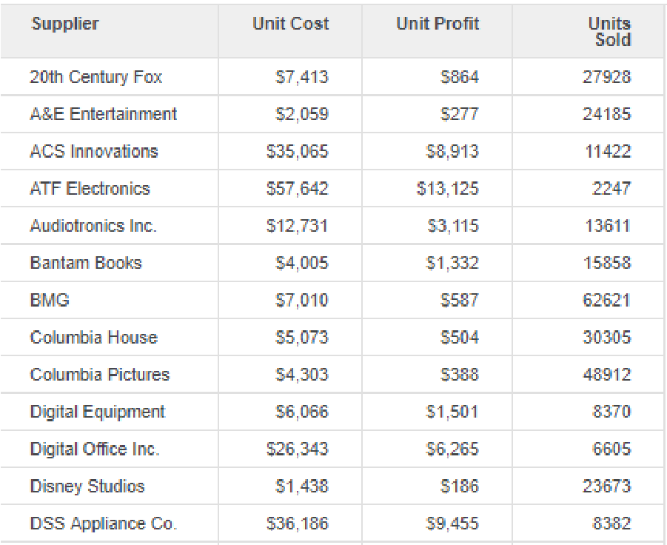

The default chapter and page names in dossiers are Chapter 1, Page 1, Chapter 2, and so on. It is best practice to name all pages and chapters with names that let

Layer related data: Chapters and pages

other analysts understand the data they contain. In this simple exercise, we will rename the chapter and pages in the Supplier Dossier.

1. In the Table of Contents panel, double-click **Chapter 1** so the text is highlighted.
2. Type: **Supplier Report**.
3. Double-click **Page 1**.
4. Type: **Profit and Revenue Analysis**.
5. Double-click **Page 2**.
6. Type: **Supplier Details**.

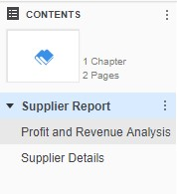

1. **Save** your dossier.

# Narrowing data: Filters

As a dossier designer, you may have a diverse audience that wants to analyze distinct data points. For example, a CEO of an online retailer may want to see sales numbers across the country, but a Regional Manager only needs to view data for his sales territory. Dossiers make slicing and dicing data simple through sleek, modern filters that allow anyone to navigate their data and hone in on specific areas of interest.

In addition to filtering on specific attributes and metrics, dossier designers can add visualizations as filters in the Filter panel for highly contextual and intuitive filtering, without using valuable page space. As in the example below (shown here in Library), the dossier designer added a marker map with options to select specific Washington, DC, monuments. A user can click on the monuments they’re interested in visiting to narrow the information on the DC Living - Monuments/ Museums page.

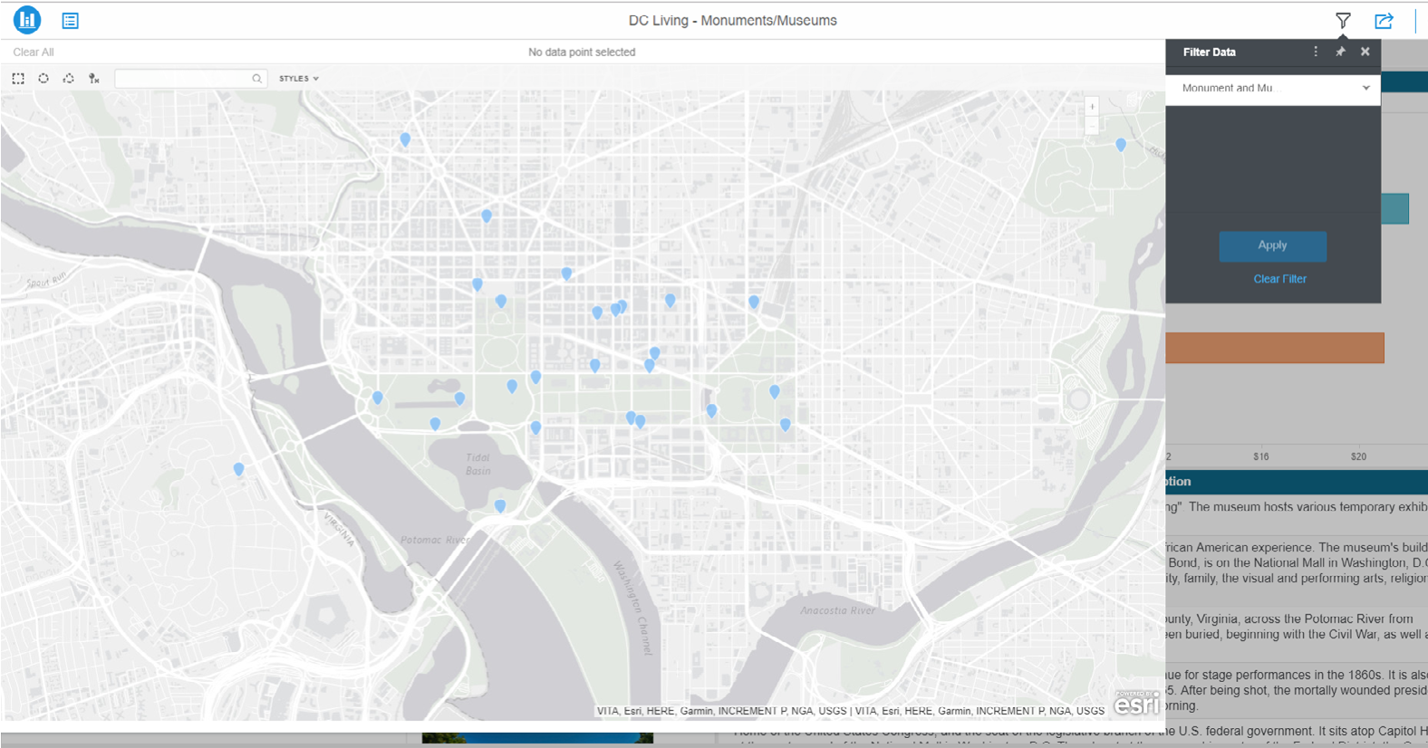

## Filtering chapters

Using the Filter panel, you can create filters that target all pages within a chapter. In the example below, the Executive Overview chapter Filter panel has three filters: office branch, year, and sales rep. These filters are only applied to the Executive Overview and Revenue vs # of Clients pages.

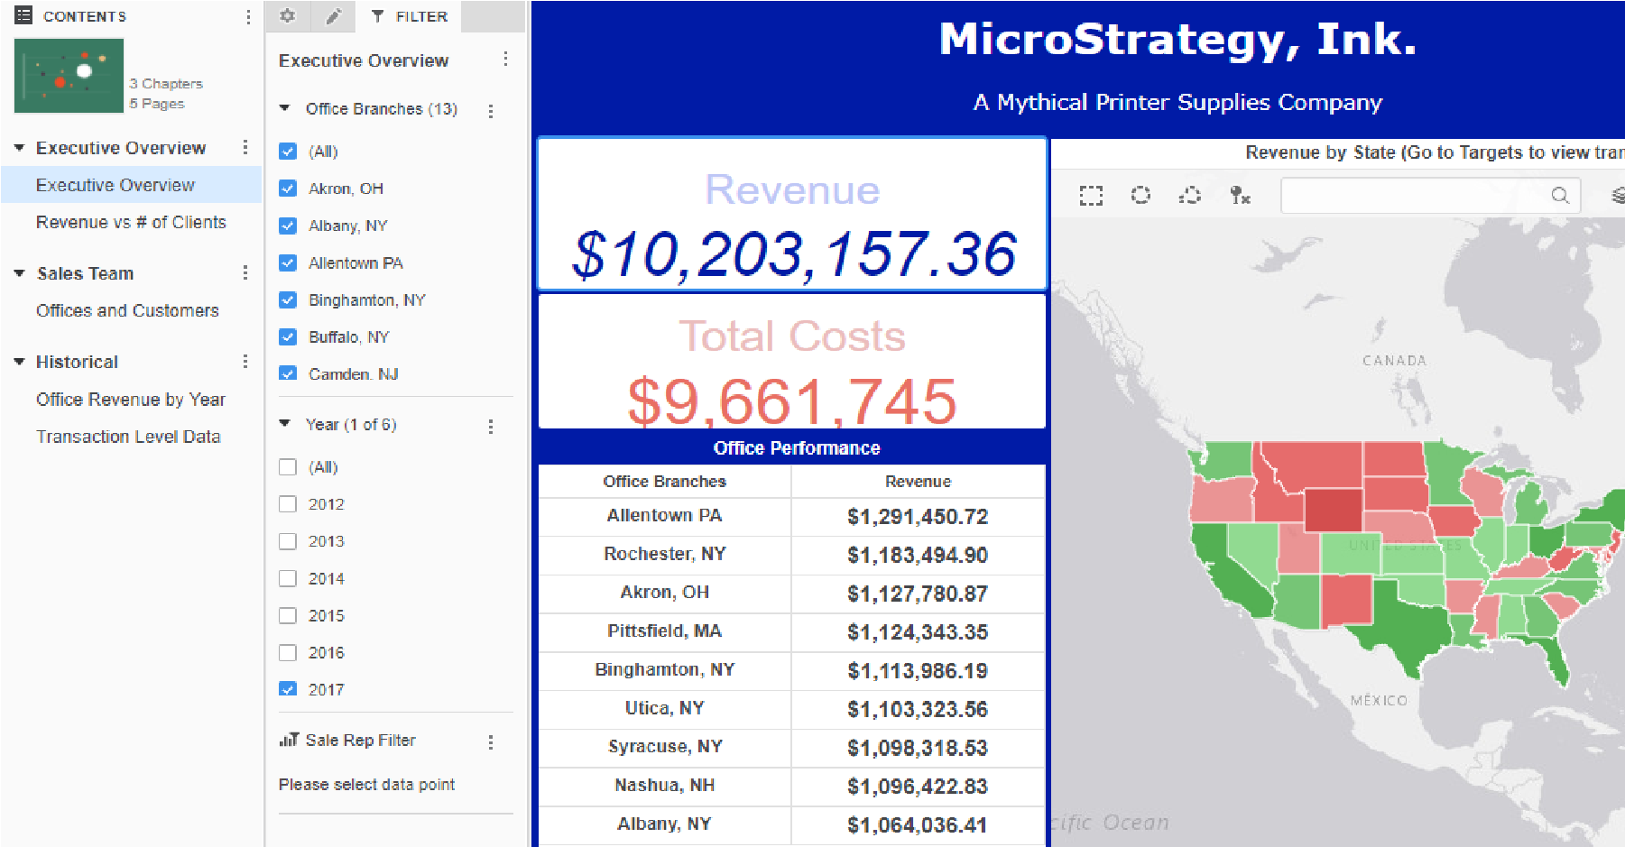

The second chapter, Sales Team, contains a Years by Revenue filter.

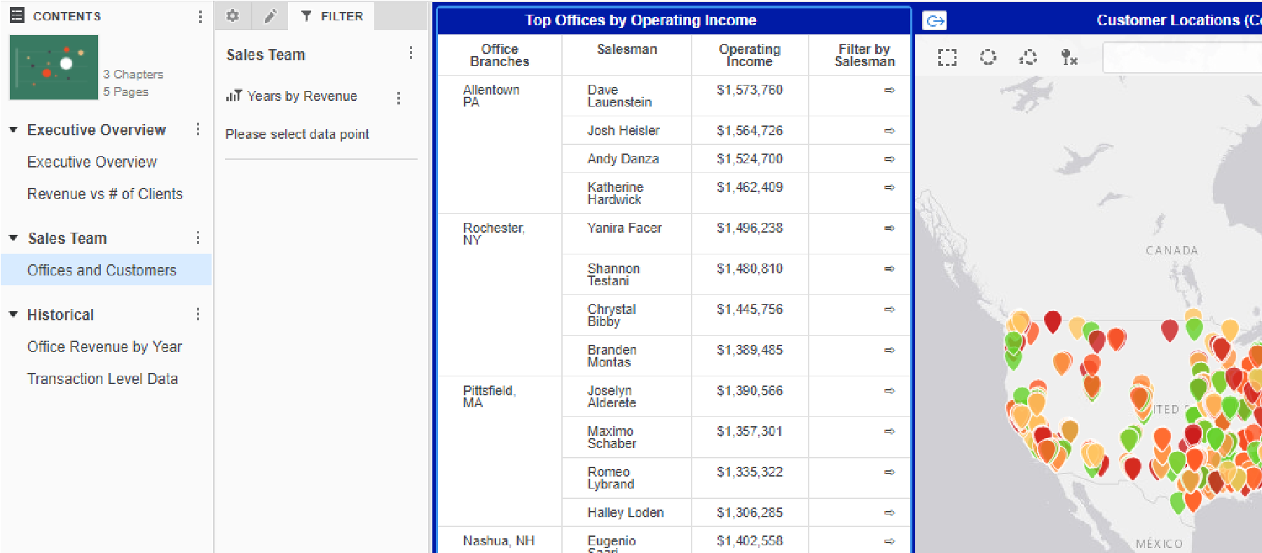

To create a metric or attribute filter, drag the desired object over to the Filter panel. Using the menu next to the filter, you can customize the filter, such as changing the display style and renaming the filter.

In the next exercise, we will add a filter to the Supplier Report chapter of the Supplier dossier.

**Exercise 3.2: Add a subcategory filter to the Supplier**

## Report chapter

Your supply chain team is organized by product subcategory. There is an assistant manager for audio equipment, action movies, TVs, etc. They would like to narrow the data in the Supplier Report chapter by subcategory so they can analyze their own suppliers. To do so, in this exercise you will add a filter in the Filter panel for Subcategory.

1. If necessary, navigate to the **My Reports** folder and open the **Supplier Dossier**.
2. Ensure you are on the **Profit and Revenue Analysis** page.
3. Select the **Filter** panel.
4. Click and drag **Subcategory** into the Filter panel.

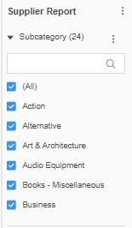

1. **Save** your dossier.

**Use the Subcategory filter to narrow chapter data**

1. From the **Filter** panel, hover over **Audio Equipment** and click **Only**.

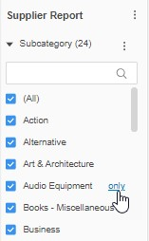

The map and bar chart have been filtered to show audio equipment data only. *Why is the Network visualization not affected by the filter?*

1. From the Table of Contents, click the **Supplier Details** page. The Subcategory filter is applied to this page as well since it is in the Supplier Report chapter.
2. To clear the filter, from the **Filter** panel, select **All**.

The filter has been cleared from the chapter.

## Filtering specific pages and visualizations

To further customize the data displayed in your dossier, you can apply filters to pages and specific visualizations. For example, you can use a pie chart on one page to filter a bar chart on another page.

All the different types of filters interact with each other. For example, a visualization can be targeted by both a chapter filter and a page filter. Both filters determine what the visualization displays.

Combine chapters, pages, and the different types and levels of filters to create layers of data focused on what you need. When you share your dossier with other users, they can change the filter selections and share those results to collaborate with other users.

## Exercise 3.3: Add an object filter to the Supplier Details page

You would like to be able to view the Supplier Details page by year, but the Profit and Revenue Analysis does not need to be filtered by year. To accomplish this, you will add a Year filter to the Supplier Details page.

**Add the Year object filter**

1. From theTable of Contentspanel, select the **Supplier Details** page.
2. From the toolbar, click **Filter** 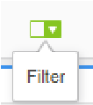 to add the filter onto the page.
3. Click and drag the **Year** attribute onto the **Filter** container.

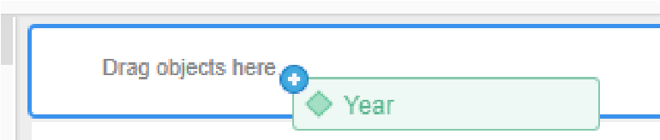

1. You would like users to be able to select specific years easily and select one at a time. To change the filter style, in the Format tab, change the Style to **Button Bar**.
2. Select **Allow multiple selections**.
3. To filter the grid, click **Select Target**.
4. Select **Visualization 1**, then click **Apply**.

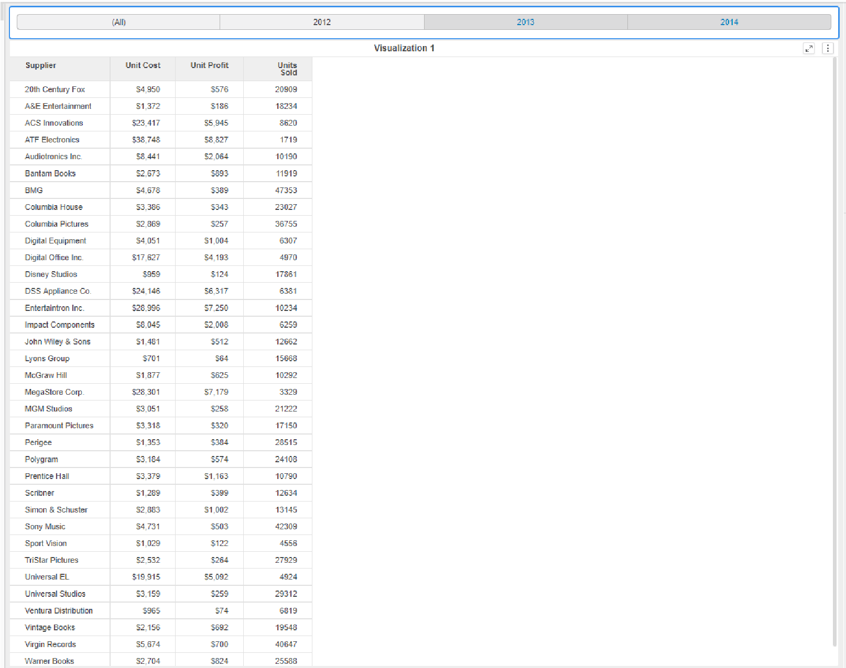

1. **Save** the dossier.

**Interact with the year filter**

1. Click the **Year** buttons to change the data in the grid.
2. Go to the **Profit and Revenue Analysis** page. Notice this page does not have the year filter applied.

# Easily identify trends

There are several ways to further enhance the analyst’s dossier experience and pinpoint pertinent information. All of the methods below can also be added by the user when interacting with dossiers in MicroStrategy Library.

## Sort data

When analysts can sort data in ascending or descending order, they can better visualize trends and identify key information, such as Sales Reps with the highest

Easily identify trends

profit. To sort, right-click the X or Y axis on a grid or graph and select the sort order. In the image below, suppliers are sorted in ascending order by revenue. The object label is the data label found on the graph axis. In the image below, Revenue and Supplier are the object labels.

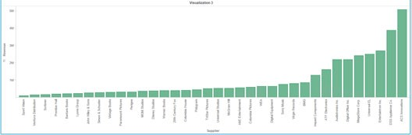

To remove the sort once it has been applied, right-click the sorted chart and click **Clear Sort**.

*Keep in mind that sorting may not be available for every visualization because not all data makes sense to sort.*

## Forecast data: Trend lines

You can display a trend line for each metric or for a specific metric to not only analyze your current data, but to also forecast or predict future values. Right-click the visualization container and select **Enable trendline** to add a trend line.

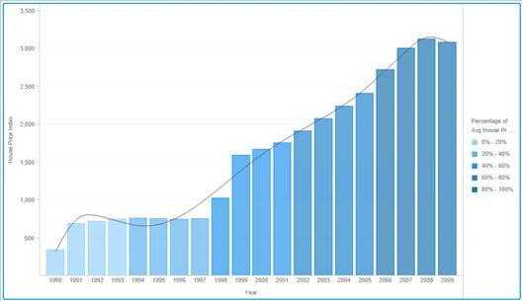

Easily identify trends

## Reference lines

You can add a reference line to a graph to help make comparisons between data points and to make a base line, such as average or max, easier to see. In the example below, the author added an average reference line to show the average tenure across all job titles.

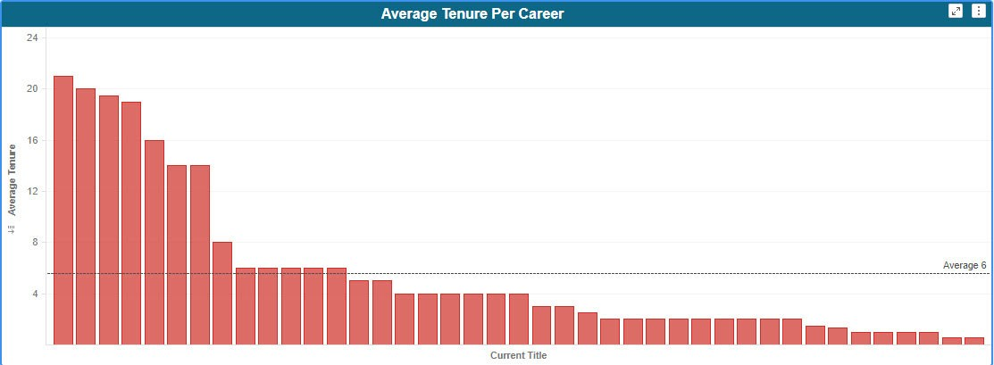

Similar to the trend line, add a reference line by right-clicking the graph and selecting **Add Reference Line**. The reference line types include:

* Minimum
* Maximum
* Average
* Median
* First
* Last
* Constant

# Dig deeper into your data: Drilling

Within a visualization, you can drill down to reveal additional detail and explore the data at different levels than what is immediately visible in the visualization. For example, if your dataset contains geographical regions, states, and cities, you may want to drill up to a more summarized level such as regional or state data, or down to a more granular level such as city or an individual store.

Dig deeper into your data: Drilling

In the example below, a dossier detailing safety benchmarks for hospitals in the Northeast includes a bar chart showing admission trends grouped by hospital.

You noticed that in March, Grace Hospital had an unusually high admission rate. So, you’d like to further analyze admission trends by diagnosis code for Grace Hospital in March.

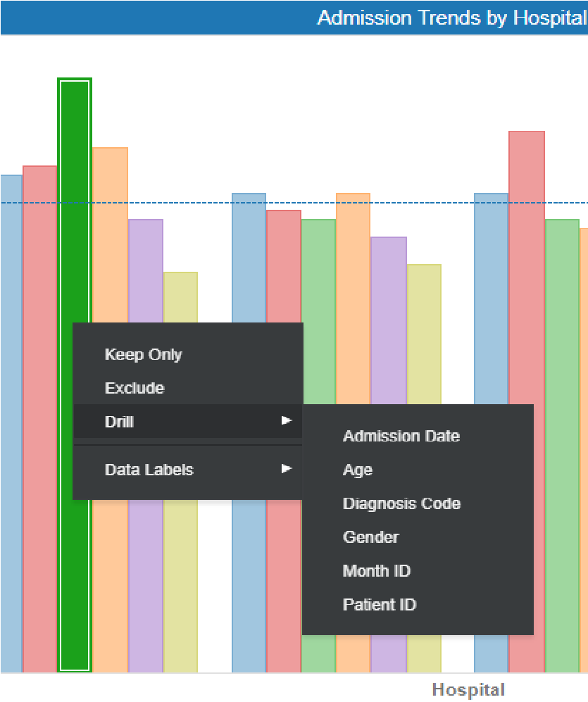

By right-clicking on the March bar for Grace Hospital, you can see all the available levels. Once you select a level, in this example Diagnosis Code, the graph will transform to show admissions by diagnosis code, specified hospital, and month.

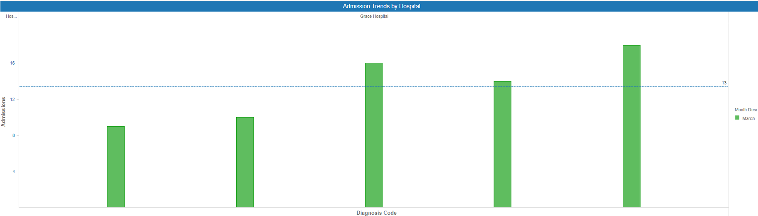

Drilling is available for Grid, Graph, Network, and Heat Map visualizations. Drilling within a specific visualization will not affect other dossier visualizations, unless the visualization is used as a filter for other visualizations. If the drilled-to visualization is used as a filter, the targeted visualizations will only show data relevant to the new level. Available drill options are dependent upon the dataset and the visualization.

Dig deeper into your data: Drilling

## Activity: Sort data

1. Reopen the **Supplier Dossier** from **My Reports**.
2. In the Supplier Dossier, in Visualization 3, right-click the **Revenue** metric name on the Y-axis of the bar graph.
3. Click **Sort Ascending**.

*What information can you now quickly determine by glancing at the graph?*

# Highlight important changes in data: Thresholds

When data meets a specific condition, you can highlight that data in a visualization by displaying the data in a different color or replacing the data with an image. For example, you can display revenue values less than $1,000 in red. After you add a color or image-based threshold, a color scale is automatically applied, such as light blue for the lowest revenue to dark blue for the highest revenue, or images to any data that meets the chosen threshold condition. This

can make analyzing large amounts of data easier as the user can quickly identify trends at a glance based on different colors and images.

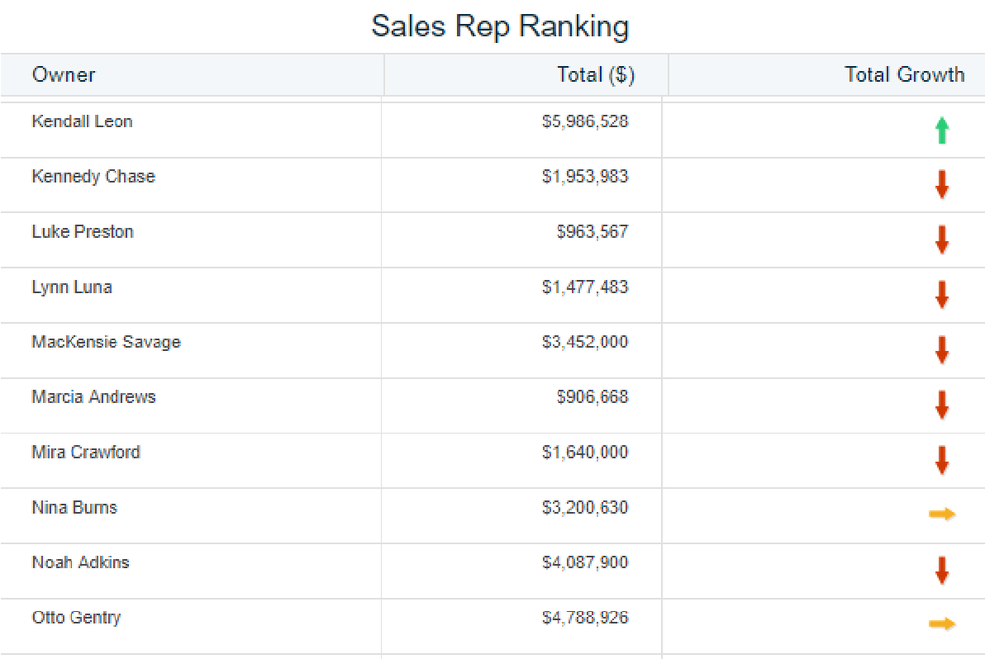

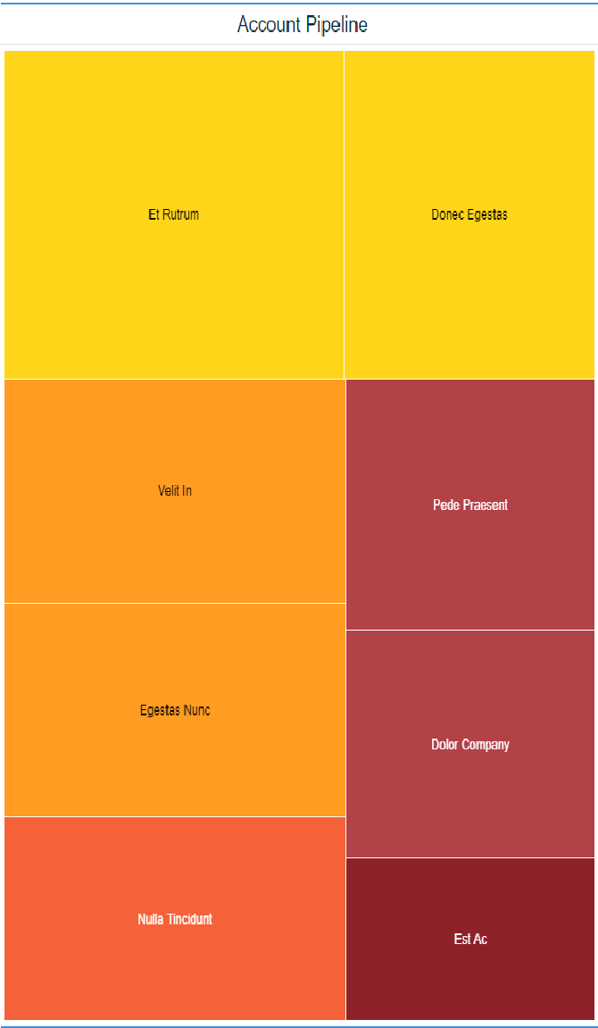

A threshold consists of two parts: the condition the value must meet to have the threshold formatting applied, and the formatting that gets displayed when the threshold is met. When you add a metric to the **Color By** area of a visualization, a default threshold is applied to the data. For a grid visualization, right-click the column header to which you want to apply the threshold, and select **Thresholds**.

You can apply the threshold formatting to:

* Metric values
* Metric subtotals
* Metric values and subtotals
* You can also apply attribute element thresholds when you use Grid visualizations.

*The elements of a business attribute are the unique values for that attribute. For example, 2016 and 2017 are elements of the Year attribute, while New York and London are elements of the City attribute.*

You can create multiple thresholds on the same visualization, including thresholds with multiple conditions. Below you will find high-level steps for adding a threshold to a metric.

1. Select the visualization to apply the threshold.
2. In the Editor panel, right-click the metric to apply the threshold.
3. Select **Thresholds** from the menu.

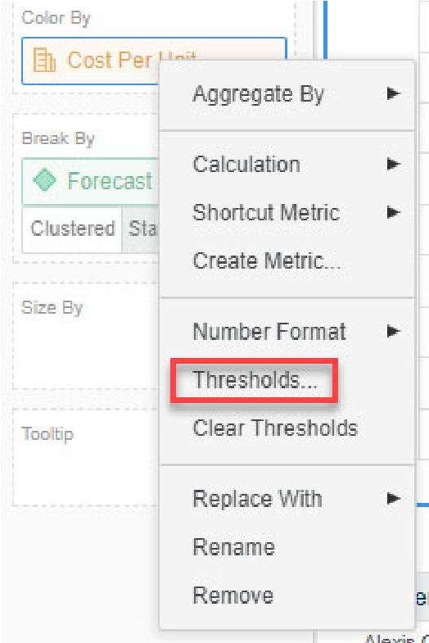

1. In the Thresholds window, you can make the following selections:

**Color**: Select the color, or color range, that you want to apply to the metric when it meets the threshold’s conditions.

**Based on**: Determine whether you want the threshold color to be applied to the metric's rank or its value, when the metric meets the threshold's condition. For example, you can display metric values greater than 5 million in blue or the top 5 metric values in green.

**Break by**: Select the attribute level to restart counting rank or percentage values. Select **None** to continue without restarting. This option is only available for rank or percentage values.

**Color band**: Click and drag the spacers to increase or decrease range values.

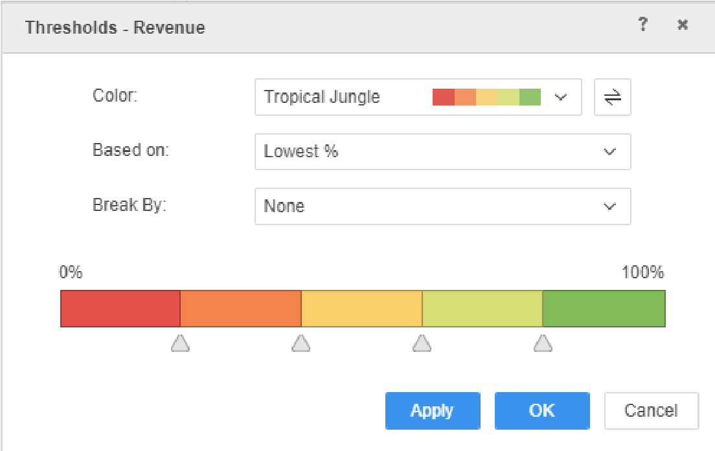

1. Click **OK** to apply the threshold.
2. To remove the threshold, return to the Editor panel for the visualization, right-click the metric, and select **Clear Thresholds**.

## Workshop 2: Visualization analysis

In this workshop, you are a travel coordinator for a boutique consulting firm. The company has delegated two consultants, Milo and Clarissa, to travel and speak at multiple conferences throughout the year. As their highly talented travel coordinator, to help these employees reach their destination in a timely manner, you will create a dossier to examine airport data, including the number of flights and percent of delayed or canceled flights for each airport so that you can make decisions such as which airport they should fly out of, and what airline and day of the week they should fly. Milo is based in Washington, DC, while Clarissa is based in Los Angeles, so the dossier must be filtered for their home base airports.

### Analyze airports and airlines

You need to analyze which airports the speakers should fly out of and which airlines have the lowest percentage of delayed or canceled flights. To begin, you will import a dataset into MicroStrategy Web. That dataset must contain the following information:

* Total number of flights for major U.S. airports
* Total number of cancellations for major U.S. airports
* Total number of delays for major U.S. airports

For the purpose of this exercise, we will assume that you have already located or created a dataset that meets all of these criteria. We will import a preformatted spreadsheet that conveniently includes all the necessary data.

You will create a bubble graph for the initial visualization.

**Create the initial visualization**

1. From the My Reports page, click **Create** and select **New Dossier**.
2. In the Datasets panel, click **New Data**.
3. Select **File From Disk**.
4. In the Upload Your Files window, click **Choose files**, then select the file **Airline Data.xlsx**
5. Click **OK**.

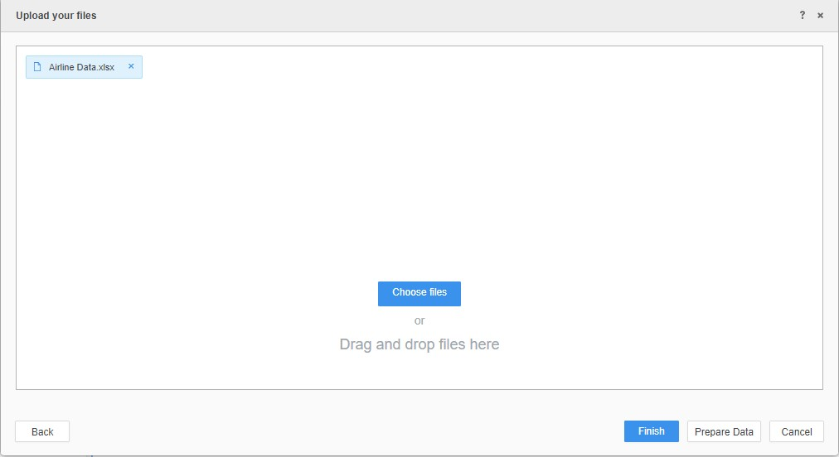

1. Click **Prepare Data**. Notice that all the objects are listed as attributes. We need to revise the data to include metrics before creating our visualizations.
2. Convert the following columns to metrics:

* Number of Flights
* Flights Canceled
* Flights Delayed

To convert these columns to metrics, click and drag the objects to the **Metrics** row in the data table.

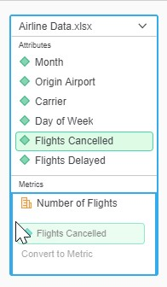

The data preview page now looks like this:

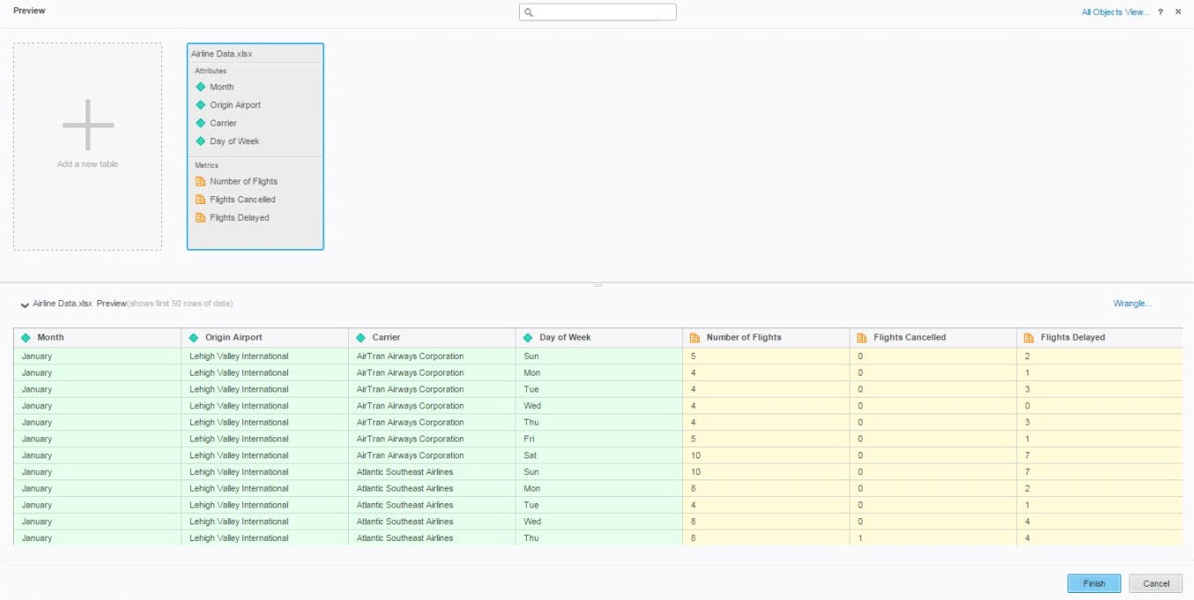

1. Click **Finish**.
2. Save the dossier as **Airline Data Dossier**. In the window, select **Run newly saved dossier**.

**Add a visualization**

1. Click the **Bubble Chart**  icon in the Visualization Gallery.
2. In the dossier, place the following dataset objects in the indicated areas:
   * Add the **Origin Airport** attribute to the **Vertical** drop zone.
   * Add the **Flights Canceled** metric to the **Horizontal** drop zone.
   * Drag the **Flights Delayed** metric to the **Color By** drop zone.
   * Drag the **Number of Flights** metric to the **Size By** drop zone.
3. Since there are a high number of data points, you want the visualization container to be compacted to show all the bubbles. Select the **Format** panel, and in the Container Fit drop down menu, select **Compact**.

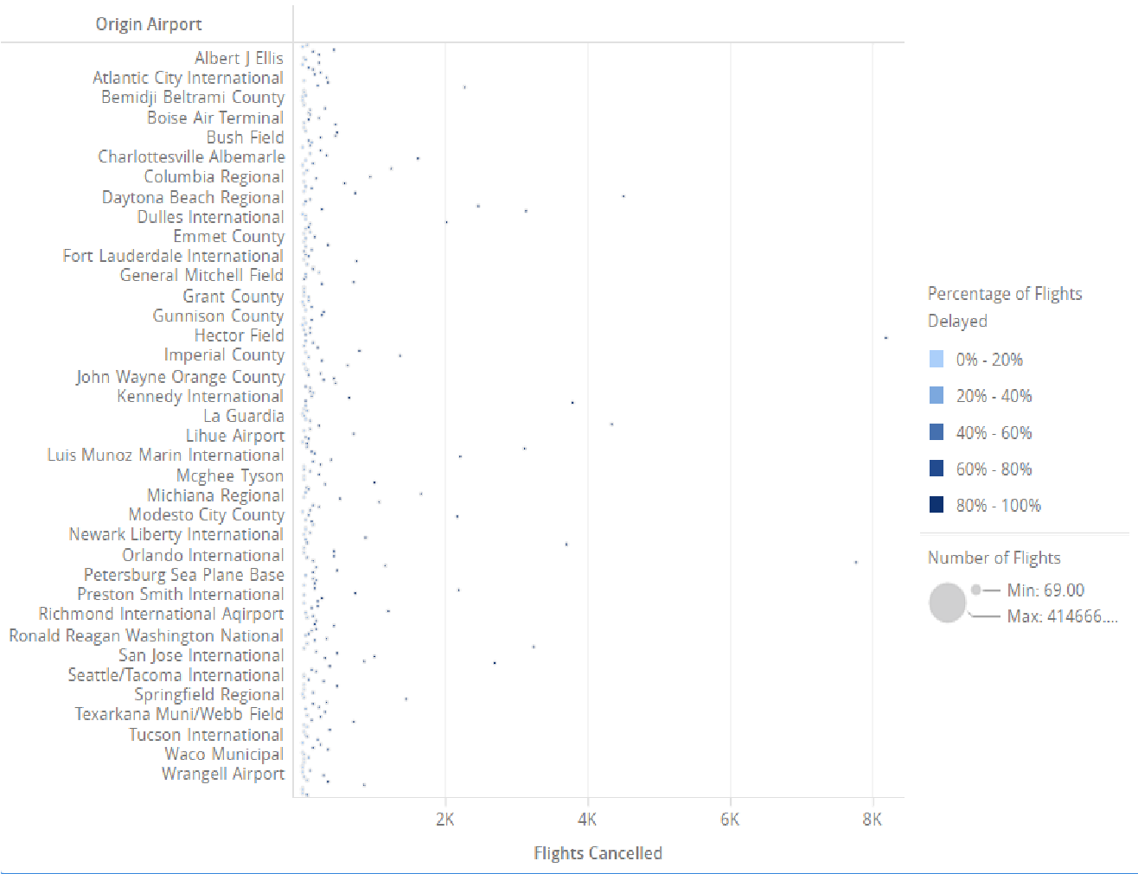

The location of each bubble in the graph shows the number of flights that were canceled for each airport: the further right the bubble, the more flights were canceled. The size of each bubble represents how many flights flew out of each airport: the bigger the bubble, the more flights flew out. The color of the bubbles represents the percent of flights delayed: light blue bubbles had 0-20% of all flights in the dataset delayed, while dark blue bubbles had 80% or more flights in the dataset delayed.

**Improve the bubble chart**

1. The size of the bubbles in this visualization is too difficult to read and interpret. Through editing, you can improve the visualization and the effectiveness of the dossier. To improve the readability of the bubbles, you can change the threshold color. Right-click the **Flights Delayed** metric in the Color By box and select **Thresholds**.

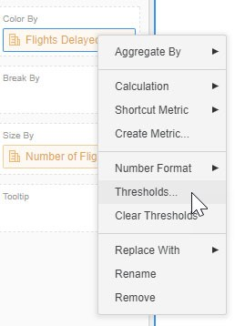

1. From the **Color** drop-down, select **Business Red**. Click **OK**.

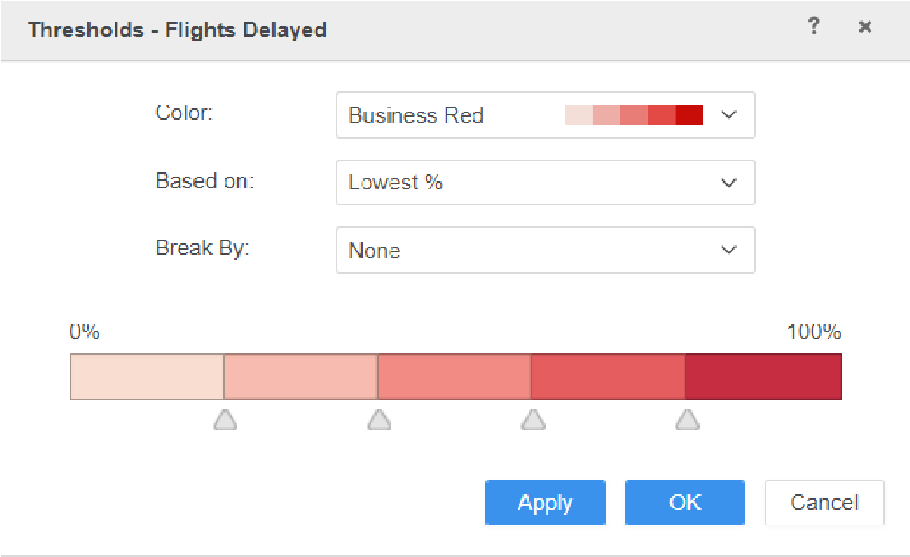

1. **Save** the dossier.

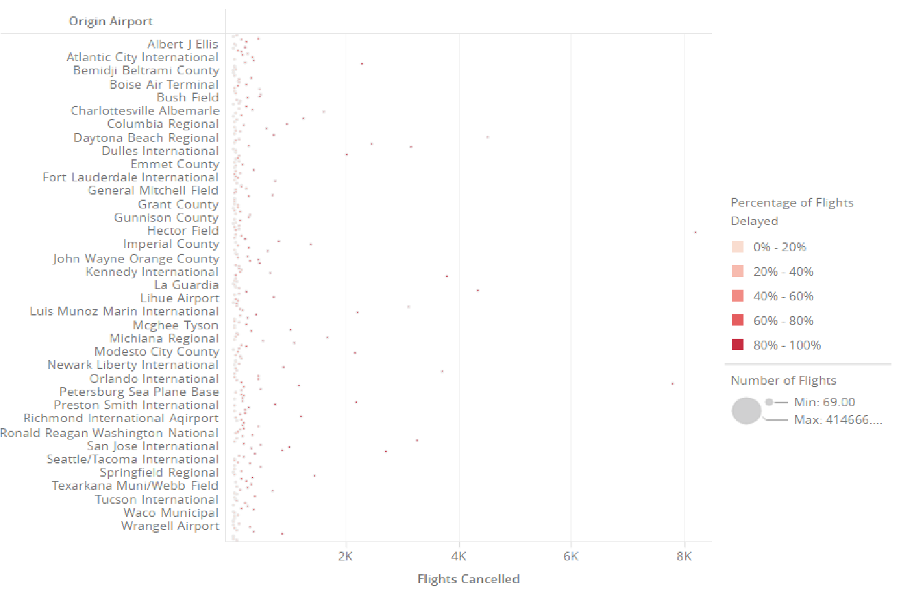

To help choose which airport and airline are best, add a filter for the Origin Airport attribute that displays only the airports in those two metropolitan areas the employees are traveling from.

**Filter the data**

1. Click the **Filter** panel to apply a filter to the dossier.
2. Drag **Origin Airport** to the **Filter** panel.

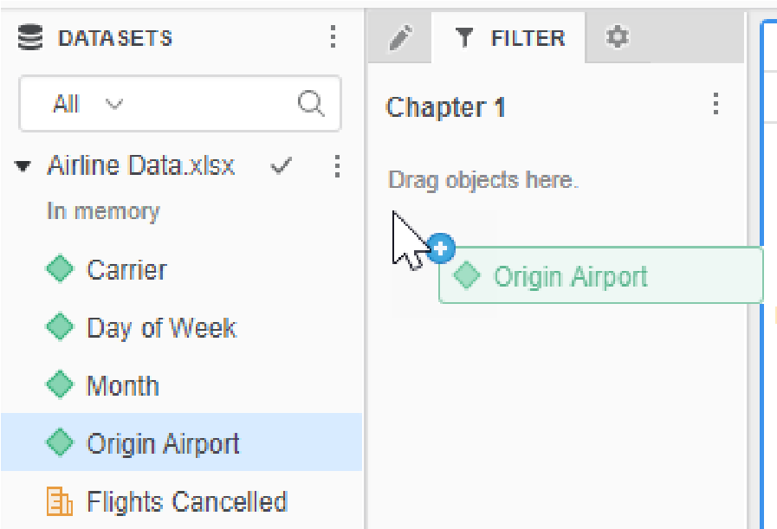

1. In the **Origin Airport** box, type the below airports in the Los Angeles and Washington, DC, areas. When you begin to type the airport name, the field will auto-populate with the names below.
   * **Baltimore/Washington International Thurgood Marshall**
   * **Dulles International**
   * **Ronald Reagan Washington National**
   * **La/Ontario International**
   * **Los Angeles International**
   * **Long Beach Daugherty Field**
2. Now that there are more data points, you can expand the graph to fit to container. Select the **Format** panel, and under Container fit select **Automatic.**

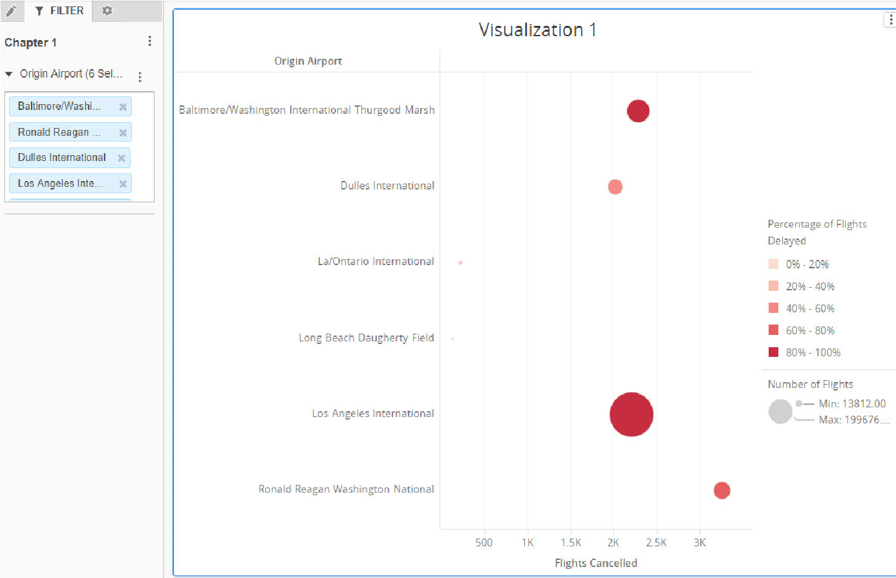

1. Click **Save**.

A quick glance the graph shows you should book a flight from Los Angeles International airport for Clarissa. Though the cancellation rate is higher, there are more flight options available.

While Baltimore has a higher percentage of delayed flights, it has a low cancellation rate and more flights. On the other hand, Dulles has a lower percentage of delays, but a higher percentage of cancellations and fewer flights. The employees would rather have their flight delayed than canceled, so you choose Baltimore for Milo.

### Analyze the best day to fly

You are making travel plans for Clarissa and Milo’s annual joint Spring Convention presentation in April. Clarissa and Milo have decided that Los Angeles (LAX) and Baltimore/Washington (BWI) are their preferred airports for commuting purposes, so you can only make travel plans using those two airports.

Additionally, because their schedules are tight, you need to know which day of the week is best for travel in terms of the percentage of delays. To determine which day of the week in April is most convenient for Milo and Clarissa, you decide to create a heat map. You choose the heat map visualization because the condensed color-coded format of the heat map chart makes the data much easier to understand.

For this portion of the consultant’s travel plans, you decide to create a new chapter in your dossier. This information is separate from their usual week to week travel, and you would like to keep it separate and include unique filters.

**Create a heat map**

1. Add a new chapter to the dossier by clicking the **Add a chapter** icon on the toolbar.
2. On Page 1 of Chapter 2, click the **Heat Map** icon in the Visualization Gallery.
3. Create a filter that ensures the visualization will only include results from the specific month and origin airport. On the Filter panel, drag **Origin Airport** and **Month** to the panel.
4. Hover over **April** and click **Only** to filter the page for April only.

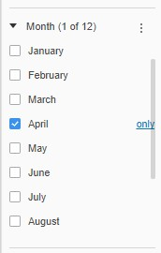

1. To filter by airport, begin typing **Baltimore/Washington International Thurgood Marshall** and **Los Angeles International** (the filter will auto-populate) for the Origin Airport filter.

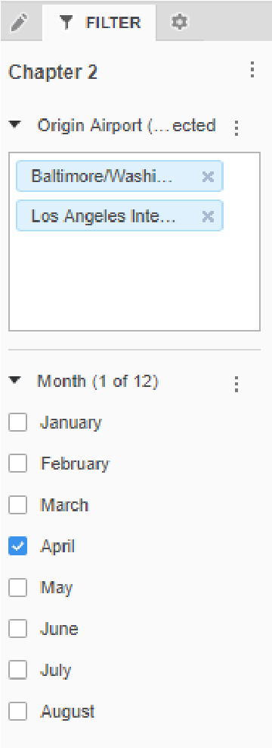

1. After the filters are applied, create a heat map that visualizes the number of flights delayed per airline, per day, in the month of April, at the selected airports:
   1. In the Editor panel, drag the **Origin Airport** and **Day of Week** attributes into the Grouping drop zone.
   2. Add the **Number of Flights** metric into the **Size by** drop zone. c Add the **Flights Delayed** metric into the **Color By** drop zone.
2. The team that will analyze this dossier moving forward has requested that pages with Heat Maps do not include legends so users can focus on the visualization. Hover over the legend and click the **X** icon to hide the legend.
3. Currently, the days of the week with the fewest flights delayed are red. To reverse the colors, right-click the **Flights Delayed** metric in the **Color By** drop zone and select **Thresholds**.
4. On the Thresholds - Flights Delayed window, from the **Based on** menu, select **Highest %**, so that red indicates the high end of the spectrum.
5. Select **Origin Airport** from the **Break By** drop down to separate the threshold by airport. Click **OK**.
6. In the **Format** panel, clear the **Show Metric Values** option.

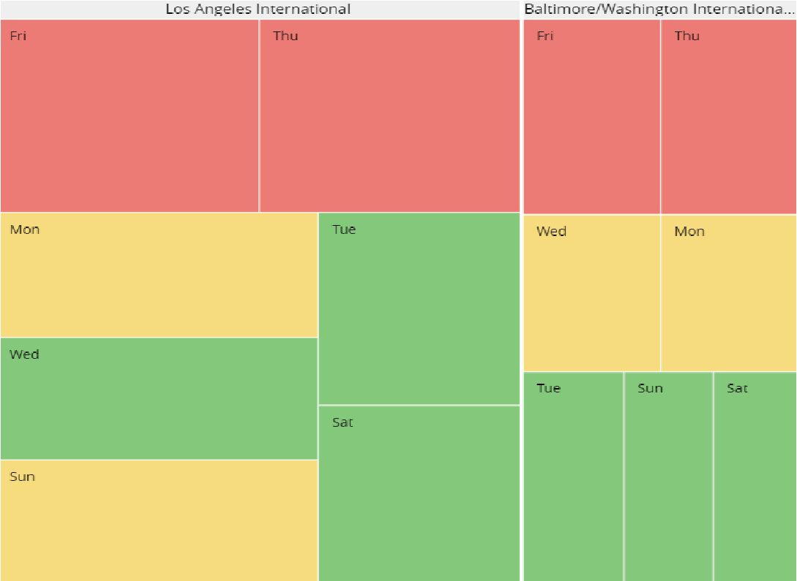

Based on this information, and bearing in mind their travel requirements, which day of the week is the best day for travel for both Milo and Clarissa? According to this heat map, the best travel day for both Milo and Clarissa is Saturday.

1. **Save** the dossier. We will continue this workshop after we learn about derived metrics.

# Create a metric based on existing metrics: Derived metrics

Derived metrics are metrics that a dossier author can create based on existing dataset objects. For example, you can calculate a monthly average, with the formula Yearly Profit / 12. Derived metrics perform calculations on the fly with available data without needing to re-execute the dossier against the data source. These metrics are an easy way to present already available data in different ways and provide further analysis.

You can use derived metrics to perform analyses such as margins, contributions, and differences between metrics on the report.

Examples of way to include derived metrics are:

* Subtracting one metric value from another.
* Ranking a metric’s value from least to greatest.
* Displaying metric values as a percentage of the total.

## Calculate values in an existing metric: Aggregate By

Aggregation functions, which are a type of derived metric, are used to calculate subtotals for a metric. Examples of aggregate functions include Sum, Average, Standard Deviation, and Median.

To create a derived metric through an aggregate function, right-click the target metric in the Dataset panel. Select **Aggregate By** and choose a function. The new metric appears as a new dataset object you can now use in your dossier to create visualizations. In the example below, the author is creating a derived metric that shows the average profit.

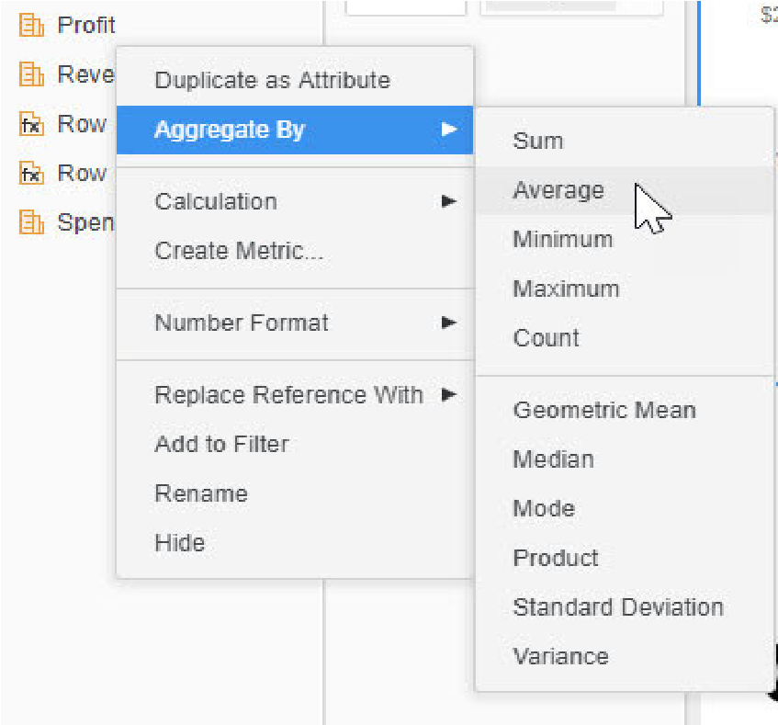

Once the function is selected, the new metric appears in the dataset as Avg(Profit).

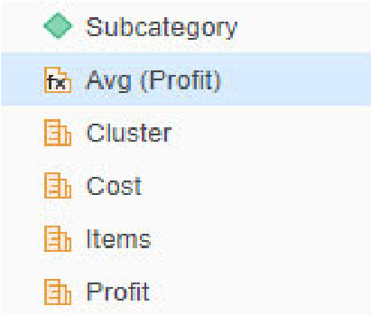

## Combine values of metrics: Calculations

You can create a new derived metric by combining existing metrics with an arithmetic operator. These operators allow you to add, subtract, multiply, divide, or find the percentage of the selected metrics.

To create a derived metric by combining two metrics with mathematical operators, right-click a metric in the dataset and select **Calculation**. The metric you initially selected will appear in the first drop-down box, though you can change to another metric. Next, select your mathematical operator.

In the example below, the author wants to create a Profit metric. After right-clicking Revenue, she selected the minus sign (-):

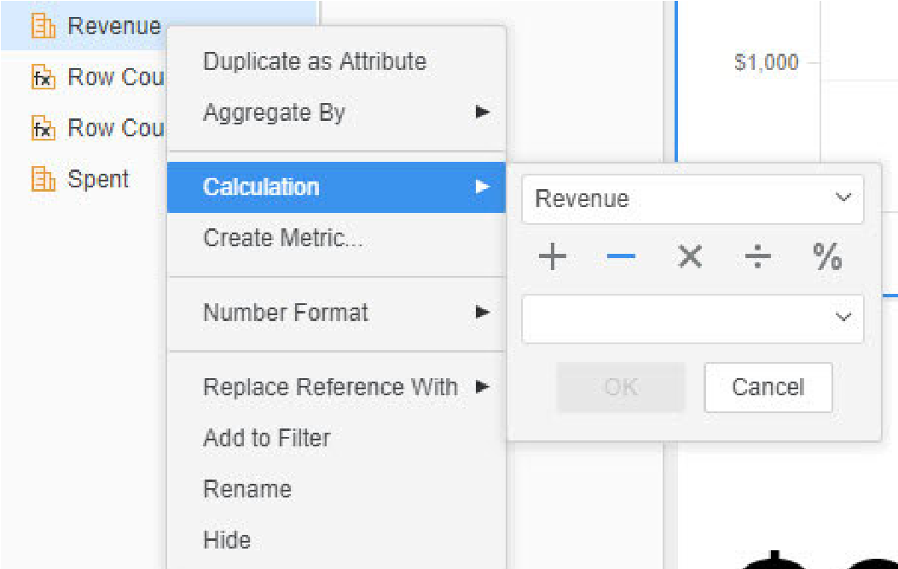

Use the drop-down menu in the next text field to select the second metric. In this example, the author selected Cost:

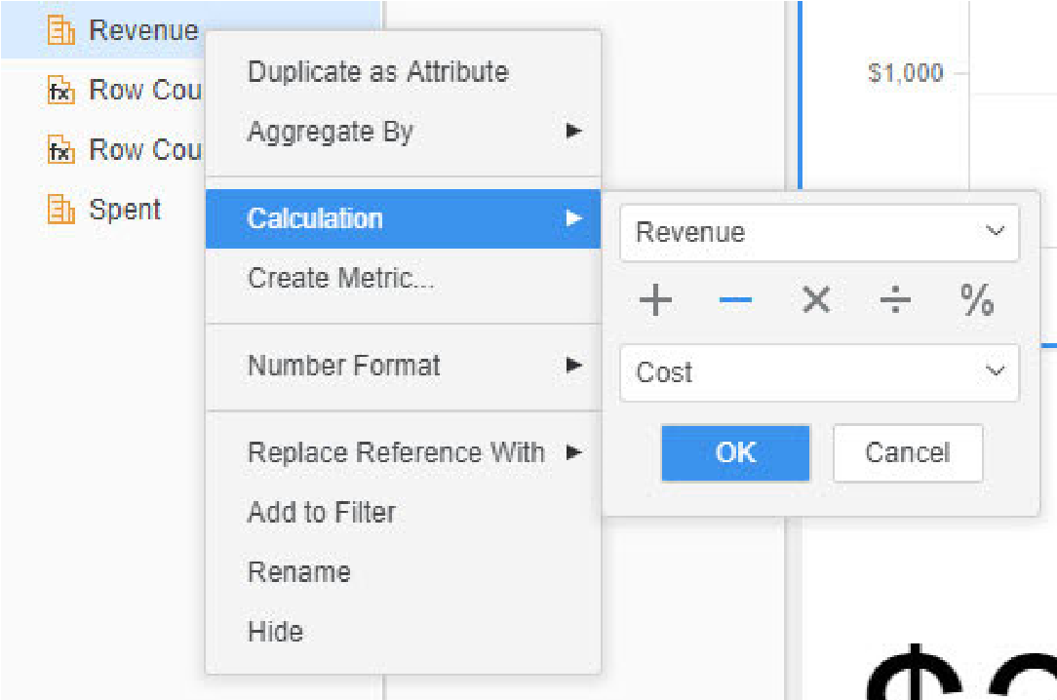

When the new metric is created, it will appear as **(Revenue-Cost)** in the dataset. To give more meaning to the derived metric, you can right-click and select **Rename**. In this case, the derived metric was renamed **Profit**.

To learn the advanced uses of derived metrics, take *11.112 Introduction to Analytics Reporting*.

## Workshop 3: Visualization analysis

This is a continuation of the previous airline workshop. In Part III, we will add derived metrics to the Airline Data Dossier to find the best airline and day to fly. Remember, you are booking flights for Milo, flying out of the DC area, and Clarissa, flying out of Los Angeles California.

**Analyze airport delays**

**Create derived metrics to analyze airport delays**

1. Navigate to the open **Airline Data** **Dossier**. In Chapter 2, select **Page 1**.
2. On the Datasets panel, right-click **Flights Delayed.**
3. Select **Calculation**.
4. Choose the division symbol and add **Number of Flights** in the bottom drop-down. Click **OK.** The new metric should be (Flights Delayed/Number of Flights).
5. Right-click the new metric and select **Rename**. Type: **Percentage Delayed**.
6. Right-click **Percentage Delayed** and select **Number Format**.
7. Ensure **Percentage** is selected. Remove the decimal points.

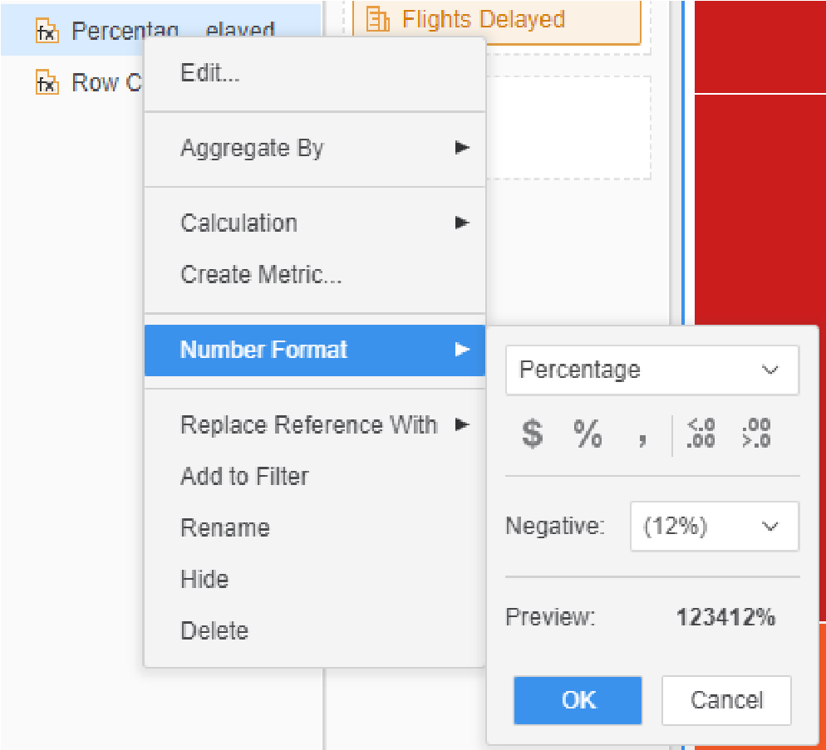

1. Click **OK.**
2. Add **Percentage Delayed** to the **Tooltip** drop zone on the Editor panel. Now, when you hover your cursor over a square, you can view percentage delayed for each airport.
3. Hover over the days for each airport to see which days have the lowest percentage of delayed flights. You will see that Saturday is the best for both airports, which reaffirms your earlier decision to try and book flights on Saturday.

Now that you have confirmed the airport and the day of the week, you should determine which airline is most likely to get Milo and Clarissa to their convention on time.

**Determine the best airline**

1. Add an additional **Day of Week** filter to the heat map by dragging **Day of Week** to the Filter tab. Filter out all days except **Saturday**. This way, we can see what’s the most reliable airline for the day we determined has the fewest delays.

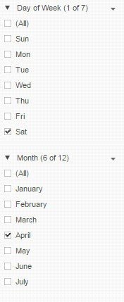

1. In the Editor panel, Remove **Day of Week**.
2. Add the **Carrier** attribute to the Heat Map’s **Grouping** drop zone below Origin Airport to view each box by airline instead of day of the week.

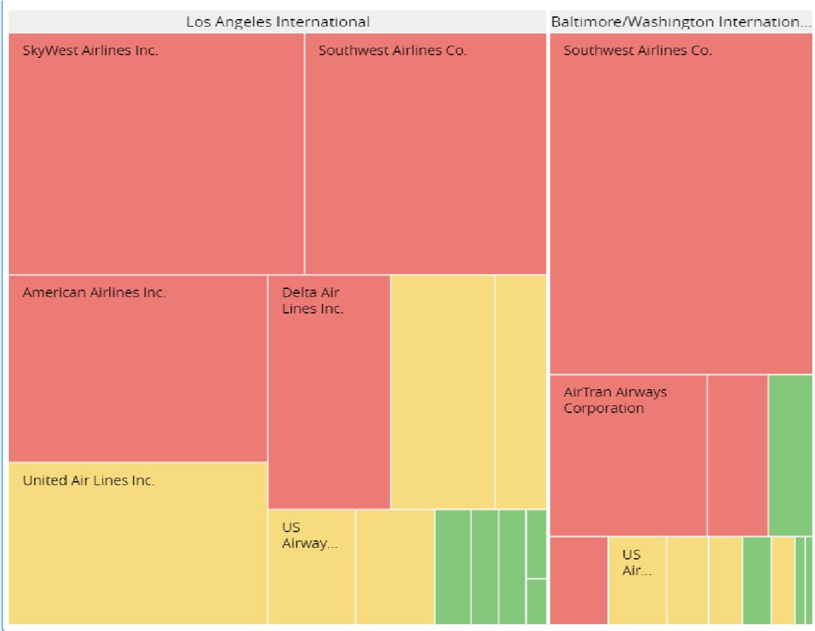

1. Click **Save**.

*Which airline is most likely to get Milo and Clarissa to their convention on time?*

At approximately 8%, Air Tran clearly has the lowest delay rate of any available airline in Los Angeles. Assuming you can find an appropriate booking, he should book Clarissa on Air Tran.

For Milo, the airline with the lowest delay rate is JetBlue, with an excellent 0% cancellation rate.

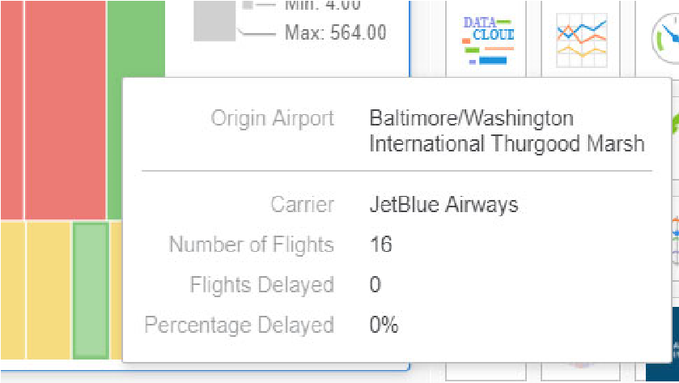

In this workshop, you were able to build clear visualizations and easily find the best airport, day of the week, and airline for the consultants. In addition to planning flights for Clarissa and Milo, you can use this dossier to plan a variety of other travel obligations throughout the year.

# Add dossier details: Insert text or images

The main focus of dossiers is the visual representation of business intelligence, and dossier pages can be enhanced by adding text or images. Text can serve as a data label or provide descriptive information to users. Images, such as a corporate logo, can give a dossier a polished and professional look.

## Add text

Adding text is a simple way to provide more information to users. Text can provide labels for visualizations, explain the data that is contained in the visualization, or provide additional information to users. Text can be formatted, resized, and repositioned on the dossier.

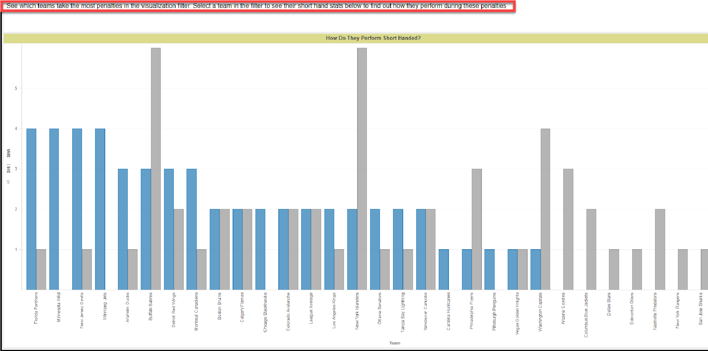

In the example above, this dossier page displays penalty trends for NHL teams. The text box, highlighted in red, helps provide guidance for the end users by explaining how to maximize the page’s analysis.

These are the high-level steps to add text to the dossier:

1. Clickthe **Insert Text** icon on the toolbar.
2. The text box by default will appear at the top of the dossier. Click and drag to move it to your desired location.

### Dynamic text

Dynamic text contains a reference to an object on a report. Each time you view the dossier, the dynamic text field will automatically update based on the latest available data. Create dynamic text by dragging dataset objects into a text box.



In the example above, if you click and drag the **Out of Stock** metric into the text box, the total number of products out of stock in the dataset appear in the text box. The next time someone views the dossier, the Out of Stock dynamic text automatically updates based on the most recent values in the data source.

Combine static text with dynamic text to give the value meaning. For example, combine the static text “Total Supplier Revenue:” before the dynamic text, as seen in the image below, to allow users to identify important metrics at a glance.

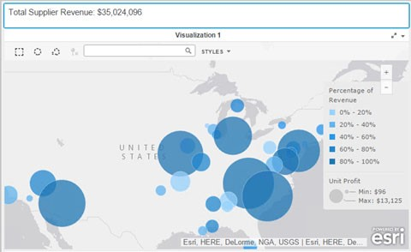

## Add an image

You can add your corporate logo or a relevant image to enhance the overall look of your dossier. You can specify that when a user clicks the logo, it opens your company homepage. You do this by inserting a URL into the logo.

## Exercise 3.4: Insert text and complete the dossier

In this exercise, you will give the dossier a title by inserting a text box. Then, to show total supplier revenue, you will add a dynamic text box. To add polish, you will add an image that links to the company website. Lastly, we will rename the visualizations with relevant titles.

**Add the dossier title**

1. Open the **Supplier Dossier**.
2. On the Supplier Dossier toolbar, click the **Insert** **Text**  icon.
3. Type **Supplier Report Dossier**.
4. With the text box selected, click the **Format** panel.
5. Change the **Font size** to **20**.
6. In the drop-down list next to the font size, set the text color to **White**.
7. Set the **Fill color** to **Black**.
8. Click **Save**.

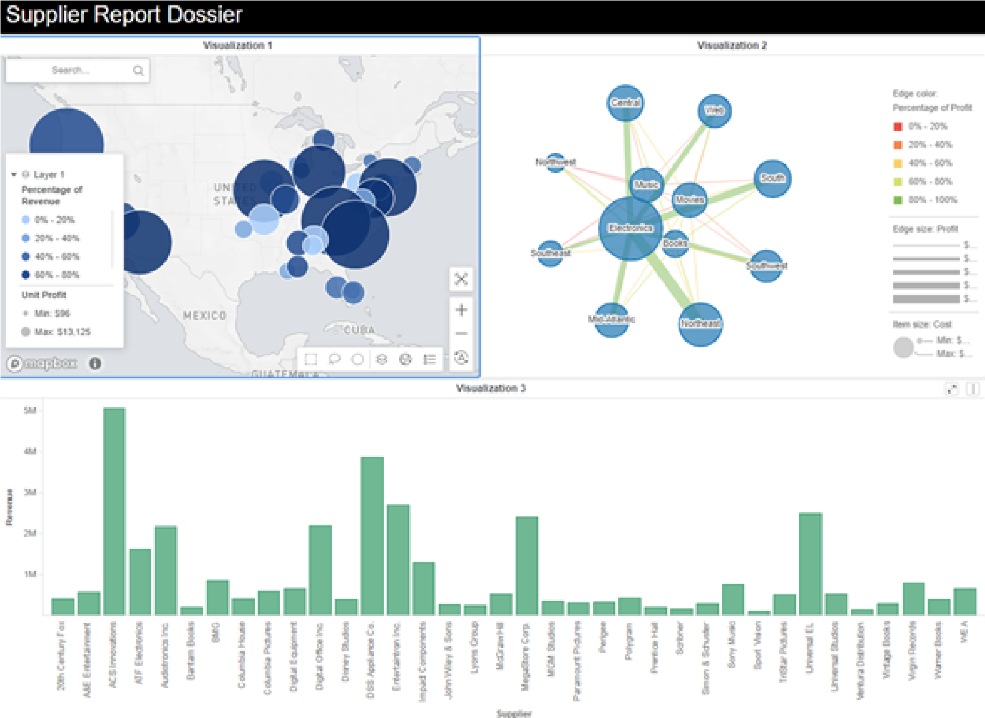

**Add dynamic text to display supplier revenue**

1. Click the **Insert** **Text** icon.
2. Click and drag the new text box to the right of the title.
3. Place your cursor in the text field and type **Total Supplier Revenue**.
4. Click and drag the **Revenue** metric from the dataset and place it to the right of the entered text.

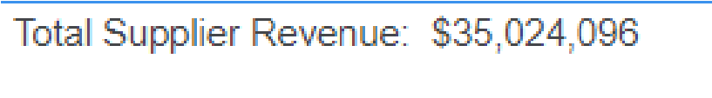

1. With the text box selected, click the **Format** panel on the Editor panel.
2. Change the **Font size** to **14.**
3. Change the text color to **White**.
4. Change the background fill color to **Black**.

**Add an image**

**1**

From the toolbar, click the

**Image**

icon.

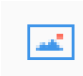

1. Click and drag the image container to the left of the text box as seen below.



1. Copy and paste the following URL into the **Enter an image field**: *http:// is3.mzstatic.com/image/thumb/Purple118/v4/0c/3a/97/ 0c3a9786-8f77-bd36-4746-bfd8f9228add/source/175x175bb.jpg*
2. Click **OK**. You will see the image appear.

**Resize the image container**

1. To resize the image container, click the right side of the container and drag it until it reaches the desired size.

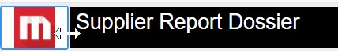

**Edit the image**

1. Select the image container and click the **Format** panel.
2. Change the **Fill color** to **Black**.
3. Click the Menu icon in the visualization container and click **Link**.

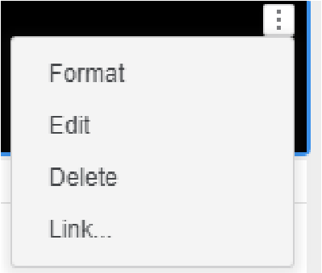

1. Enter the following URL: **https://www.microstrategy.com/us**
2. Click **Save**.

Now, we will create labels for the visualizations to help users interpret the data.

**Rename the visualizations**

1. To rename the Map visualization, double-click the title **Visualization 1** so the text is highlighted.
2. Type the new title: **Profit and Revenue per Supplier Location**.
3. Repeat these steps and rename the Network visualization: **Profit Analysis for Region and Category**.
4. Rename Visualization 3 as: **Revenue per Supplier**.

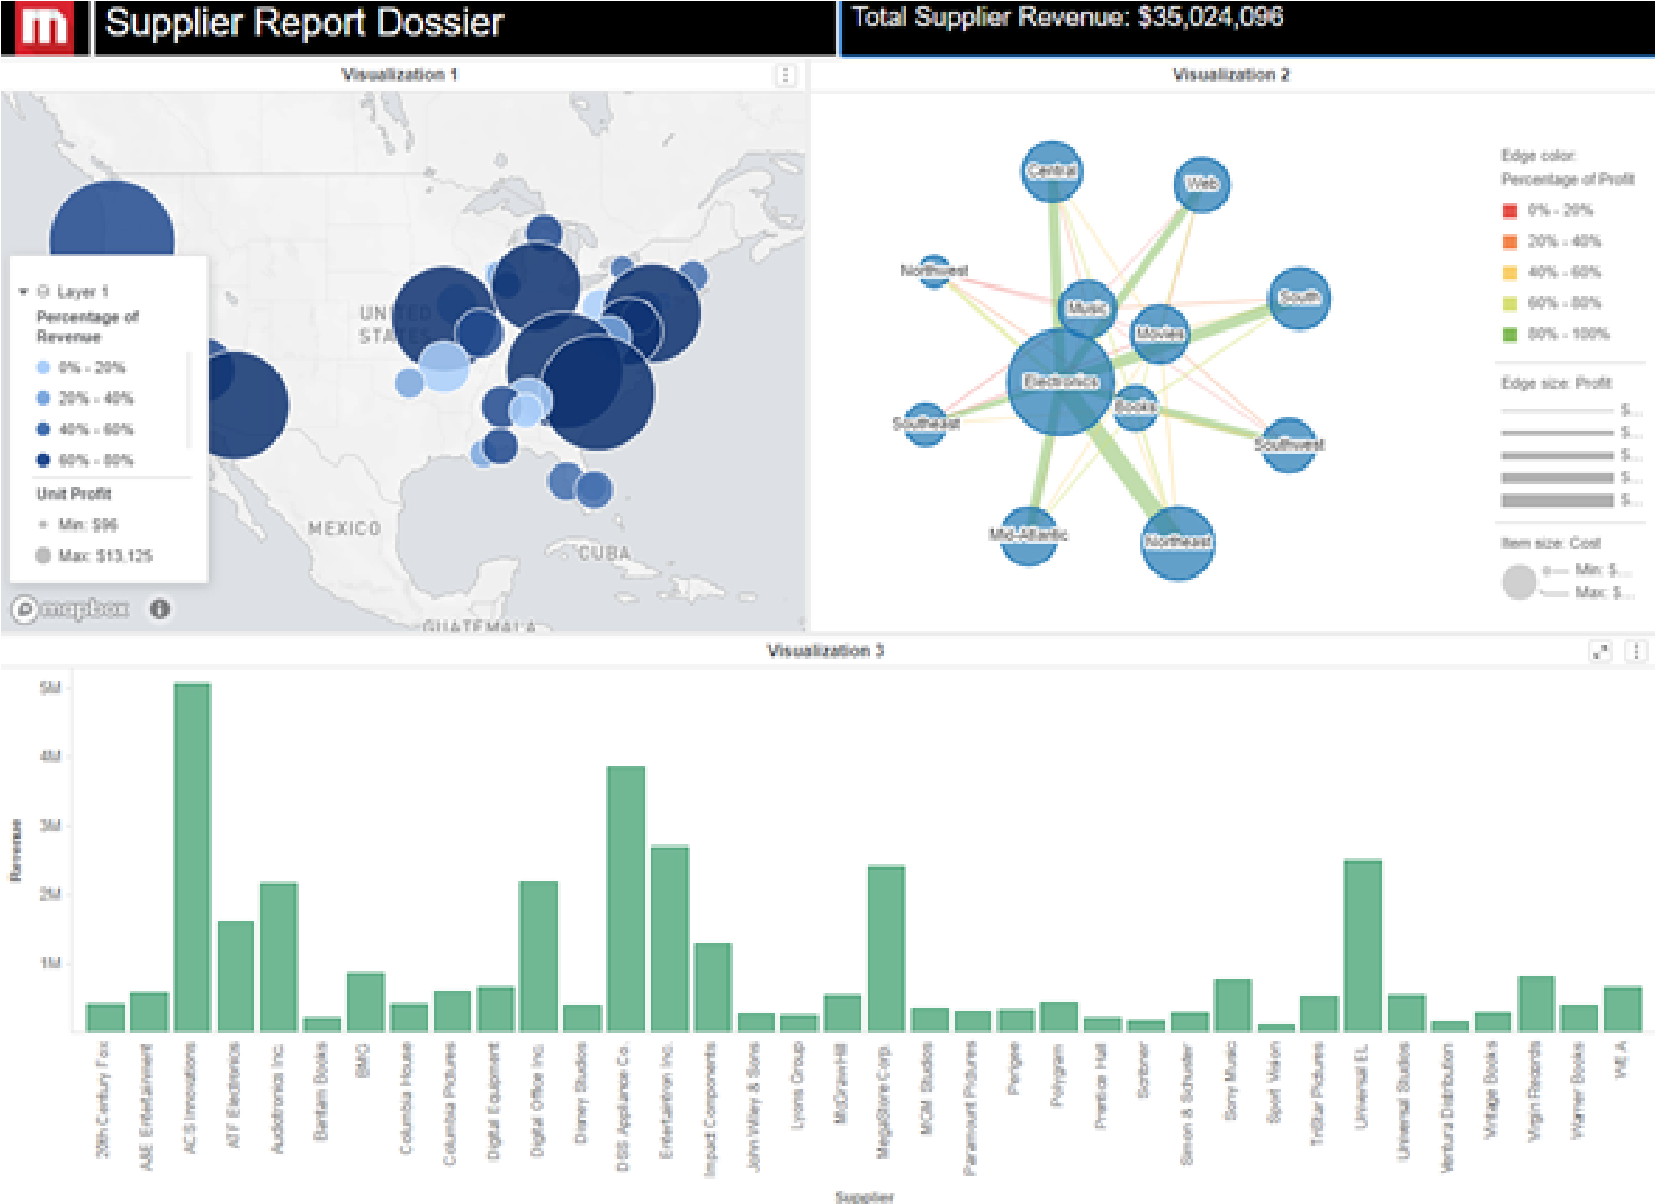

1. Click **Save**.

**Analyze the dossier in Library**

1. Click **Share** from the toolbar and select **Get a link to MicroStrategy Library**.
2. Click **Launch** under the link.
3. If needed, log into Library with your **User Name** and **Password**.
4. Explore the visualizations by doing the following:
   * Hover over a data point to view more details.
   * Use the Filter panel to change the subcategory.
   * Sort a visualization.
   * View drill options for the bar graph.
   * Change the view of the Network visualization.
   * Change the style of the map.

## Workshop 4: Analyze data to determine areas of opportunity

Sydney Electronics is a growing online retailer selling electronics products. The company recently created a blog to engage with customers and increase its online presence. The executives of Sydney Electronics want to analyze both successes and failures of each blog article author. Specifically, they are looking for any areas that need to be improved or adjusted.

To help gauge blog author performance, they want to see the growth in the number of views and the number of different interactions for each author. In this exercise, you will create a dossier that enables the executives to explore the overall and detailed information about each author. We will create derived metrics and apply them to visualizations to determine areas of success and where improvements can be implemented.

**Add a dataset**

1. From the My Reports page, create a new dossier.
2. Click **Add Data** and select **New Data**.
3. Click **File From Disk**.
4. Click **Choose files** and upload the **Article Database.xlsx** file.
5. Click **Prepare Data**. Select both the **Blog Stats** and **Followers** worksheets when prompted, then click **Select**.
6. In the Preview window, there are several columns marked as attributes that need to be converted into metrics. Convert the following columns into metrics by clicking the specific attribute and dragging it into the **Metrics** box:
   * Number of Comments
   * Number of Favorites
   * Number of Shares
   * Shares
   * Favorites
   * Comments

The revised data should look like this in the Preview window:

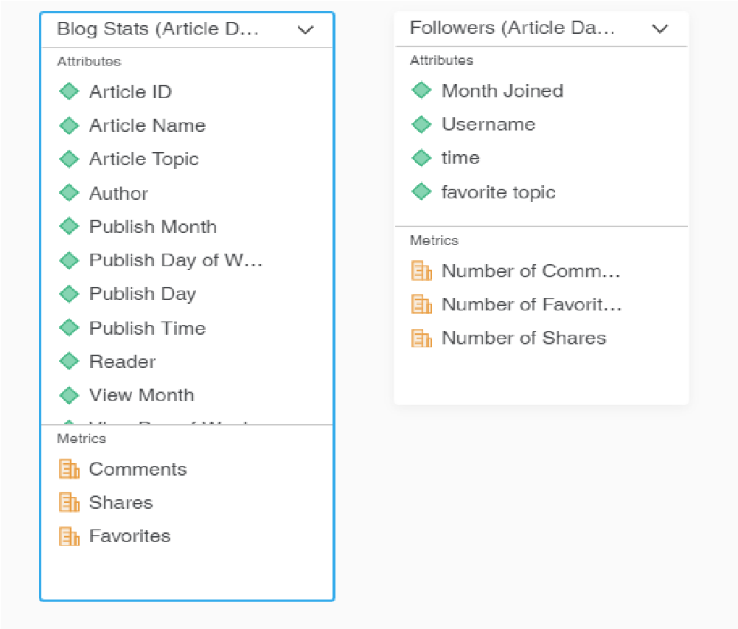

1. Click **Finish** to update the dataset.

**Create a derived metric to add the Number of Views metric**

You would like to show number of views for each article. However that metric is not included in the dataset. To create the Number of Views metric, you can create a derived metric based on a count of the Reader attribute, as each view has a unique reader name in the dataset.

1. In the Datasets panel, right-click the **Reader** attribute and select **Duplicate as Metric.** The new Count (Reader) metric is created and displayed.
2. In the Datasets panel, right-click the **Count (Reader)** metric and select **Edit**. In the **Display Name** box, type **Number of Readers**.

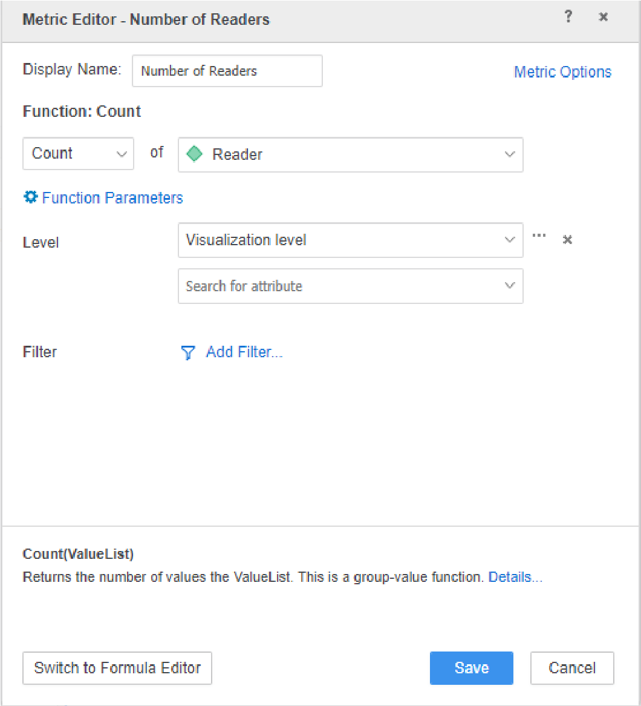

1. Click **Save**.

**Create a Line chart to show readers per month by author**

1. In the Visualization Gallery, click **Line Chart**.
2. In the Dataset panel, drag the **View Month** attribute to the **Horizontal** drop zone to show each view by month.
3. Drag the **Number of Readers** metric to the **Vertical** drop zone. Now, the chart shows number of views per month, but you would like to see views per author.
4. To distinguish each author in the Line chart, drag the **Author** attribute to the **Color By** drop zone.

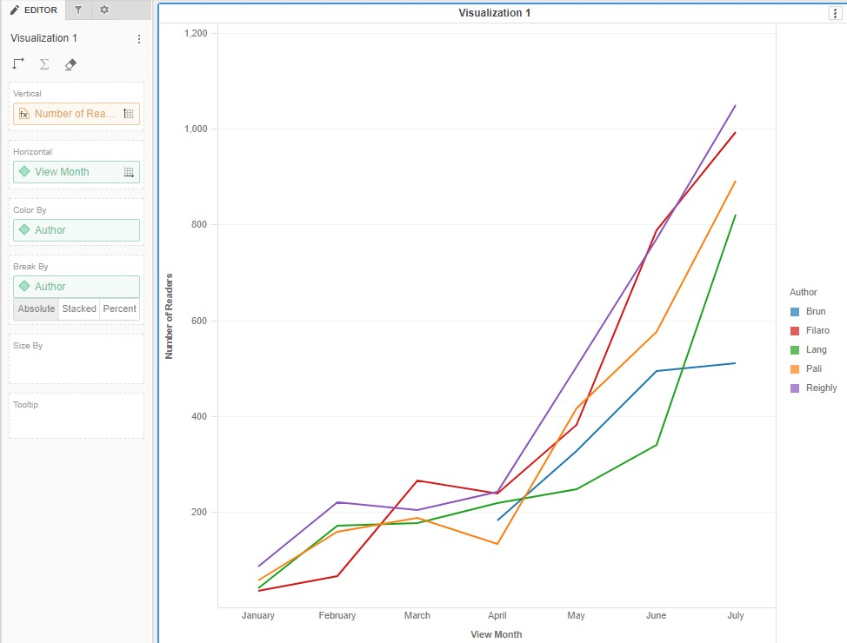

**Add a grid visualization**

1. You would like to add a grid visualization to show key performance indicators, such as shares and favorites, by author. Add a second visualization using the **Insert Visualization** icon on the toolbar.

Make sure that the new visualization is displayed as a grid. If it isn’t, click the Grid icon in the Visualization Gallery.

1. In the new visualization, drag the **Author** attribute to the **Rows** drop zone. Drag the **View Month** attribute to the **Columns** drop zone.
2. Add the **Shares**, **Favorites**, and **Comments** metrics to the **Metrics** drop zone. **4** Click theVisualization 2 container and drag it below the first visualization.

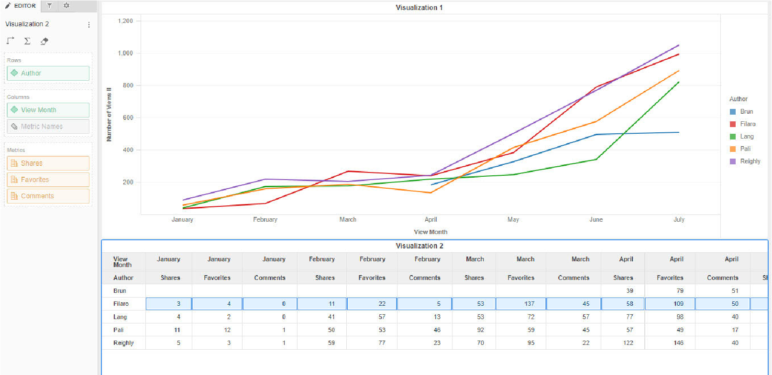

**Use the Line chart to filter the grid visualization by month**

1. You would like to add a filter by month to the grid to analyze each author’s performance by month to view any outliers. To make an interactive filter using the Line chart, in the first visualization click the **Menu** icon, then click **Select Targets**.

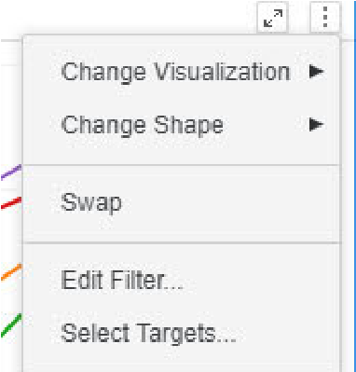

1. Click Visualization 2, then click **Apply**.

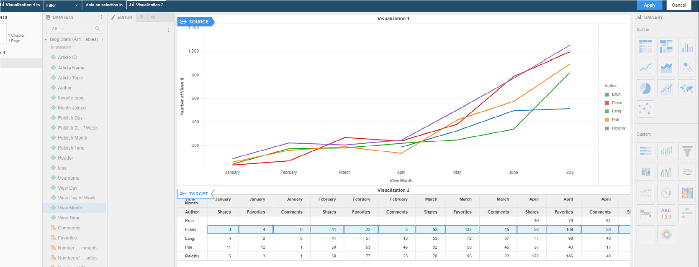

You can now filter the grid in Visualization 2 by selecting a month or months in Visualization 1 using cross-hairs to create a box.

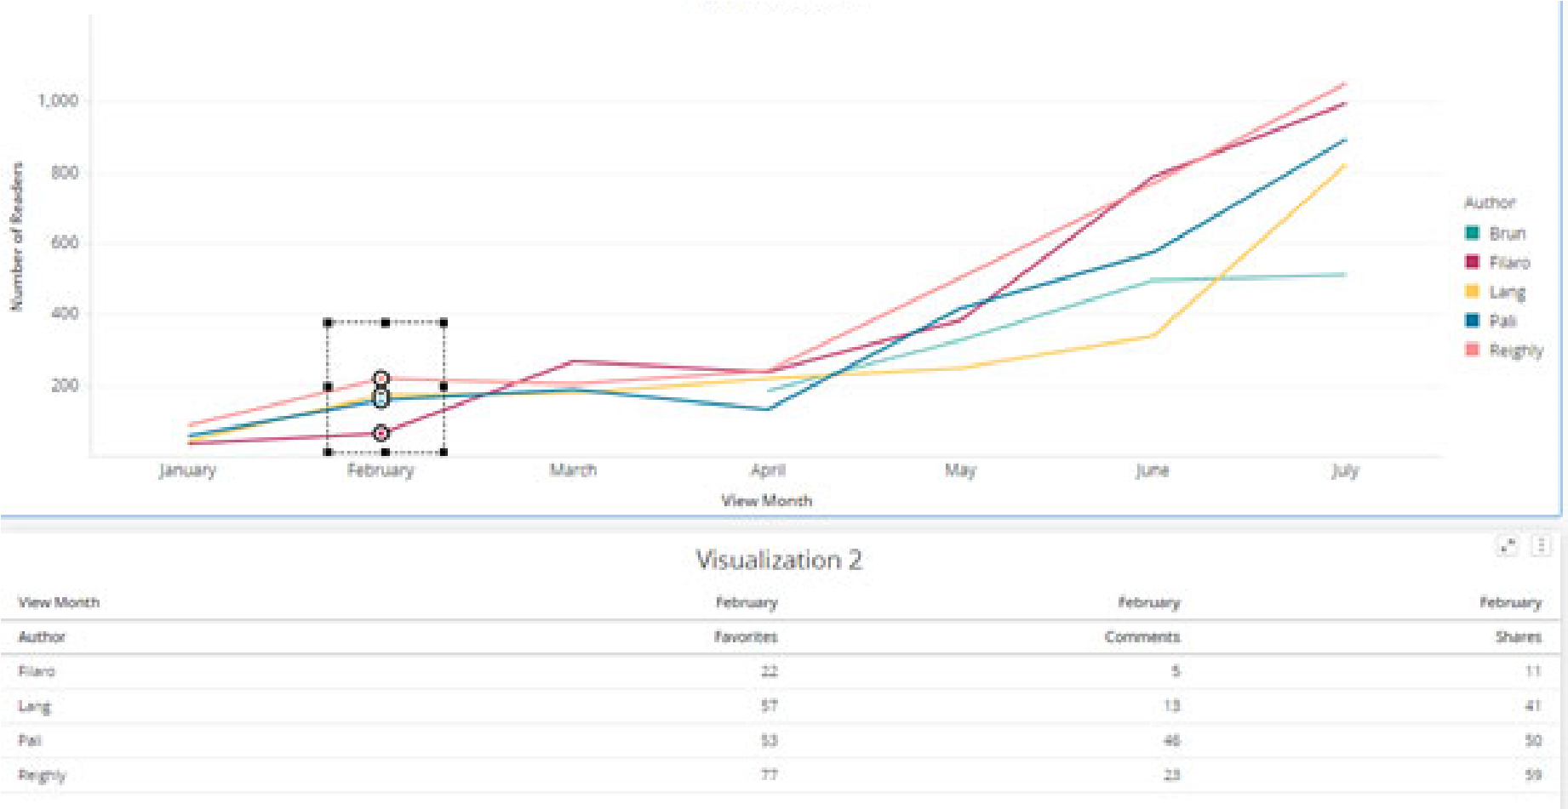

1. Save the dossier as **Article Database Dossier** in the My Dossiers folder.

### Analyze the visualization

* Which author had the most readers in July?
* In June, which author had the highest number of favorites, shares, and comments?
* In April, which authors show a decrease in the number of readers?

**Add a new page and create derived metrics**

1. You would like to further analyze individual author performance by KPI rates. Since this is separate from the actual number of KPIs, you want to create a new page. At the bottom of the dossier window, click the **Add a page** icon in the toolbar.
2. You would like to analyze the rate of comments, favorites, and shares per view. In the Dataset panel, right-click **Comments**, point to **Calculation**,and click **÷**.
3. In the top drop-down list, leave **Comments** selected, and in the bottom drop-down list, select **Number of Readers**. Click **OK.**

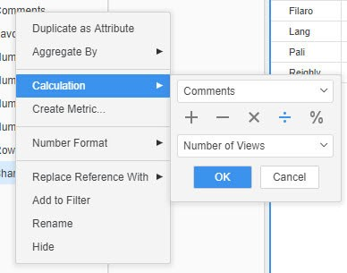

1. A derived metric displays in the Dataset panel. This derived metric is named **(Comments/Number of Readers)**. Give the metric an easily understood name by right-clicking it and selecting **Rename** to rename it as **Comment Rate**.
2. Repeat the appropriate steps above by dividing **Favorites** by **Number of Readers**. Name the new metric as **Favorite Rate.**
3. Repeat the appropriate steps above by dividing **Shares** with **Number of Readers**. Name the new derived metric **Share Rate.**

**Add a bubble chart**

1. Click the **Bubble Chart** icon in the Visualization Gallery.
2. In the Dataset panel, drag the **Author** attribute to the **Vertical** drop zone.
3. Drag the **Comment Rate** metric to the **Horizontal** drop zone. The further right the bubbles are located, the higher the comment rate.
4. Drag the **Share Rate** metric to the **Color By** drop zone. The darker the bubble, the higher the share rate of the author’s post.
5. Drag the **Favorite Rate** metric to the **Size By** drop zone. The larger the bubble, the higher the favorite rate.
6. A single color scheme for the bubbles does not allow for quick analysis. To make the color scheme more visually representative of the data, right-click the **Share Rate** metric in the **Color By** drop zone. Select **Thresholds**.
7. Select **Traffic Lights** for a color scheme, as it displays a higher degree of contrast. In the **Based on** drop-down list, select **Value** and click **OK**.
8. To further distinguish the bubbles to help with visual analysis, you can change the minimum and maximum size of the bubbles. In the Editor panel, click the **Format** tab.
9. In the top drop-down box, select **Data Exploration**.
10. In the **Max size** drop-down list, select **Manual**.
    * In the box, type **1**.
11. From the **Min size** drop-down list, select **Adjusted Range**.
    * Type **.5** in the box.

The Format tab in the Editor panel should look like the image below:

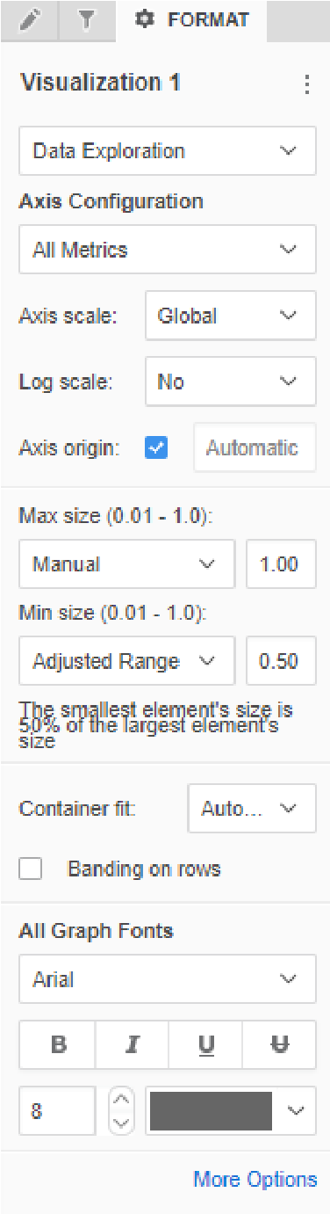

The dossier should now look like this:

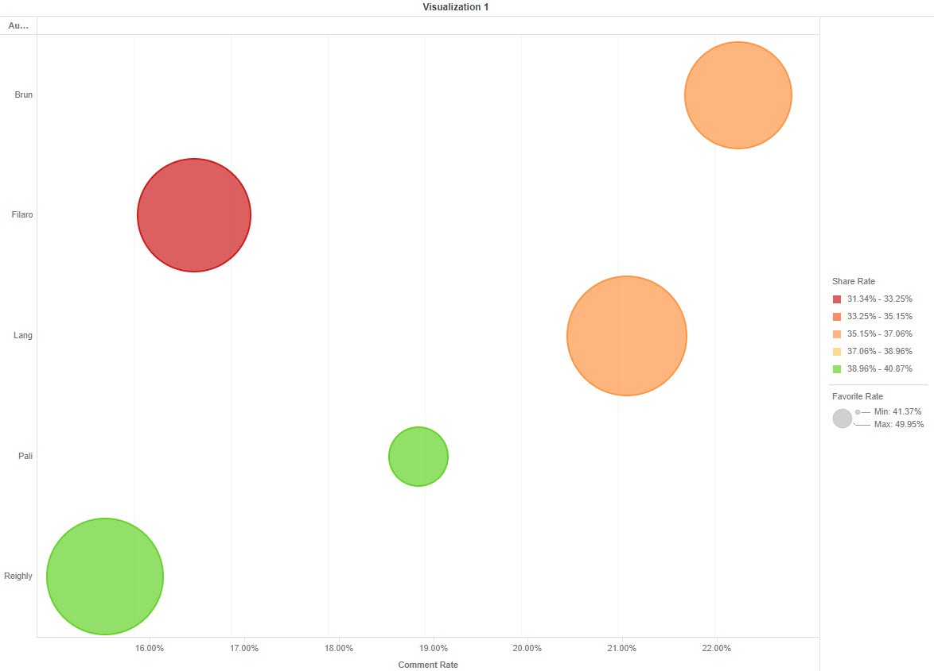

### Analyze the visualization

Based on this dossier, answer the following questions:

* Which author has the lowest comment rate?
* Which authors have the best share rate?
* Which author has the highest favorite rate?

**Drill down from author**

Filaro has the lowest share rate, so you would like to further analyze his performance by article topic.

**1** Right-click the circle for **Filaro,** point to **Drill**, and select **Article Topic**.

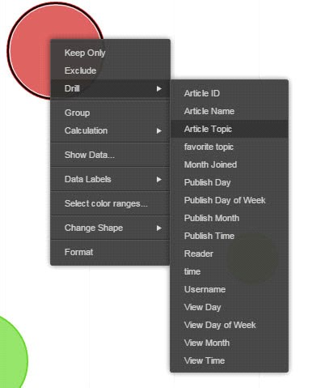

The resulting bubble visualization displays Filaro’s article topics.

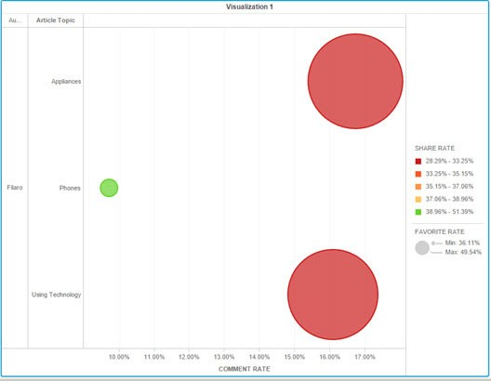

### Analyze the visualization

Answer the following questions based on this visualization:

* Which topic had the highest comment rate?
* Which topic had the highest share rate?
* Which topic had the lowest share rate?
* Which topic was the least favorite?



**4**

**A**

**NALYZE**

**D**

**ATA**

**AND**

**C**

**OLLABORATE**

**WITH**

**M**

**ICRO**

**S**

**TRATEGY**

**L**

**IBRARY**

# Share and collaborate: MicroStrategy Library

You can access all your dossiers in a single location from a personalized virtual bookshelf called MicroStrategy Library. Library combines powerful search functionality, real-time collaboration, and a simplified design to make accessing and sharing analytics fast and easy.

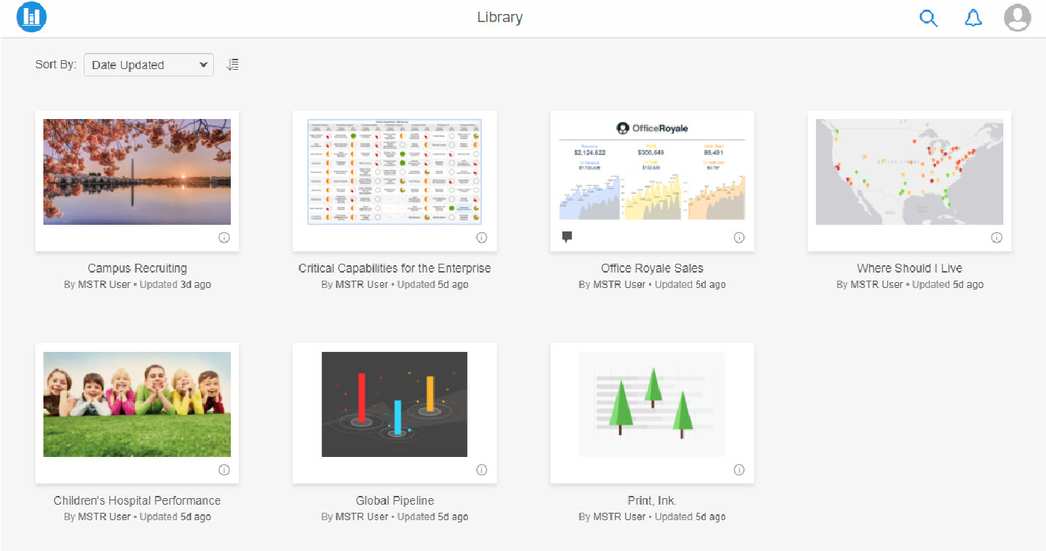

Share and collaborate: MicroStrategy Library

Each dossier in the library is represented by a customized thumbnail image, making it easy to visually identify content. Powerful search options are available to find content quickly. Notifications and comments marked with the user will show up clearly as an alert, so you won’t miss an update.

To launch your Library, simply click **MicroStrategy Library** on the toolbar in MicroStrategy Web.

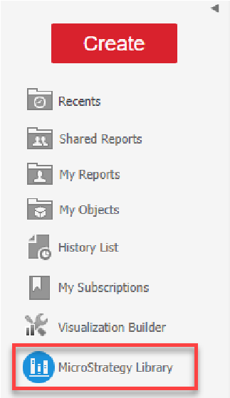

You can access your Library even when you are away from the office, using Library Mobile. Regardless of what mobile device a user is on, the MicroStrategy Library is responsive and will automatically resize as needed.

For more detailed information on Dossier Mobile, take *11.121 Overview of Enterprise Mobility*.

Share and collaborate: MicroStrategy Library

# Exercise 4.1: Add a cover image

MicroStrategy Library organizes dossiers by displaying them as thumbnails on the main home page to browse through and find content. When selecting a thumbnail, choose from MicroStrategy stock images, add a web URL, or your own custom images.

To quickly identify the Supplier dossier in your Library, we will add a cover page thumbnail in this exercise.

**Add a cover image**

1. Open the **Supplier Dossier**.
2. From the Table of Contents panel, click **Change Cover**.

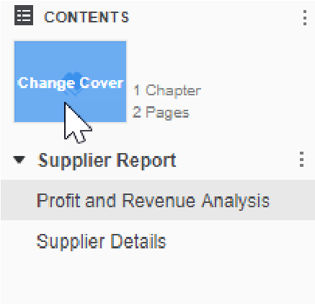

1. Click the **Bar Chart** icon, then click **Save** to apply the new cover image.

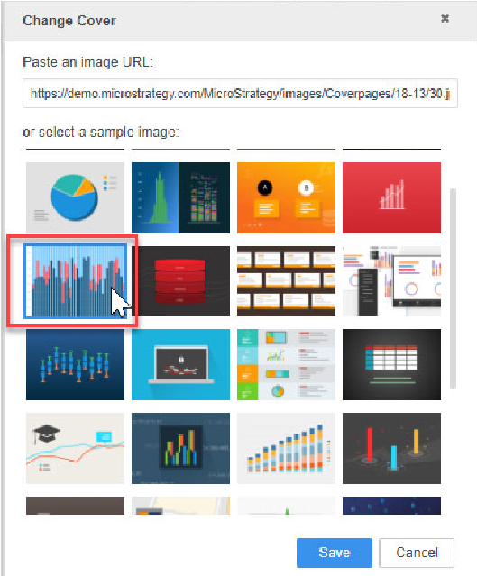

1. **Save** the dossier.

Exercise 4.1: Add a cover image

# Verify and validate: Certified dossiers

When making business decisions based on data, data governance, the overall management and integrity of data across the enterprise, is a critical asset. To ensure accuracy within MicroStrategy Library, analysts and data stewards can watermark content with a certified stamp. Certification offers an easy way to implement governance across a self-service deployment and makes it clear for business users which content is tied to trusted data sources.

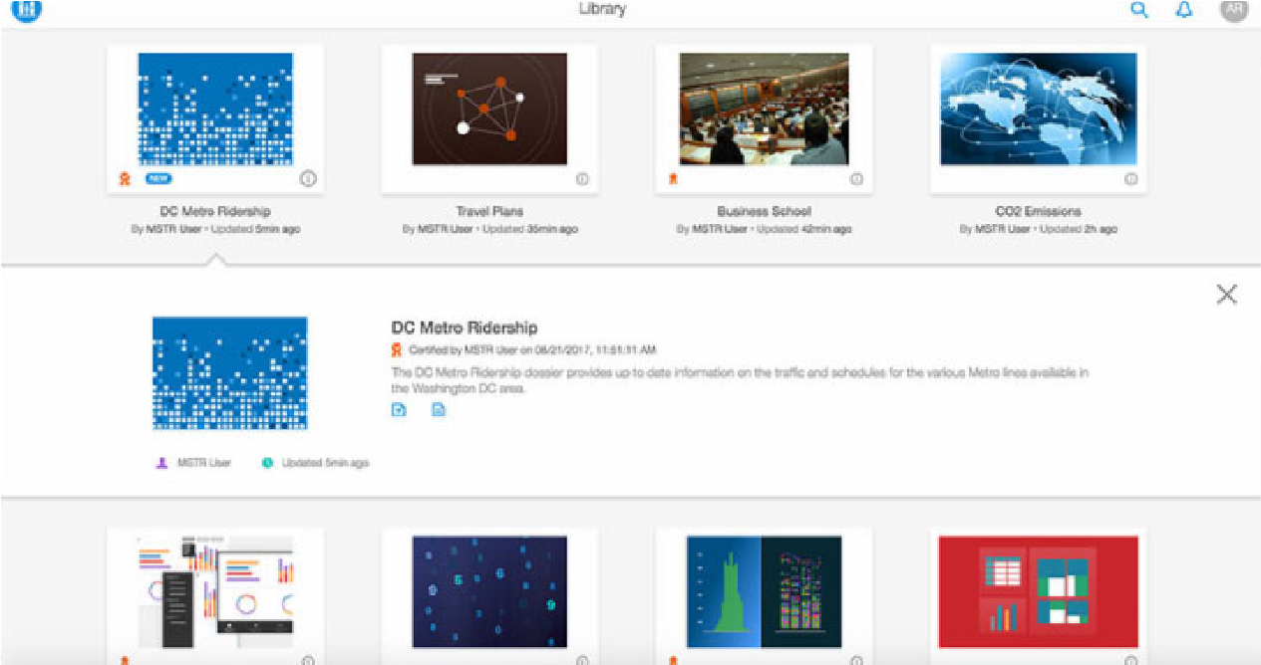

To certify a dossier in MicroStrategy Web, a user with the appropriate permissions can right-click the dossier icon, click **Properties**, and select **Certified**. When the dossier appears in Library, it will show the certified stamp and the name of the user who certified the dossier.

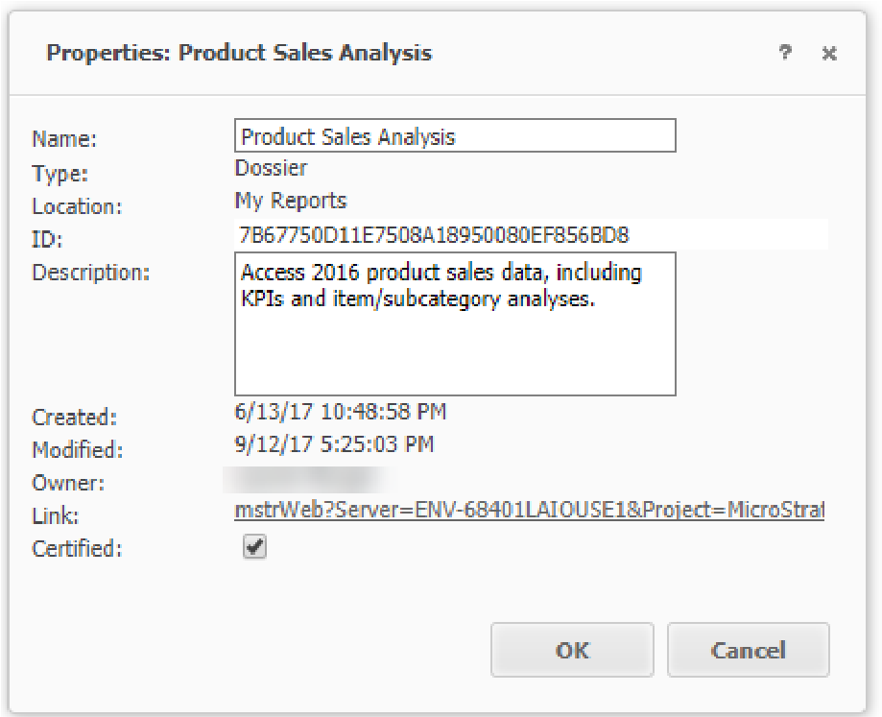

Verify and validate: Certified dossiers

# Personalize and manage your Library

As you add more dossiers and other MicroStrategy objects to your Library, you'll want to manage and personalize your virtual bookshelf. To make your Library easy to navigate, you can sort your dossiers by name, date added, date updated, or date viewed. Additionally, you can rename or delete dossiers in your Library. These options are available when you click the user ID icon (for this class, the user ID is MU) and select **Manage My Library**.

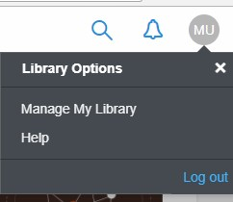

To help find the data you need, use Library’s powerful search options. Use key words to find dossiers, metrics, attributes, and other MicroStrategy objects in your Library.

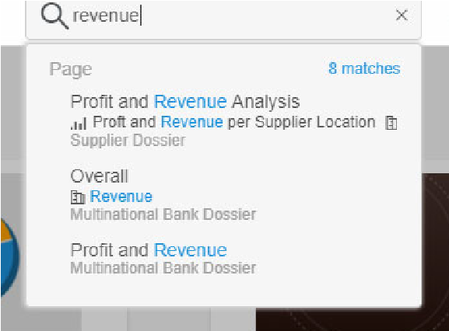

Additionally, each dossier thumbnail also indicates the owner name, time of last update, and number of comments made on that dossier. Click the **Information**

Personalize and manage your Library

 icon on the dossier thumbnail to find details and export the dossier as either a PDF or .MSTR file.

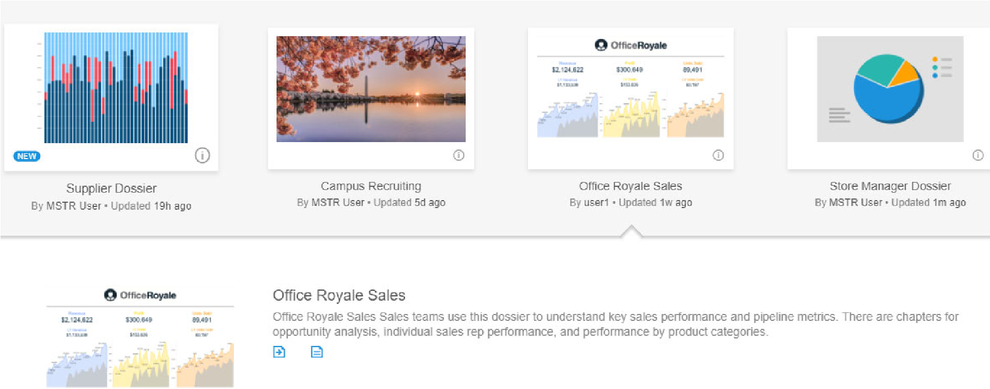

# Collaborate and communicate with MicroStrategy Library

Now that you've created your dossier, you will want to share your findings with colleagues and clients. Through MicroStrategy Library, you can collaborate via page-specific discussion threads and real-time comments within dossier pages. Anyone who has access to a dossier through MicroStrategy Library can ask questions, highlight trends, and share their current filter state with others. Once you tag users in comments or invite them to view a dossier, they can receive real-time notifications via email, browser banners, page and library alerts, or push notifications.

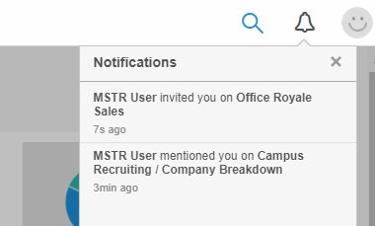

With Library comments, you and your team can:

* Gain new insight on your analytics through reading other users’ thoughts and conclusions.
* Share findings with your colleagues in real time, not in another email thread.
* Add comments to specific users by tagging them with @user_name.
* Reach out to subject matter experts and have a real-time conversation alongside your data visualizations.
* Share a link to your view of a dossier, such as your current filter settings, to provide additional context by using @filter in your comment. You can reset any filters you’ve added by clicking the **Reset** icon on the toolbar.

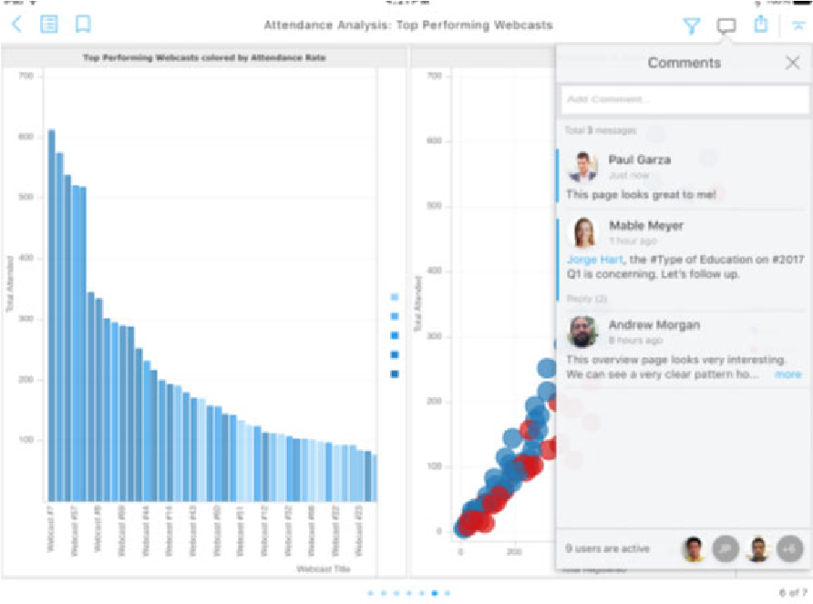

Collaborate and communicate with MicroStrategy Library

## Activity: Explore collaboration in Library

In this activity, we will explore collaboration methods with the Campus Recruiting dossier.

**Upload and add the dossier to your Library**

1. From the **My Reports** page in MicroStrategy Web, click **Create**, then select **Upload MicroStrategy File**.
2. Navigate to your Jump Start Exercises folder, then double-click the **Campus Recruiting.mstr** file.
3. In the Upload window, click **View Dossier**.
4. From the toolbar, click **Share**, then select **Get a link to MicroStrategy Library**.
5. Under the link, click **Launch**.

You will arrive on the About MicroStrategy page.

1. Click **Add to Library** to add the Campus Recruiting dossier to your Library.

**Explore and collaborate the Campus Recruiting dossier**

**1** While you explore the Campus Recruiting dossier pages and chapters, use collaboration methods to do the following:

1. Ask a question to the dossier author by tagging **@mstr_user**.
2. In the **DC Living - Restaurants** page, click the **Filter**  icon to narrow the data on the page based on restaurant category and price range.
3. Add a comment with your restaurant choices by using **@filter** to save your page view. Then, use the **Revert**  icon to return to the unfiltered state. Use the Table of Contents to go back to the **DC Living**

**- Restaurants** page. Click the **Filter** icon on your comment to view your restaurant picks.

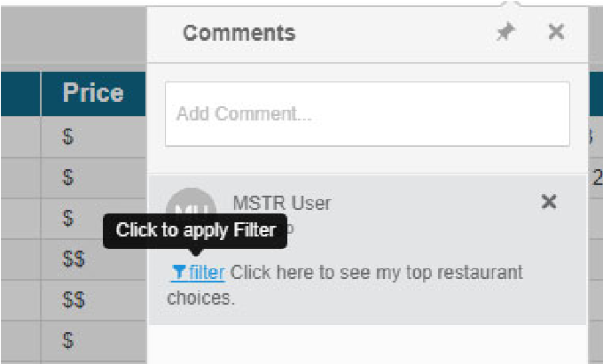

1. You’re interested in monitoring Computer Science majors in the 2017 Campus Hire Overview page. To save this as a personal view in your dossier, add a bookmark. Bookmarks allow you to quickly return to a specific view when reopening a dossier, bypassing the need to navigate to a specific page and apply the filter you need. Unlike comments, other users will not be able to see bookmarks you add.
   1. Use the **Table of Contents** to navigate to the **2017 Campus Hire Overview** page.
   2. Click the **Filter** icon and select **Major**. Hover over Computer Science and select **Only**, then click **Apply**.
   3. Click the **Bookmarks**

icon, then select

**Add new**

. Type

**Computer**

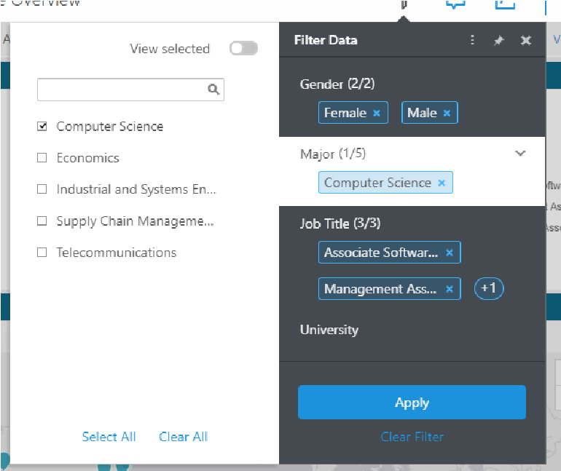

**Science Majors** and press Enter.

The page and filter state are now saved as a bookmark. When you navigate away from the 2017 Campus Hire Overview page or change a filter, click

Collaborate and communicate with MicroStrategy Library

the bookmark and the dossier will navigate to the page with any saved filters.

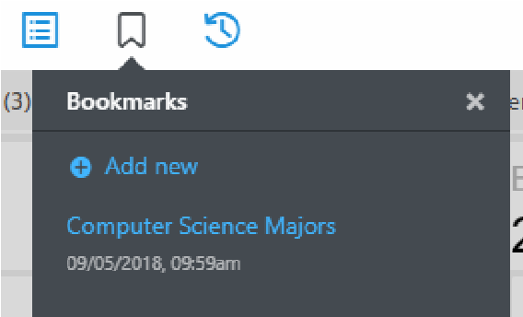

1. Use the **Table of Contents** to navigate throughout the rest of the dossier. Be sure to view the different visualizations, filters, and design techniques in the dossier.

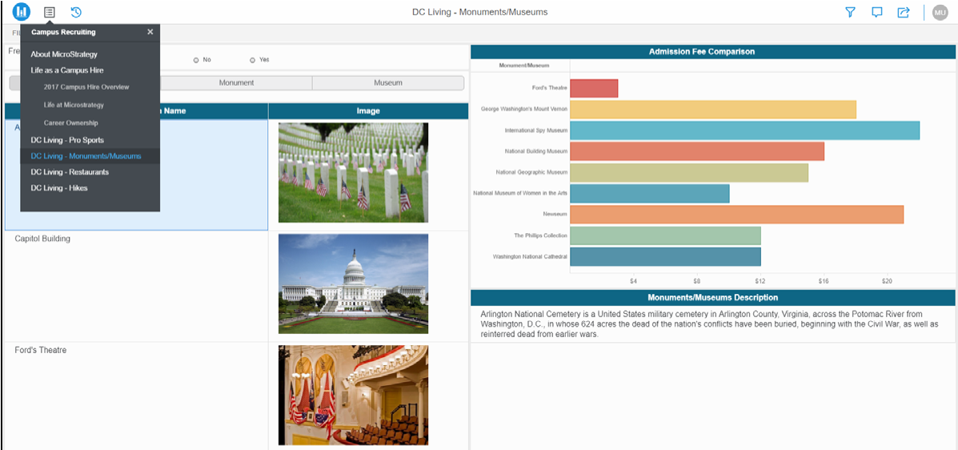

* 1. Throughout the dossier, which visualizations did the author use?

Which filter types are employed?

# Activity: Elevate your dossier analysis using HyperIntelligence

In this activity, you are a soccer analyst for an online sportsbook company. You created a dossier that tracks upcoming matches and KPIs for the European football leagues. While reviewing the dossier in Library, you want to be able to analyze team statistics while viewing upcoming matches.

## Explore zero-click analysis with HyperIntelligence in Chrome

To help you view team KPIs and match schedules simultaneously, the Application Architect and her team created a HyperIntelligence plug-in using the soccer data your company has access to. The plug-in displays shooting, passing, and tackling statistics when you hover over a team name in your Chrome browser. This allows all users within the company to access Business Intelligence and make data-driven decisions.



**Add the HyperIntelligence plug-in to your Chrome browser**

1. Navigate to **https://chrome.google.com/webstore/category/extensions** in Google Chrome.

Activity: Elevate your dossier analysis using HyperIntelligence

1. Search for **MicroStrategy** in the search bar and press **Enter**.

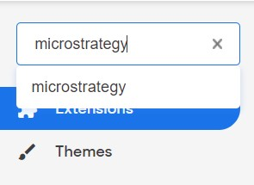

1. Click **Add to Chrome** on the MicroStrategy HyperIntelligence extension. In the pop-up, click **Add extension**.



You are notified that HyperIntelligence has been added to your chrome browser and the MicroStrategy logo is shown on your toolbar.

1. Click the **MicroStrategy logo**  on the toolbar and enter **https:// demo.microstrategy.com/MicroStrategyLibrary/api** for the environment URL. This connects your plug-in to your MicroStrategy Cloud environment.

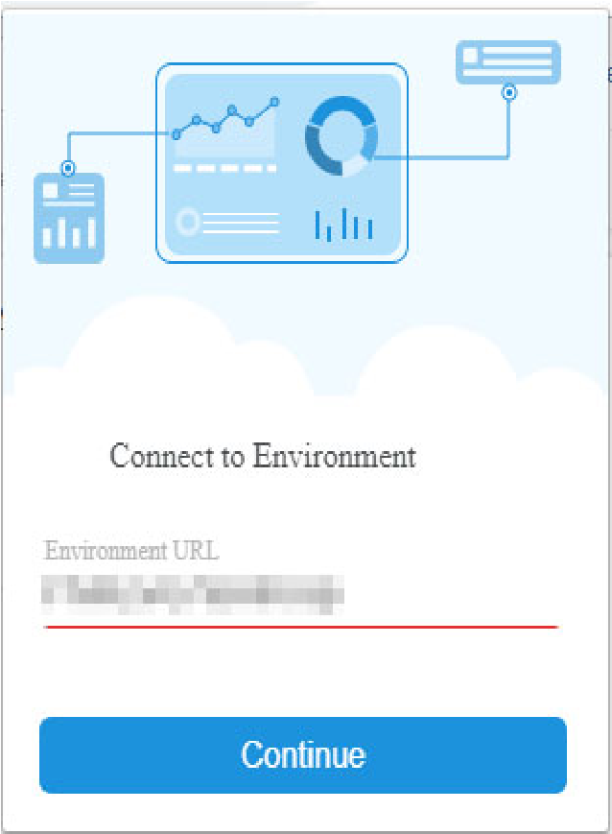

Activity: Elevate your dossier analysis using HyperIntelligence

1. Click the **MicroStrategy logo** in the corner of your browser. Toggle on the **Football Team** card.

*Notice the Certified badge next to each card. Cards, like dossiers, are certified to help maintain a single version of truth and adhere to your Intelligence Enterprise’s data governance policies. Certifying a card also allows it to be distributed to other users.*

1. In an online search engine, search for **Leicester City**. Hover your cursor over **Leicester City** to see team KPIs.

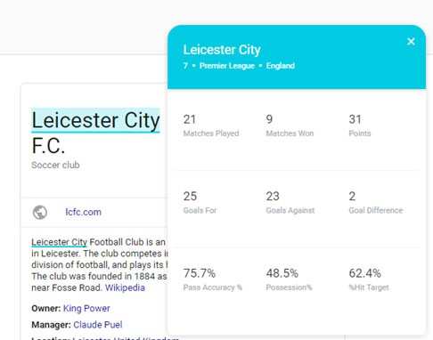

**Access the European Football League dossier**

1. [In your Chrome browser, navigate to](https://env-91341.customer.cloud.microstrategy.com/MicroStrategyLibrary2/app/2BC4445811E81DF3A7450080EFB507B0/CB3E30FE11E89A3D81F40080EFE50A77/W670--K46) **https:// env-124849.customer.cloud.microstrategy.com/MicroStrategyLibrary/**

**app/2BC4445811E81DF3A7450080EFB507B0/**

**CB3E30FE11E89A3D81F40080EFE50A77/W670--K46**.

1. On the MicroStrategy Library login page, click the **Guest** icon .
2. Click the **Table of Contents** and ensure you are on the **Schedule** page which displays upcoming matches. Hover over any of the club names to view team

Activity: Elevate your dossier analysis using HyperIntelligence

KPIs. The HyperIntelligence plug-in and the dossier are both powered by the same MicroStrategy data.

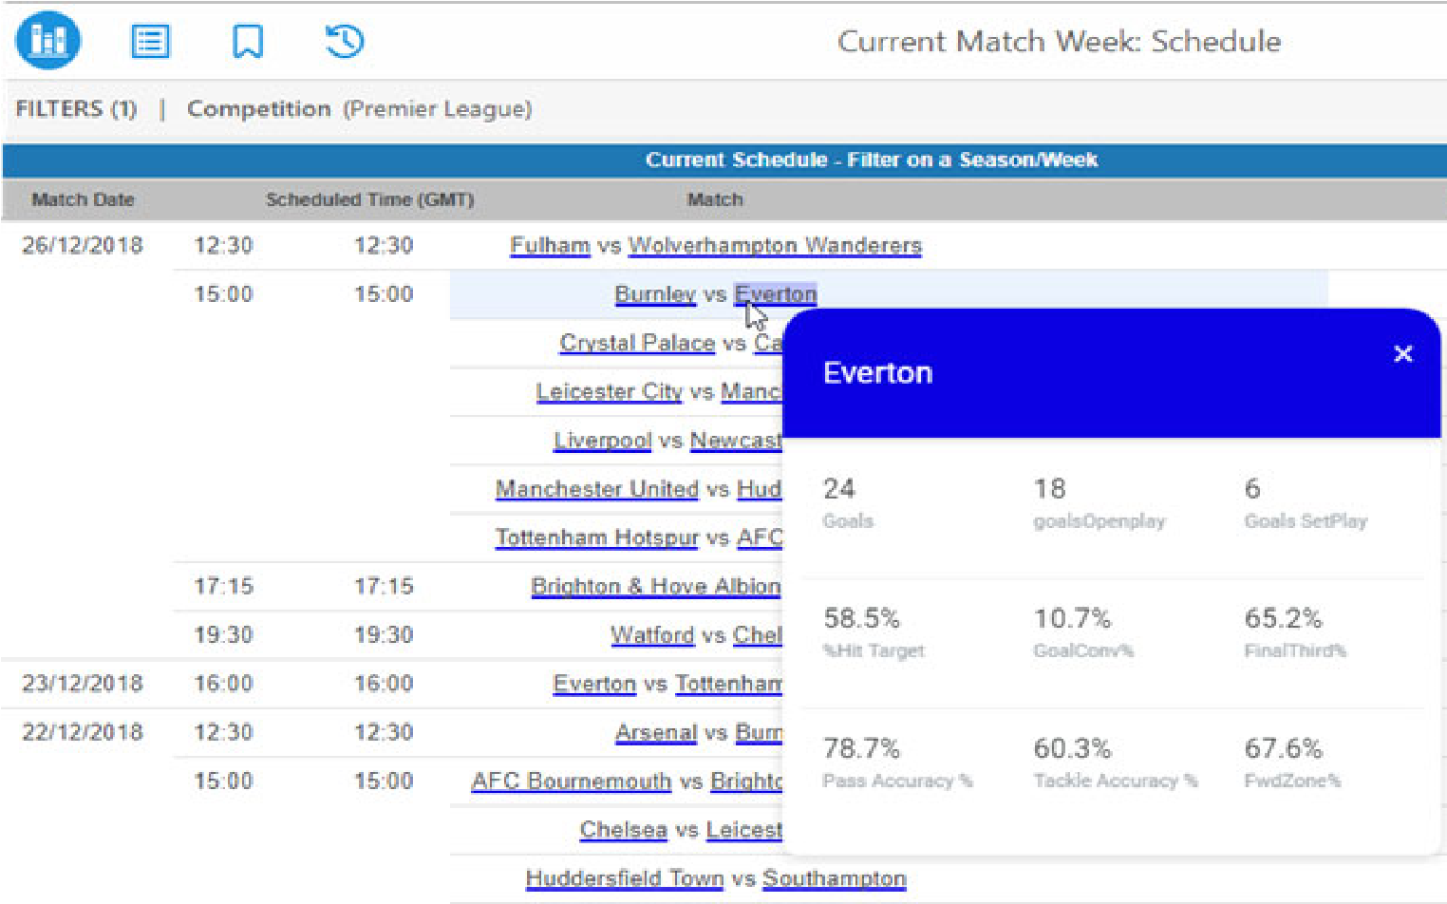

1. Use the Table of Contents to explore the dossier. Which team would you place your bets on this week?

# Data on the go: MicroStrategy mobile

Now that you have viewed dossiers and HyperIntelligence in Chrome, you will explore the Mobile capabilities. In today’s fast-paced world, your employees and clients need to be able to view and analyze their business data on-the-go. With MicroStrategy Library and MicroStrategy HyperMobile you are able to access your business data from anywhere.

Data on the go: MicroStrategy mobile

# The Library app: Seamless dossier mobile deployment

In addition to creating apps with documents, you can also interact with your dossiers on-the-go with the Library App. Download the Library app, log-in with your credentials, and view all your dossiers in one place.

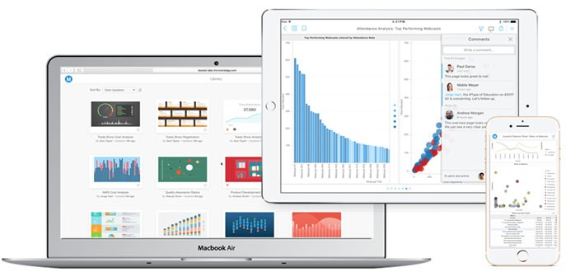

The Library App was created with user experience in mind. The app includes native design for iOS and Android, responsive design regardless of the device you interact with your dossiers on, and a touch-optimized interface.

## Mobile preview in MicroStrategy Web

To ensure your dossier pages’ content is optimized for mobile use, when designing your dossier in Web, you can preview each page in Responsive Preview. Use the Responsive Preview mode to see if any changes need to be made before you deploy your dossier to Library Mobile. For example, you can group visualizations related together so users can see contextual data all in one screen in portrait view.

# Mobile Library: Your virtual dossier bookshelf

The MicroStrategy Library App provides a simple visual library where you can find the dossier content you and your colleagues need. From tagging users in

The Library app: Seamless dossier mobile deployment

comments to a fast and efficient search bar, the Library App makes sharing and collaborating on dossiers simple.

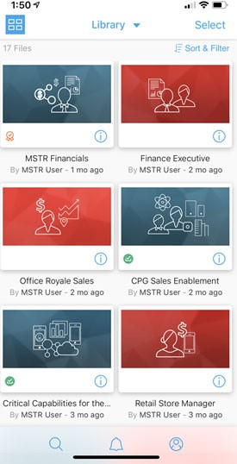

On the app home page, tap the **Information** icon to view details on the dossier, such as the author, and download either a PDF or .mstr file of the dossier. You can also view notifications by tapping the **Notification** panel to see comments other users tagged you in, or new dossiers a user invited you to view.

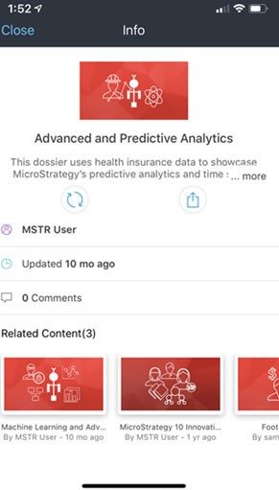

In your mobile Library, when interacting with a dossier you can collaborate via page-specific discussion threads and real-time comments within dossier pages. Anyone who has access to a dossier through MicroStrategy Library, either in Web or on a mobile device, can post comments to tag users, ask questions, and share their current filter state with others. Once you tag users in comments or invite them to view a dossier, they can receive real-time notifications via email, page and library alerts, or push notifications.

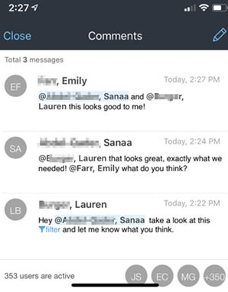

## Activity: Download and explore the Library App

**Download the Library App**

1. From the Apple App Store (iOS) or Google Play (Android), search for and download the MicroStrategy Library app on your mobile device.
2. Once the app downloads on your mobile device, tap the **Library** icon to open the app.



1. To configure the Library Mobile to your Library, on your web browser, click **MicroStrategy Library** from the Shared Reports home page.
2. Copy and paste the **Library URL** into an email. Send the email to an address that is accessible on your mobile device.
3. Open the email on your device, then tap the **Library URL**
4. Once the page opens, tap **Open in App**, then tap **Open**. The Library Mobile app opens to the log in page.
5. Login using your credentials provided at the beginning of class and tap **Log**

**In**.

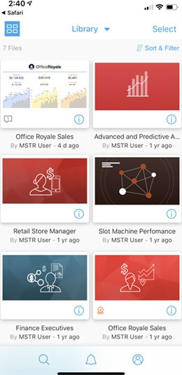

You arrive on your Library App home page containing your dossiers.

**Interact with the Investment Firm dossier in Library Mobile**

1. On your mobile device, tap the **thumbnail image** representing the Investment Firm dossier to open it.
2. Tap the **Table of Contents**, and select the **Trends** page. Switch the view from landscape to portrait mode (or vice versa). Notice the visualizations remain grouped as seen in Responsive View mode.

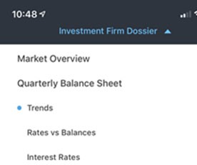

1. You would like to sort the area chart in descending order to easily view the quarter with the highest balance. First, tap **Avg Balance** on the y axis.
2. The Sort window opens. Tap the **Descending** icon.

The areas now display in descending order. You can display the data in ascending order by long-swiping a second time, or return the data to its original display with a third long-swipe.

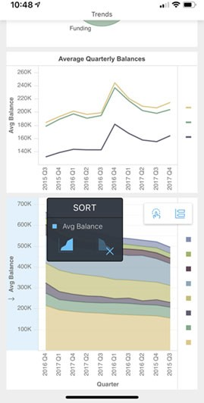

1. Tap the **Table of Contents** and navigate to the **Rates vs Balances** page, or swipe left.
2. You would like to see data for only 2017. As the dossier author, you added a year filter. Tap the **Filter** icon  to narrow the chapter’s data.
3. Tap **Year (0/3)**, then select **2017**.
4. Tap **Apply**. The chapter is now filtered for 2017.
5. You’d like to show your colleague 2017 data in the dossier as he is interested in doing an end-of-year analysis for 2017. With Library, you can tag users and add filter states to comments. Tap the **Comment** icon  to add a comment.
6. Tap the **Write a comment pencil** icon  and type: **@MSTR User, look at the @(Filter)**. Within the parenthesis, delete **Filter** and type **2017 data**. Tap **Post** to leave your comment. When you type @user, you will tag the user in your comment, prompting notifications to that user. When you type @filter, the comment will save your current filtered view of the dossier chapter.

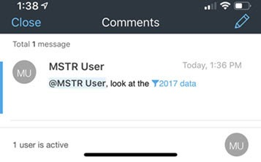

1. To interact with the filter in your comment, first clear the current filter. Close the Comments window, then tap the **Filter** icon  and tap **Clear Filter**.
2. Tap the **Comment** icon, then tap **2017 data**. The chapter filters to only show 2017.

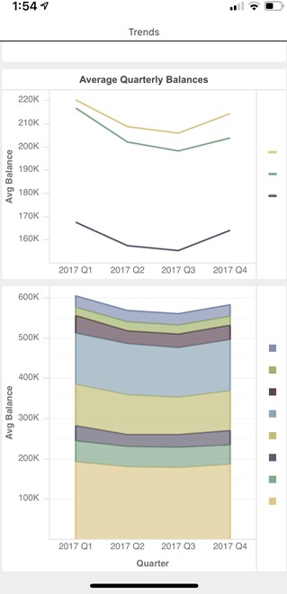

1. Explore the rest of the dossier, interact with filters, and write comments to your colleagues across the pages. To reset the dossier without any filters or changes you made while exploring the app, tap the **Reset** icon .

## Explore zero-click analysis with HyperMobile

In this exercise, you have an off-site meeting with your manager to discuss draft pricing for fantasy soccer players. To justify pricing, you will use HyperMobile to quickly pull up player statistics on your phone.

**Download the HyperMobile App**

1. From the Apple App Store (iOS), search for and download the MicroStrategy HyperIntelligence app on your mobile device.
2. Once the app downloads on your mobile device, tap the **HyperMobile** icon to open the app.



The app is configured to the same demo environment as the Chrome plug-in, so you do not need to log in for this exercise.

1. On the home screen, tap **Cards**  to select the cards you would like to view.
2. Toggle on the **Football Player** and **Football Team** cards, then navigate back to **Home**.

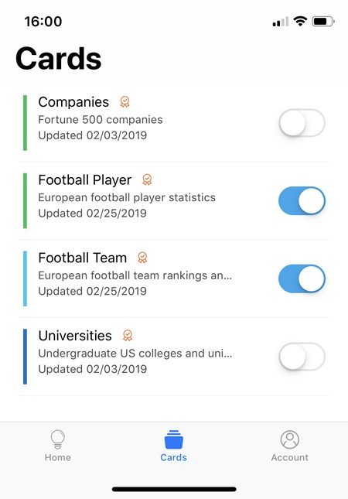

1. Your manager wants to know why you placed Shane Long in the lowest pricing tier. In the search bar, type **Shane**.

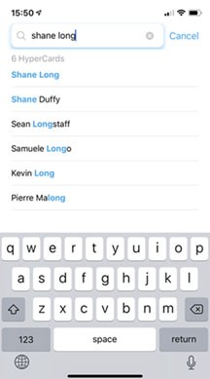

1. Tap **Shane Long** to open his card.

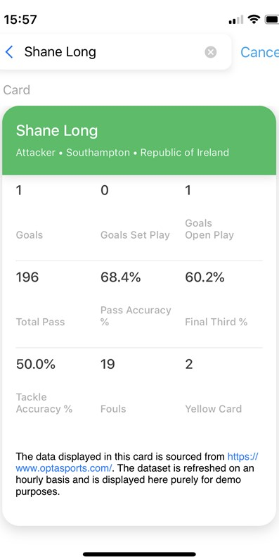

**Use Spotlight to search for cards**

1. Alternatively, you can use Spotlight to search for cards. To access Spotlight, swipe down from the middle of the Home screen.
2. Tap the **Search** field, then type **Shane Long**.
3. Tap **Search** in the app, then tap the **Shane Long** card search result to open the card.





**5**

**U**

**NIFIED**

**A**

**UTHORING**

**AND**

**A**

**DMINISTRATION**

**:**

**W**

**ORKSTATION**

**Managing the Enterprise Platform:**

# MicroStrategy Workstation

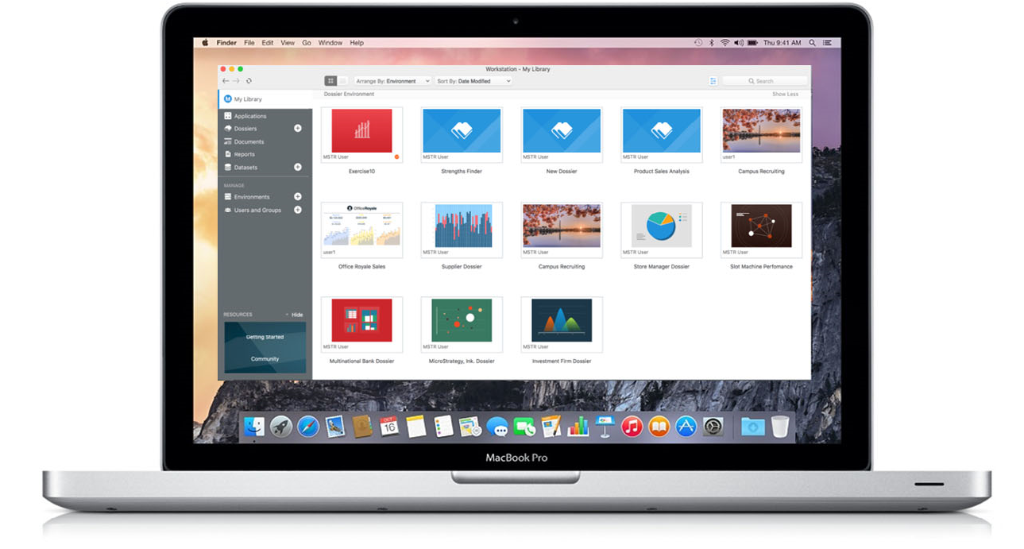

Many business roles today are fast-paced and dynamic, with employees rarely working on the same project every day. A banking business analyst may need to analyze data, share compelling information and solutions, and implement new procedures or trainings for multiple bank sites. With that in mind, MicroStrategy Workstation provides you the tools to accomplish multiple goals to manage the Enterprise Platform.

Workstation is a unified tool that combines the power of MicroStrategy Library, environment management, user administration, and content authoring into a single user experience. Use Workstation to generate insights off-line or when connected to the server. You can access dossiers, reports, Library, documents, datasets, and user management in Workstation. If you need assistance or have questions, you can access Workstation tutorials and MicroStrategy Community right from Workstation.

## Resources at your fingertips

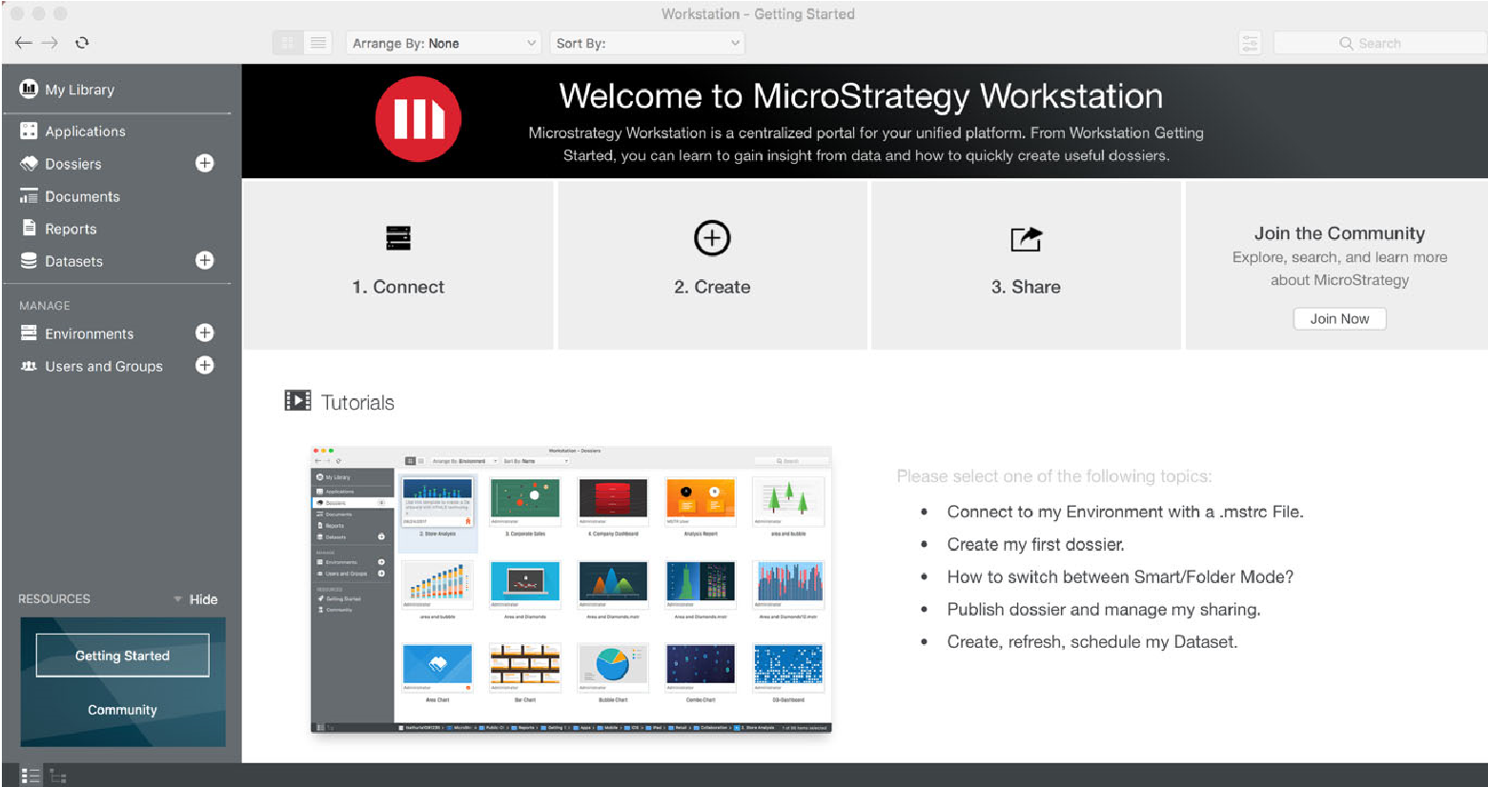

To get started, you can access live resources directly in Workstation. Select **Getting Started** under Resources to watch video tutorials, such as how to connect to an environment, how to build a dossier, and how to refresh a dataset. You can also view sample dossiers to provide you ideas to help you create your best-in-class dossier.

Have more questions or want to learn more about MicroStrategy from product experts and other MicroStrategy users? Select **Community** under Resources to access the MicroStrategy Community forum. Leverage the MicroStrategy community to ask questions, download visualizations, and add your ideas. For example, type **dossier** into **Search** to view articles, ideas, and discussions on dossiers.

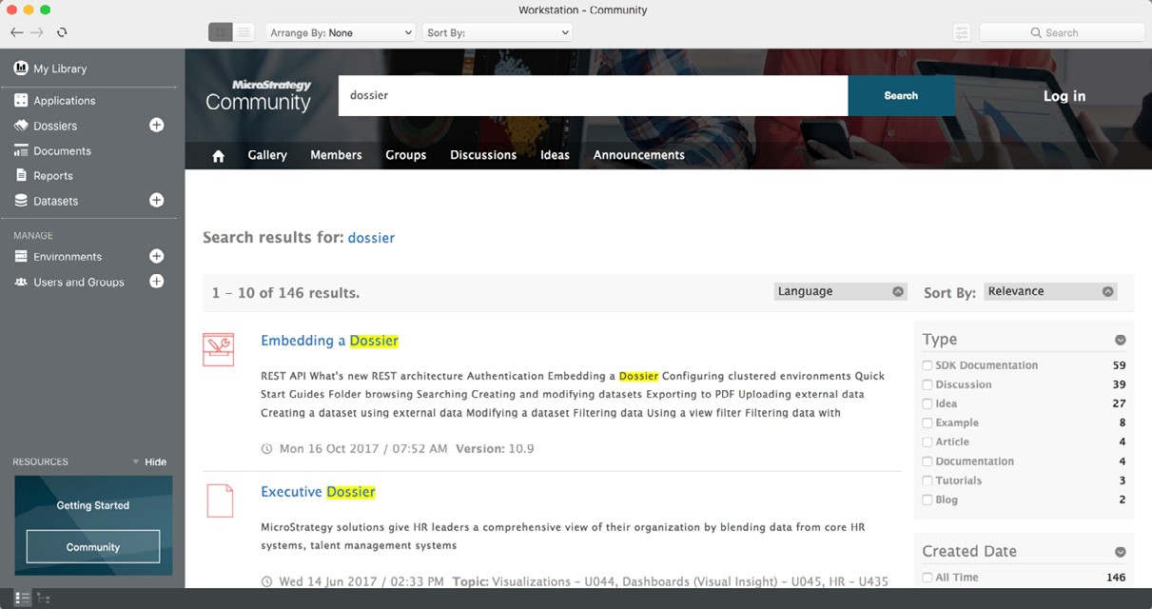

## Design and distribute dossiers

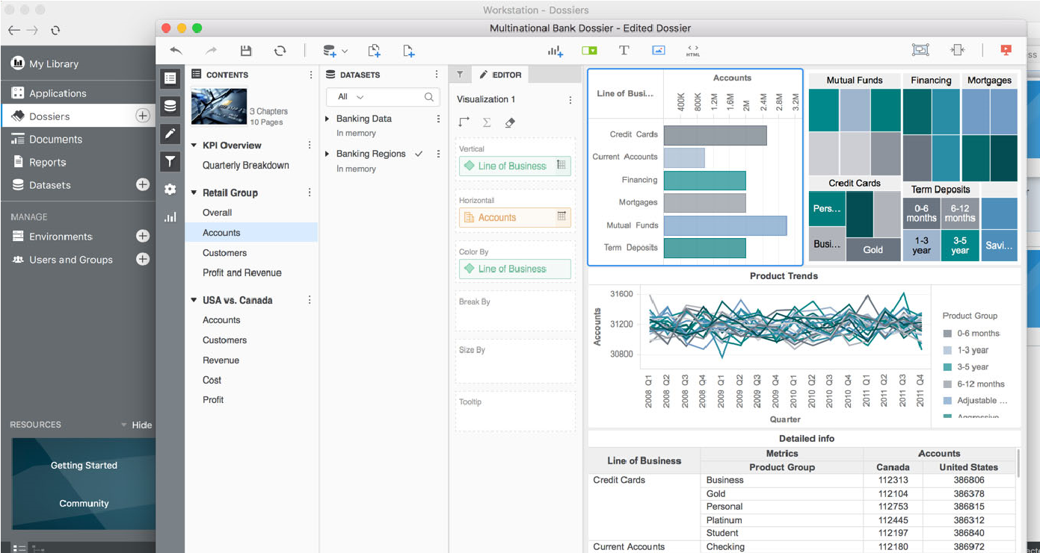

Workstation provides a parallel authoring and sharing experience with MicroStrategy Web. Add a dataset to Workstation or connect to an environment to build your analytical story with the dossier design interface.

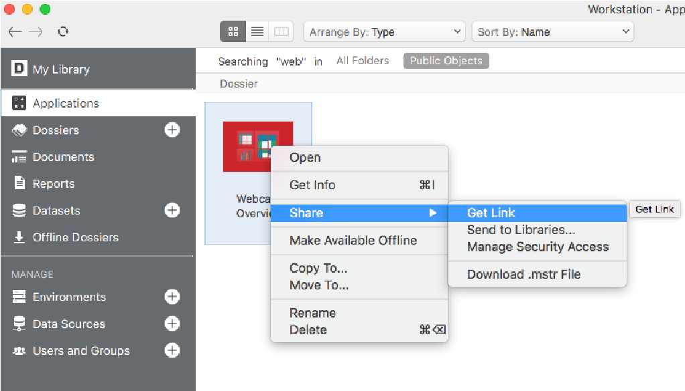

To share your content, right-click the dossier’s icon in the dossier area of Workstation. Select Share, then you can send a link, send the dossier to Library, or download the .MSTR file.

**Connect to the cloud and on premises data storage:**

## Access multiple environments

Through Workstation, you can connect to and search multiple environments, allowing you to access different projects and datasets from a single interface, known as Live Mode. While some MicroStrategy users choose to host their data locally, MicroStrategy also provides cloud storage through Amazon Web Services (AWS). Enterprises can deploy and manage the full MicroStrategy platform on dedicated AWS infrastructure.

To allow Workstation to access your environment, connect Workstation to your Intelligence Server. Below are the high-level steps to access your environment:

a From the Workstation Home window, select **Environments**. b Click **Add New Environment Connection**.

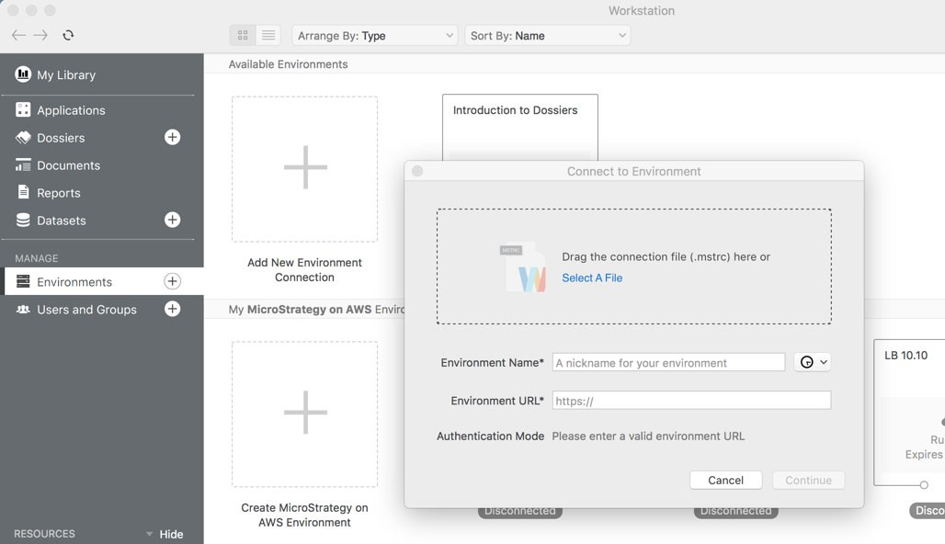

1. Enter your **Environment Name** and **Environment URL**. The URL is your Library server URL, which is connected to both the Collaboration Server

(which allows you to communicate via comments) and the Intelligence Server. Or, you can drag a **.mstrc connection file** to the Connect To Environment window.

1. Click **Continue**.
2. Enter your User Name and Password, then click **Connect**.
3. Select a **Project** you would like to work in. A project stores all schema objects you need to create your dossiers and other MicroStrategy objects. You are now connected to your MicroStrategy Environment.

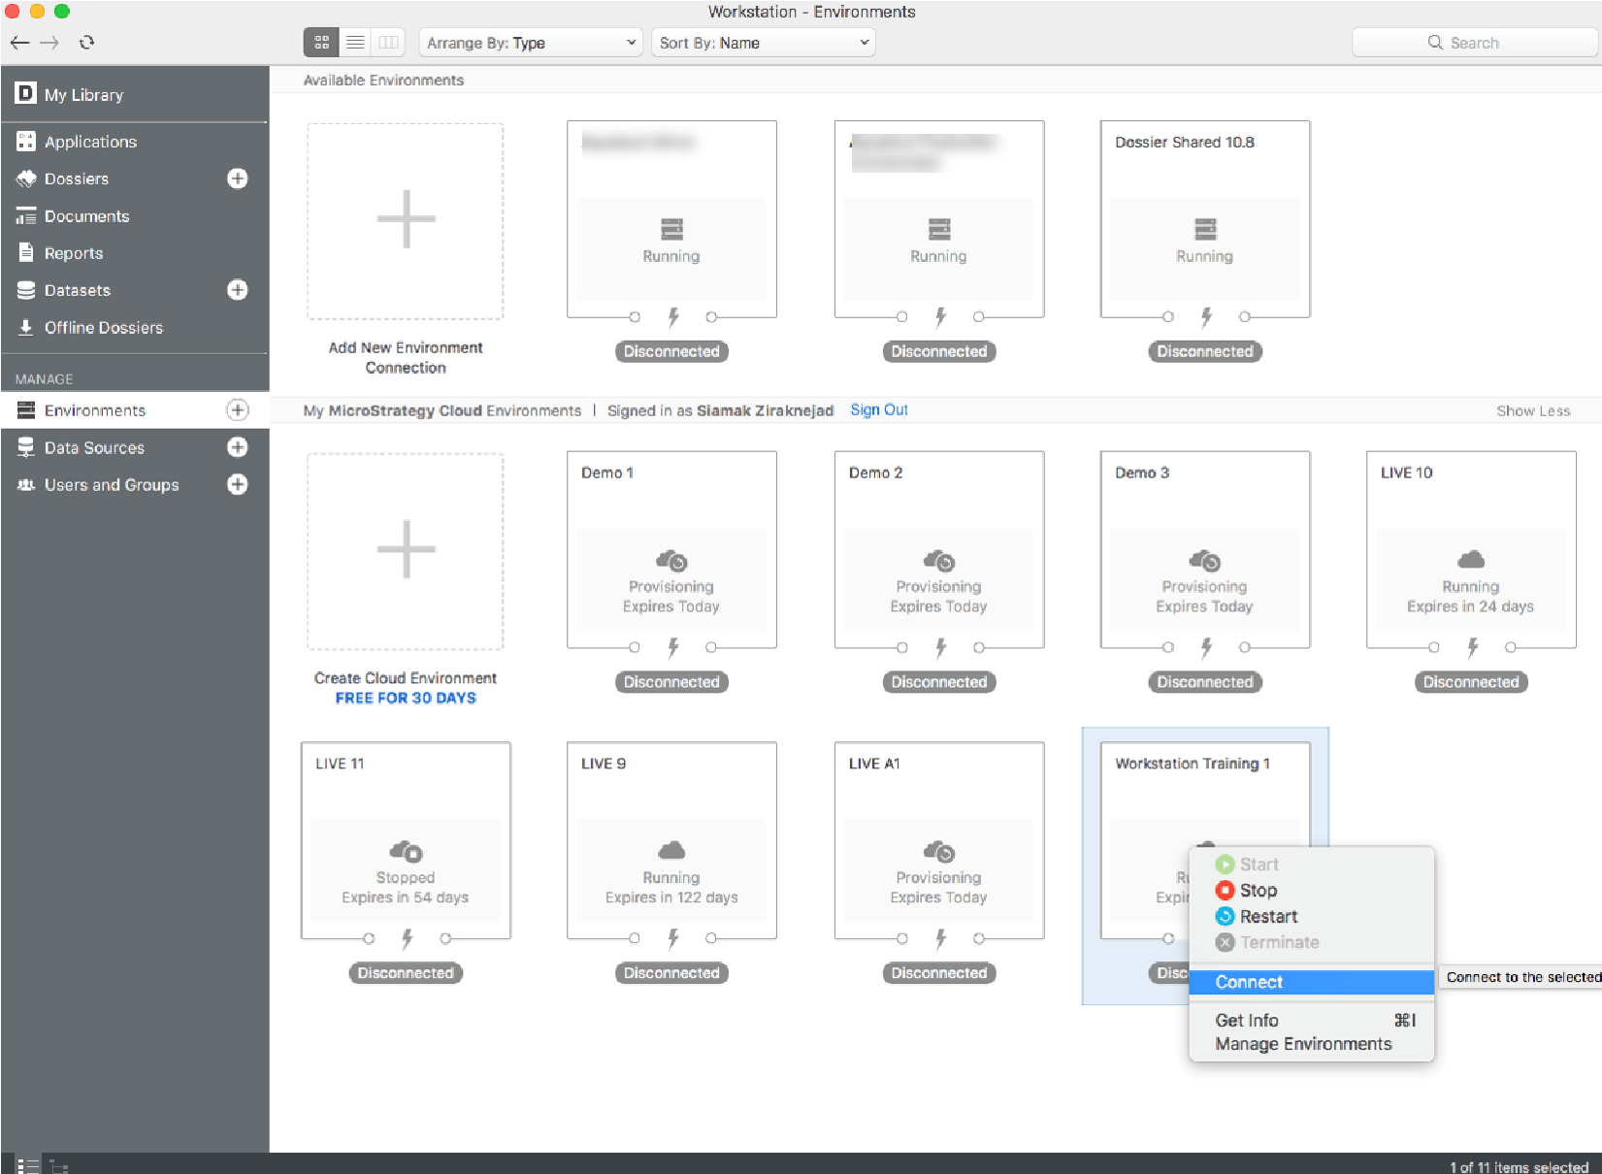

*The MicroStrategy Intelligence Server is the architectural foundation of the MicroStrategy platform that shares objects and data, manages the sharing of objects and data, and protects the information in the metadata.*

Thinking back to our banking analysts, these users can connect to multiple bank environments to access the information they need all in one place. When connected to your environment, you can access your datasets, reports, dossiers, and documents. Reports and datasets open as a new dossier, while documents open in Library.

## Upload and prepare data

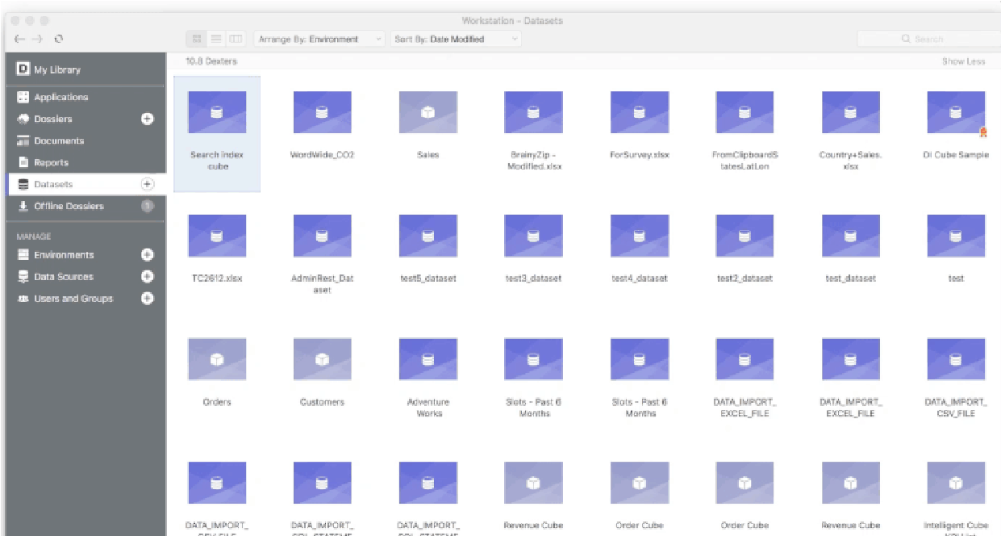

To build your dossiers in Workstation, in addition to connecting to enterprise environments to access data, you can upload data from over 70 sources. Just as in Web, you can wrangle the data to ensure usability and accuracy.

In the image above, all datasets, including those already in an environment, are accessible through the Datasets menu. Right-click a dataset to create a new dossier, edit the data, and refresh the data, among other options. When you double-click a dataset from Workstation, a new dossier window opens.

## Build HyperIntelligence Cards

As discussed earlier in the course, HyperIntelligence delivers zero-click, real-time data analytics that injects intelligence into the tools, websites, devices, and screens you already use. With Workstation, you can build HyperIntelligence Cards using your enterprise data.

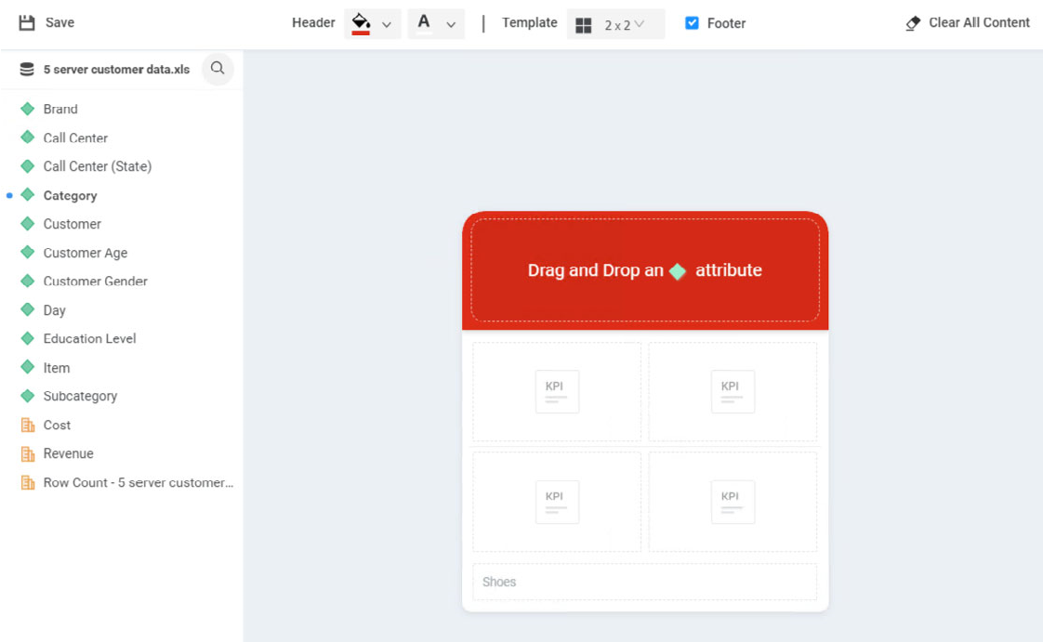

Using a simple drag and drop interface, you can add an attributes and metrics to build your card. The attribute identifies the elements you want to highlight to trigger the card in your web browser, while additional attributes and metrics are the KPIs that will populate the card based on the highlighted attribute. Additionally, to customize the card further, you can:

* Change the fonts and header color to adhere to corporate branding standards.
* Add a secondary attribute form to identify other key words to highlight in a Chrome browser.
* Change number formatting, such as changing a number to currency and adding decimals spaces.

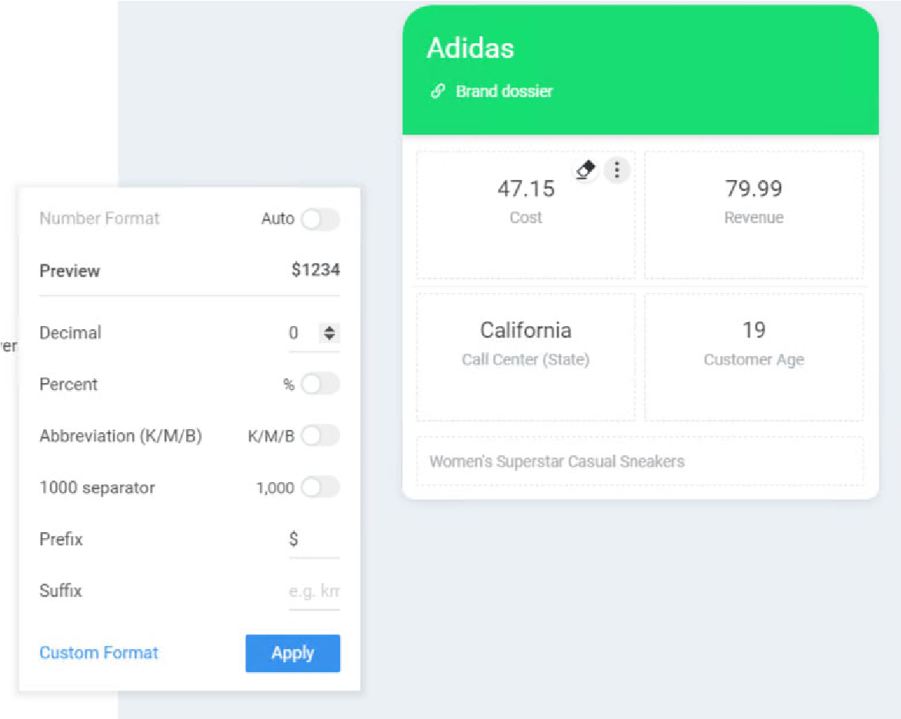

* Add a static link, such as a link to a relevant dossier.
* Set user and user group permissions to secure the card.
* Certify the card for distribution.
* Blacklist websites so key words are not highlighted on specified websites.

## MicroStrategy administration: User and group management

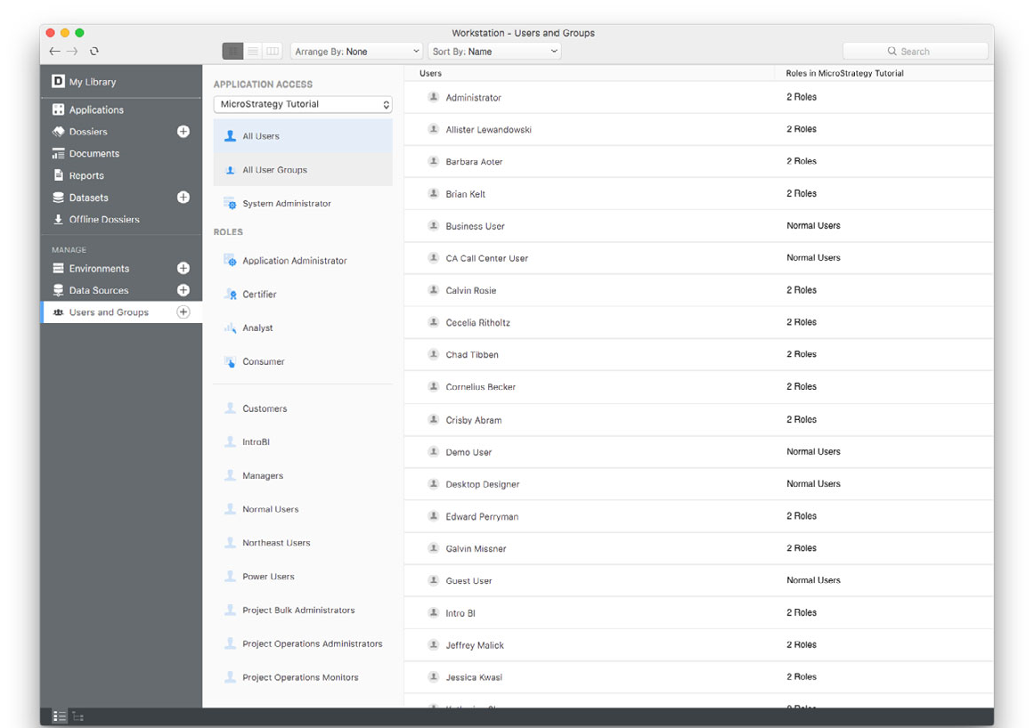

In Workstation, administrators can create a group of users, providing a convenient way to manage a large number of users. Instead of assigning privileges to hundreds of users individually, privileges can be assigned to all users at one time, as a group. Administrators can manage who views MicroStrategy and how, per each environment.

Administrators can assign the following roles:

* **Consumer**: Can only view and collaborate on a dossier or document that they have access to
* **Analyst:** Can author dossiers and reports
* **Application Administrator:** Can access all application specific tasks, such as database and user management
* **Certifier**: Can certify objects in addition to the authoring capabilities

### Analyze user engagement

In addition to user management, Workstation provides activity data that help identify the degree of user engagement with your Workstation applications. For example, you can see the number of dossiers, documents, reports, and cubes in each application. You can also identify the top 10 users who have executed these objects over the last 30 days.

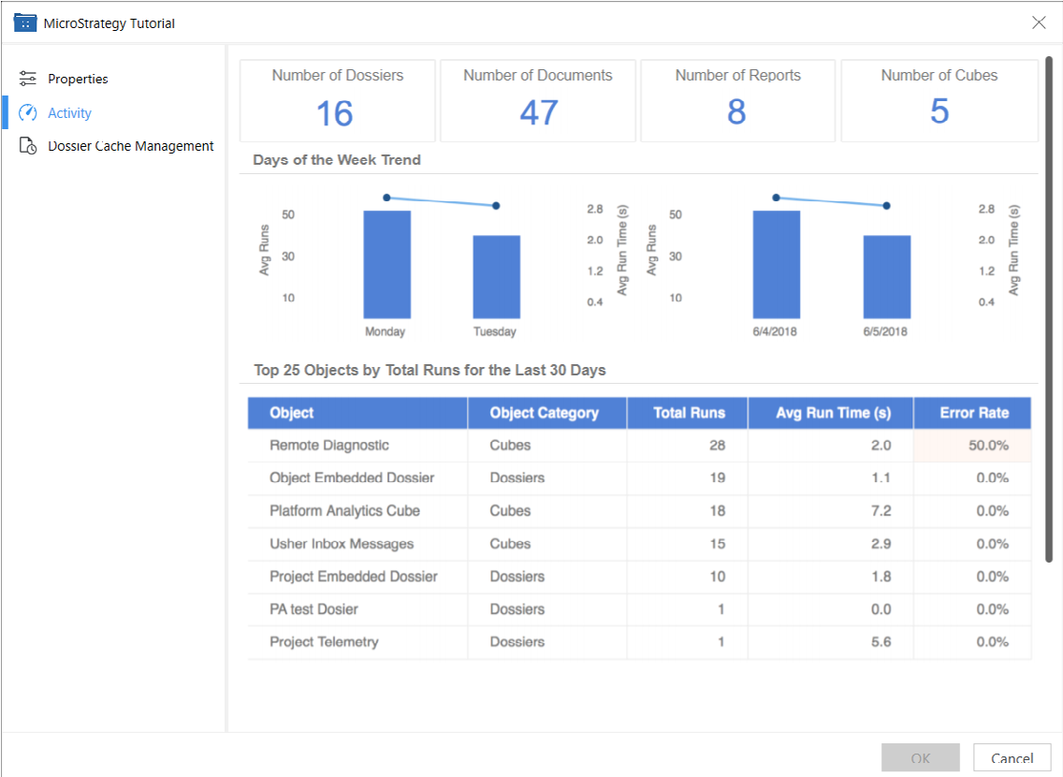

You can also analyze how each dossier is utilized. For example, you can see the average execution time, number of users, number of executions, and error rates associated with each dossier in the last 30 days. Trend graphs help you quickly identify user activity fluctuations over time.

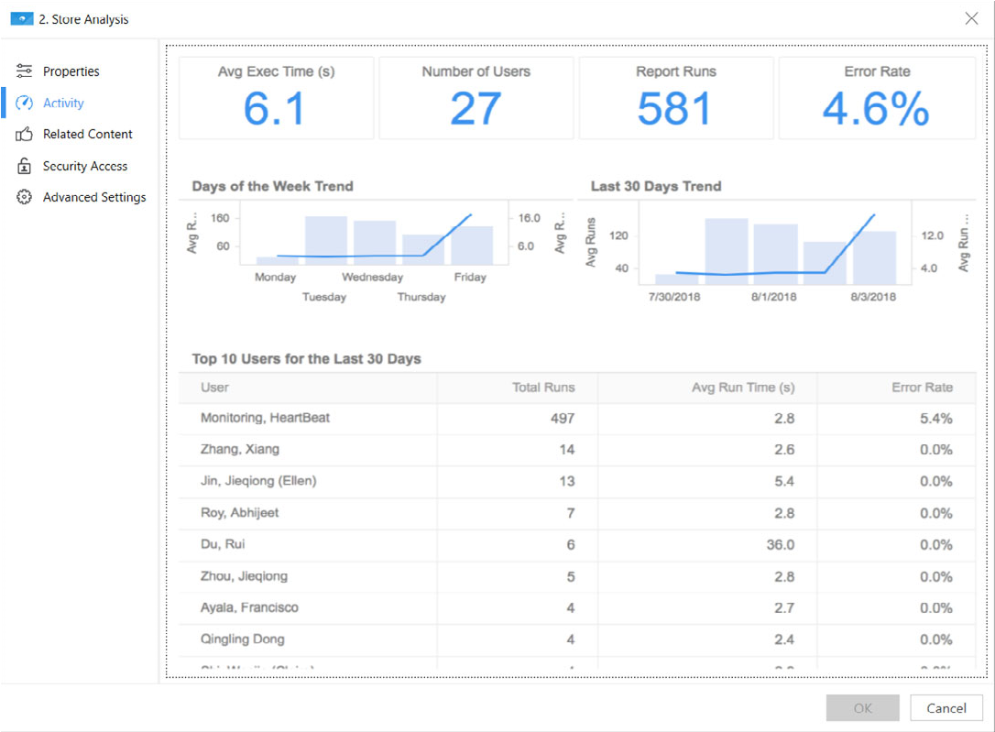



**6**

**W**

**ORKSHOP**

**:**

**P**

**ORT**

**A**

**NALYSIS**

**D**

**OSSIER**

# Create and analyze the Port Analysis dossier

You are the captain of a ragged band of pirates piloting a three-masted ship across the ocean. We want to target ships that contain the most profitable product types (categories). To visualize this, we want to map the ports and their states, which will allow us to see their location and their total trade values. Your fellow pirate colleague started a dossier using Excel and Wikipedia data sources, but unfortunately, he had to walk the plank, so you need to complete the dossier.

**Add the .mstr file**

1. From the Shared Reports page, click **Create**, then select **Upload MicroStrategy File**.
2. From the files your instructor sent in the beginning of class, select the **GeospatialService.mstr** file.
3. In the Upload window, click **View Dossier**. The dossier opens.

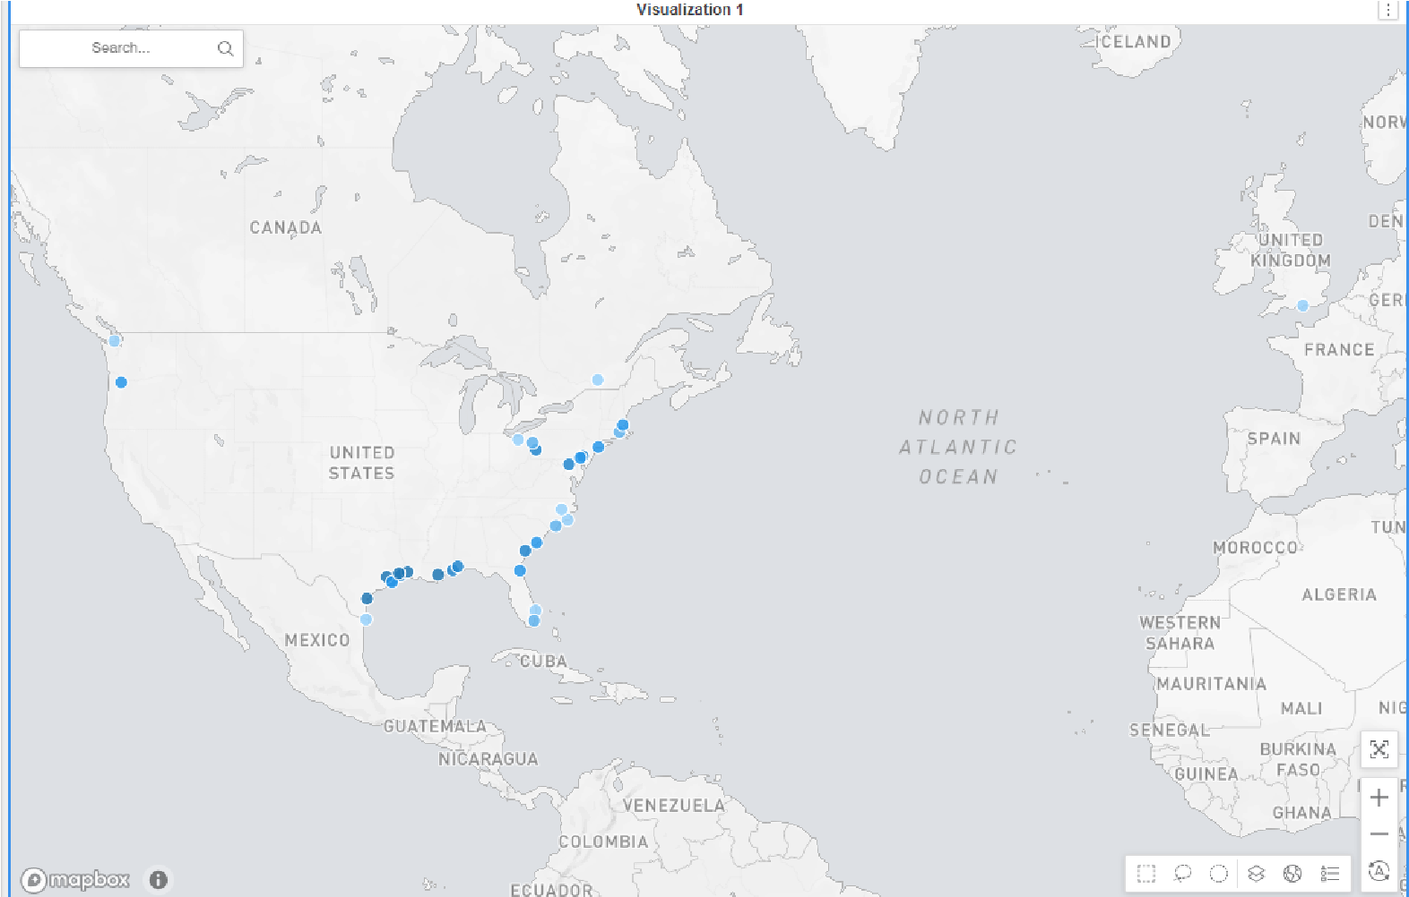

If needed, select the Map page from the contents panel. This map plots ports colored by total revenue; the darker the marker, the higher the revenue. You also want to analyze total trade by state. To do so, add a State layer to the map.

**Create the State map layer**

1. In the Editor panel, in the Layers drop zone, click **Add**.
2. Right-click the new layer and select **Rename**. Type **State**.

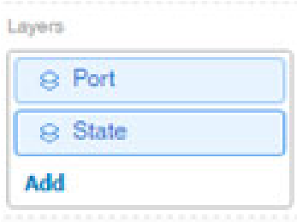

1. Drag **State** from the Port Export Info Data dataset to the **Geo Attribute** drop zone.
2. Drag **Total trade** from the Port Export Info Data dataset to the **Color By** drop zone.

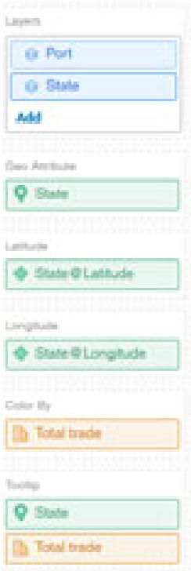

States are two-dimensional areas, so you want to change the map to an Area Map. This will help you to quickly visualize which state has a higher profit.

1. Click the **Format** icon to open the Format panel.
2. From the first drop-down list, select **Formatting on layer**.
3. From the second drop-down list, select **State**.
4. From the Type drop-down list, select **Area**.
5. You want to change the threshold color range to gray since the Ports layer uses the blue color range and you want the ports to be easily visible on the map. Click **Select color ranges icon**.

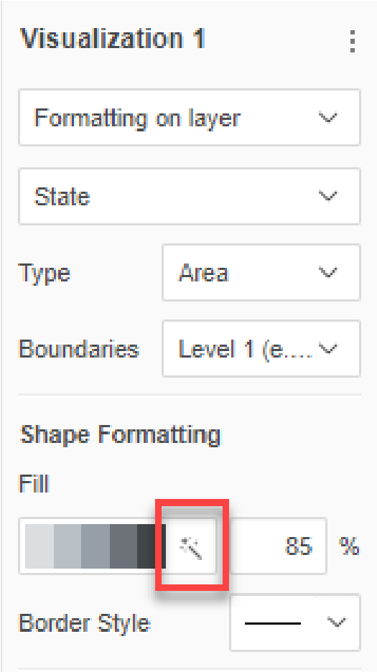

1. From the Color drop-down list, select **Gray**.

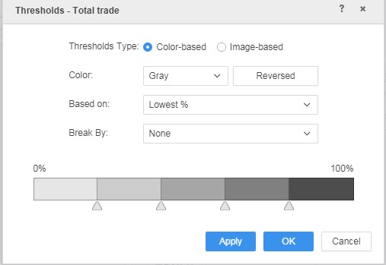

1. Click **OK**.
2. Select the **Show Legend** check box to view the color range parameters for the State layer.
3. Geospatial Service maps provide several map styles. You want the oceans to be colored blue. On the map toolbar (displayed on the map), click the **Map**

**Styles**

icon

, and select

**Basic**

**Resolve the location conflict**

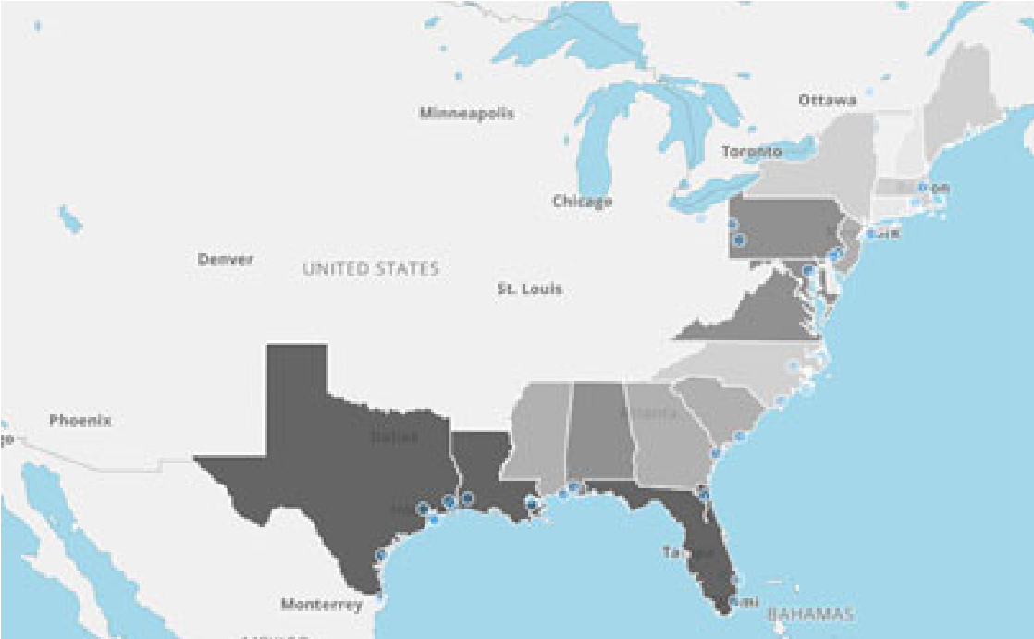

1. Switch back to the **Editor** panel.

Now that the layer is an area map, the State attribute in the Geo Attribute drop zone has an alert indicating there is a conflict with common place names that exist in multiple countries or states. With Geospatial Service visualizations, you can resolve duplicate geo names by adding another geo attribute to better define results.

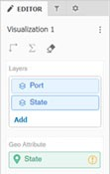

1. Hover your cursor over the indicator to display more information, along with a suggestion to resolve it.

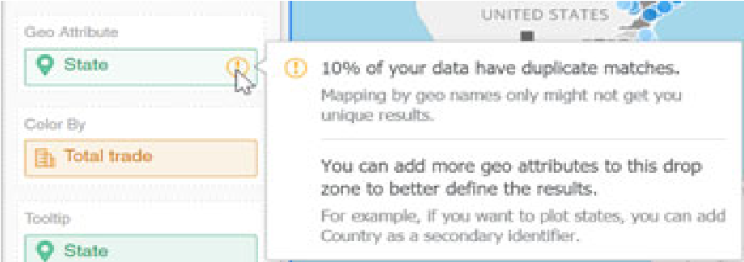

1. Drag the **State (Country)** attribute to the Geo Attribute drop zone, below State. The duplicate matches are resolved.

**Define how the layers are displayed based on the zoom level**

Defining how the layers are displayed based on the zoom level controls whether certain map layers are displayed or hidden at different magnifications (zoom levels). Defining this allows you to control how an end user moves between global information (summary or holistic) down to city (detail or granular).

1. Return to the **Format** panel.
2. From the first drop-down list, select **Map Options**.
3. From the **Zoom Behavior** drop-down list, select **Static**. When a user zooms in or out on the map, it will retain that zoom level when a change is made or the user reopens the dossier.
4. Select the **Zoom through layers** check box.

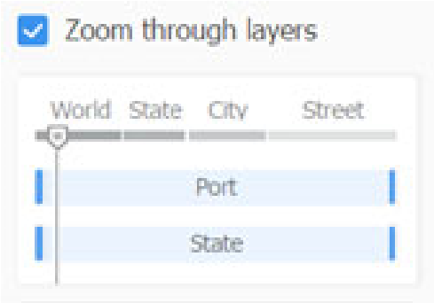

The whisker line (shown below World in the example above) indicates the current zoom level of the map. The blue lines at the start and end of the Port and State bars indicate the level at which that map layer is displayed. Right now, both layers are displayed all the time, as shown above:

1. Drag the **start line** for **Port** to the **3.5** level, or as close as you can get it.

The numbers are displayed when you hover your cursor over the bar.

1. Drag the **end line** for **State** to the **5.6** level, or as close as you can get it.

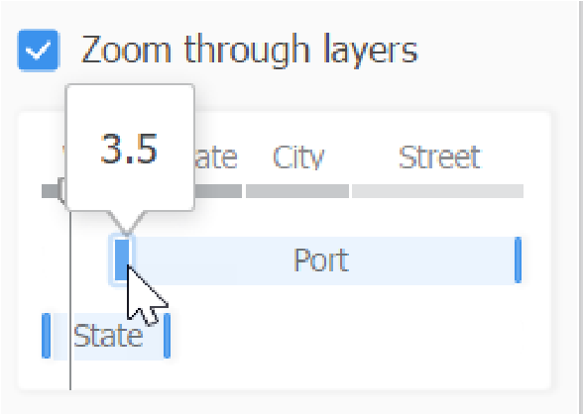

1. Click the **Save** icon to save your work.

**Explore the Geospatial Service Map in Library**

1. To view your dossier in Library, click the **Share** menu. Then select **Get a link to MicroStrategy Library**.
2. In the Share window, click **Launch**. Your dossier opens in Library.
3. Since New York/New Jersey and Norfolk are the two most profitable ports (from a pirate's view), we need a home port between the two. You think Baltimore could work as a home port. Search for **Baltimore** on the map. (The search box is displayed when you hover your cursor over the map.)



The map zooms in to display Baltimore. Notice that the State legend is not displayed, since the State layer is not displayed. We did not select to display the Port legend. If you want to display the Port legend, click the **Show Legend** icon 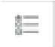 in the map toolbar. Close the Port legend by clicking the x in the upper right corner of the Port legend.

1. Zoom out, using the map toolbar, until both port and state are displayed, so that you can view alternative ports for your home port. Notice that the State legend is displayed now.

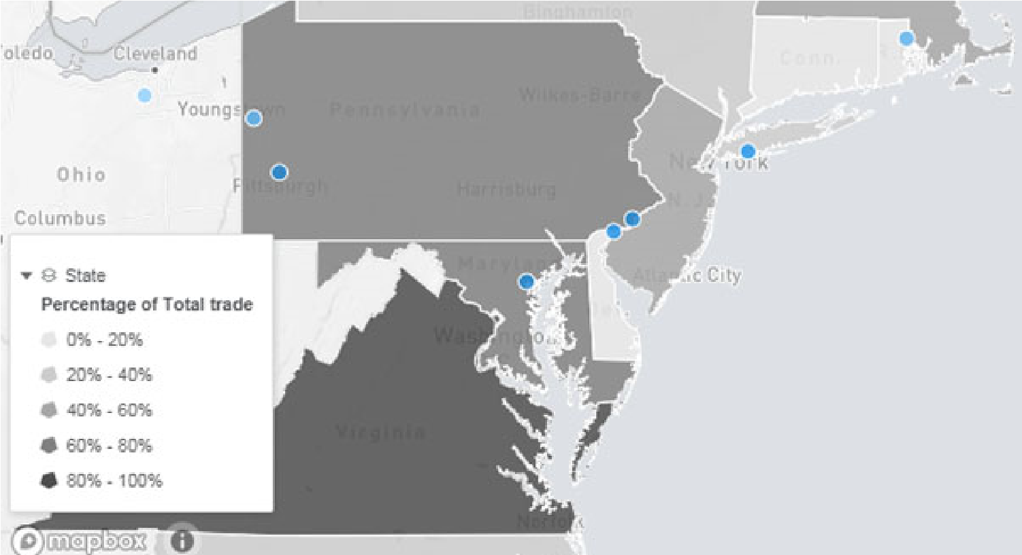

1. Zoom out one more time, using the map toolbar, to view more ports. The ports are now clustered, according to the clustering zoom level that we set.

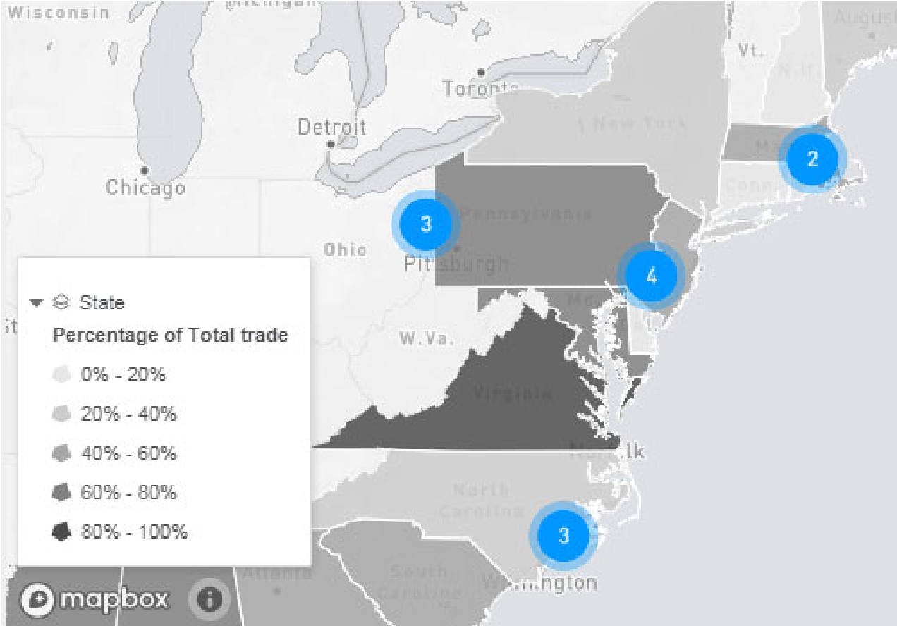

1. Zoom out again, using the map toolbar, until the ports are no longer displayed. This allows you to compare the total trade for all the states.

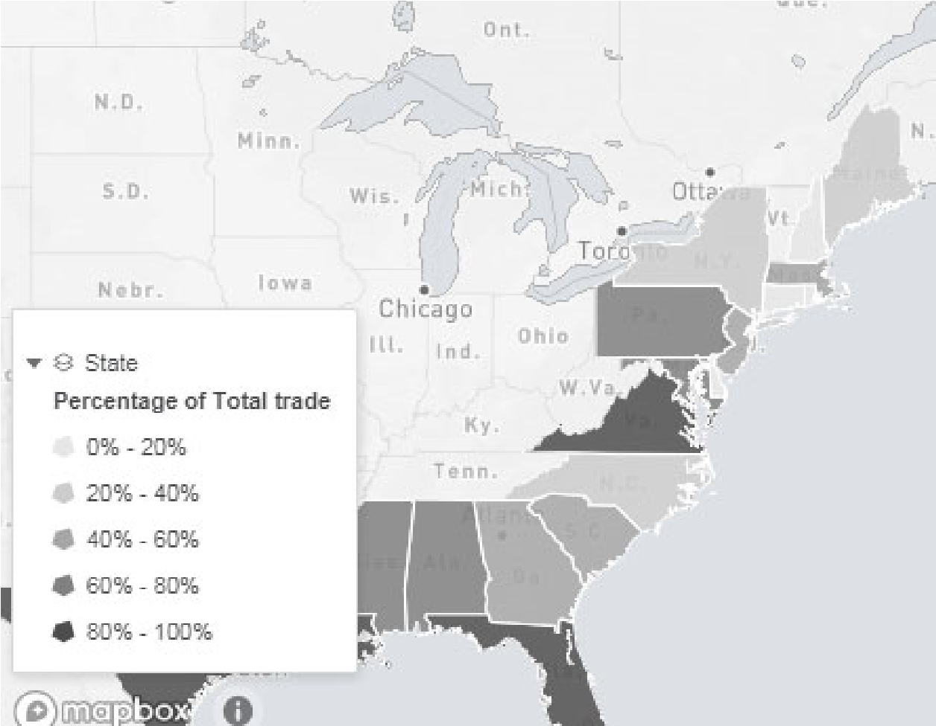

1. Tilt the map, by clicking the tilt icon  on the map toolbar and rotating the icon.

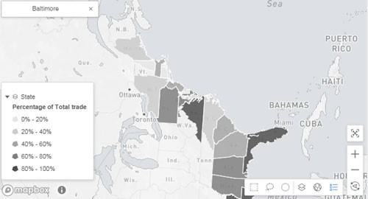

1. Click the reset icon  on the map toolbar to return to the initial view of the map.
2. Resize the browser window. Because we selected static zoom behavior, the level of magnification does not change. If we had selected dynamic instead, the map would zoom to refit the contents.

**Explore the ESRI Map**

Your team member who started the original dossier also created an ESRI map using the same dataset as your Geospatial Service map. Perform the same operations on the ESRI map as you did on the Geospatial Service map, to see the differences between the two kinds of maps.

1. From the Table of Contents panel, click the **ESRI Map** chapter.

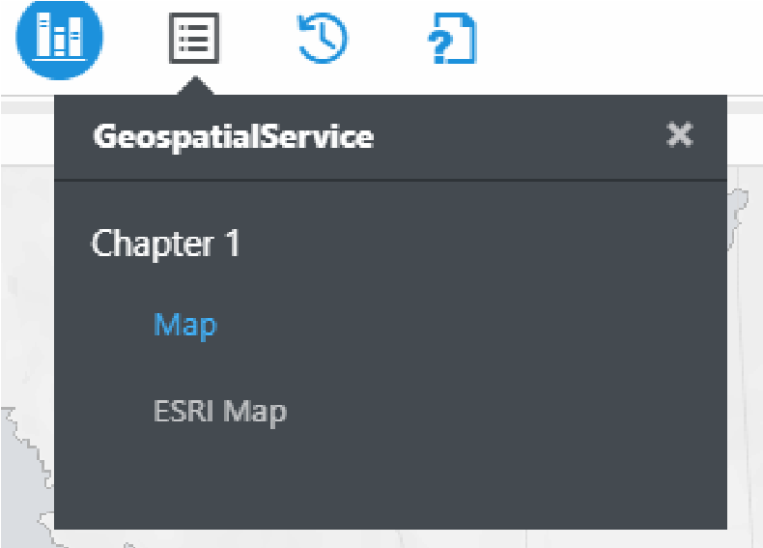

1. Search for **Baltimore** as a potential home port.

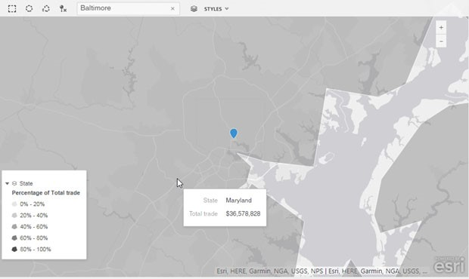

The map zooms in to display Baltimore. The State legend is displayed, unlike in the Geospatial Service map. In an ESRI map we cannot define how the map layers are displayed based on zoom level, so all layers are always displayed at all zoom levels. Likewise, legends are displayed at all zoom levels. Port is not selected to display the legend, otherwise that would also be displayed.

*A Geospatial Service map allows you to display and hide legends for all map layers. With both maps you can expand and collapse displayed legends.*

1. Zoom out, using the map toolbar, until you can see various states and the ports are clustered, so that you can view alternative ports for your home port. The clustering of the ports occurs automatically, when multiple ports are too close to easily distinguish their pointers. In a Geospatial Service map, you can set the zoom level that clustering occurs at.

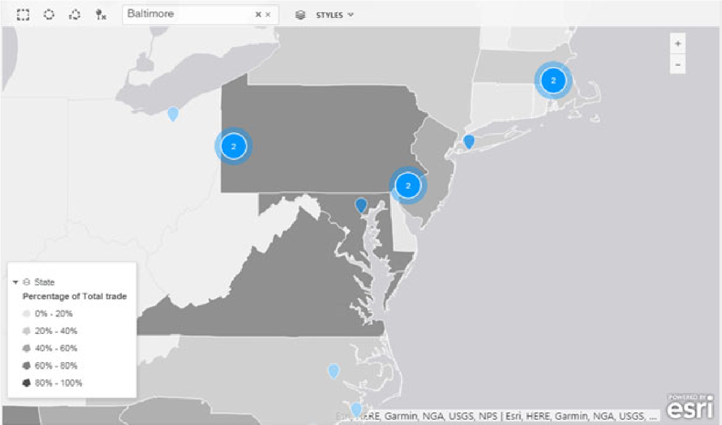

1. Zoom out again, using the map toolbar. All layers always being displayed in an ESRI map can be a positive feature-you do need to set the zoom levels for each layer. You can also easily compare the number of ports in each state using the ESRI map. (In the Geospatial Service map, the ports would no longer be displayed at this zoom level.)

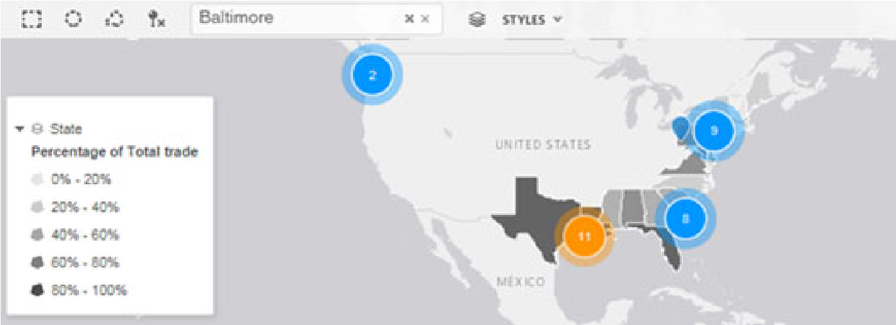

**Copyright Information**

All Contents Copyright © 2019 MicroStrategy Incorporated. All Rights Reserved.

**Trademark Information**

The following are either trademarks or registered trademarks of MicroStrategy Incorporated or its affiliates in the United States and certain other countries:

MicroStrategy, MicroStrategy 2019, MicroStrategy 11, MicroStrategy 10, MicroStrategy 10 Secure Enterprise, MicroStrategy 9,

MicroStrategy 9s, MicroStrategy Analytics, MicroStrategy Analytics Platform, MicroStrategy Desktop, MicroStrategy Library,

MicroStrategy Operations Manager, MicroStrategy Analytics Enterprise, MicroStrategy Evaluation Edition, MicroStrategy Secure Enterprise, MicroStrategy Web, MicroStrategy Mobile, MicroStrategy Server, MicroStrategy Parallel Relational

In-Memory Engine (MicroStrategy PRIME), MicroStrategy MultiSource, MicroStrategy OLAP Services, MicroStrategy

Intelligence Server, MicroStrategy Intelligence Server Universal, MicroStrategy Distribution Services, MicroStrategy Report

Services, MicroStrategy Transaction Services, MicroStrategy Visual Insight, MicroStrategy Web Reporter, MicroStrategy Web

Analyst, MicroStrategy Office, MicroStrategy Data Mining Services, MicroStrategy Geospatial Services, MicroStrategy

Narrowcast Server, MicroStrategy Health Center, MicroStrategy Analyst, MicroStrategy Developer, MicroStrategy Web

Professional, MicroStrategy Architect, MicroStrategy SDK, MicroStrategy Command Manager, MicroStrategy Enterprise

Manager, MicroStrategy Object Manager, MicroStrategy Integrity Manager, MicroStrategy System Manager, MicroStrategy

Analytics App, MicroStrategy Mobile App, MicroStrategy Tech Support App, MicroStrategy Mobile App Platform,

MicroStrategy Cloud, MicroStrategy R Integration, Dossier, Usher, MicroStrategy Usher, Usher Badge, Usher Security, Usher

Security Server, Usher Mobile, Usher Analytics, Usher Network Manager, Usher Professional, MicroStrategy Identity,

MicroStrategy Badge, MicroStrategy Identity Server, MicroStrategy Identity Analytics, MicroStrategy Identity Manager,

MicroStrategy Communicator, MicroStrategy Services, MicroStrategy Professional Services, MicroStrategy Consulting, MicroStrategy Customer Services, MicroStrategy Education, MicroStrategy University, MicroStrategy Managed Services, BI

QuickStrike, Mobile QuickStrike, Transaction Services QuickStrike Perennial Education Pass, MicroStrategy Web Based Training

(WBT), MicroStrategy World, Best in Business Intelligence, Pixel Perfect, Global Delivery Center, Direct Connect, Enterprise

Grade Security For Every Business, Build Your Own Business Apps, Code-Free, Welcome to Ideal, Intelligent Enterprise, HyperIntelligence, HyperCard, HyperVoice, HyperVision, HyperMobile, HyperScreen, Zero-Click Intelligence, Enterprise Semantic Graph, The World’s Most Comprehensive Analytics Platform, The World’s Most Comprehensive Analytics Platform. Period. Other product and company names mentioned herein may be the trademarks of their respective owners. Specifications subject to change without notice. MicroStrategy is not responsible for errors or omissions. MicroStrategy makes no warranties or commitments concerning the availability of future products or versions that may be planned or under development.

This Course (course and course materials) and any Software are provided “as is” and without express or limited warranty of any kind by either MicroStrategy Incorporated (“MicroStrategy”) or anyone who has been involved in the creation, production, or distribution of the Course or Software, including, but not limited to, the implied warranties of merchantability and fitness for a particular purpose. The entire risk as to the quality and performance of the Course and Software is with you. Should the Course or Software prove defective, you (and not MicroStrategy or anyone else who has been involved with the creation, production, or distribution of the Course or Software) assume the entire cost of all necessary servicing, repair, or correction.

In no event will MicroStrategy or any other person involved with the creation, production, or distribution of the Course or Software be liable to you on account of any claim for damage, including any lost profits, lost savings, or other special, incidental, consequential, or exemplary damages, including but not limited to any damages assessed against or paid by you to any third party, arising from the use, inability to use, quality, or performance of such Course and Software, even if

MicroStrategy or any such other person or entity has been advised of the possibility of such damages, or for the claim by any other party. In addition, MicroStrategy or any other person involved in the creation, production, or distribution of the Course and Software shall not be liable for any claim by you or any other party for damages arising from the use, inability to use, quality, or performance of such Course and Software, based upon principles of contract warranty, negligence, strict liability for the negligence of indemnity or contribution, the failure of any remedy to achieve its essential purpose, or otherwise.

Dashboards and Data Discovery

The Course and the Software are copyrighted and all rights are reserved by MicroStrategy. MicroStrategy reserves the right to make periodic modifications to the Course or the Software without obligation to notify any person or entity of such revision. Copying, duplicating, selling, or otherwise distributing any part of the Course or Software without prior written consent of an authorized representative of MicroStrategy are prohibited.

© 2019 MicroStrategy, Inc. **179**